FCC Technical Manual

Contents Page

- Flow Diagrams 3
- Heat Balance 5
- Prediction of Standard Yields 35
- Fractionation & Prediction of Plant Yields 40
- Product Quality Prediction 53
- Product Recycle Prediction 74
- Catalyst Management Calculations 76
- Elemental Balances 79
- Cubic Spline Functions 82
- Distillation Conversion Methods 84
- Physical Property Calculations and Conversions 90

Appendix 1: Quench Add-in 96
Appendix 2: CatCalc Add-in 99
Appendix 3: Model Input/Output 111
Appendix 4: Molecular Weight Constants 112

CALCULATION FLOW DIAGRAMS
Calibration

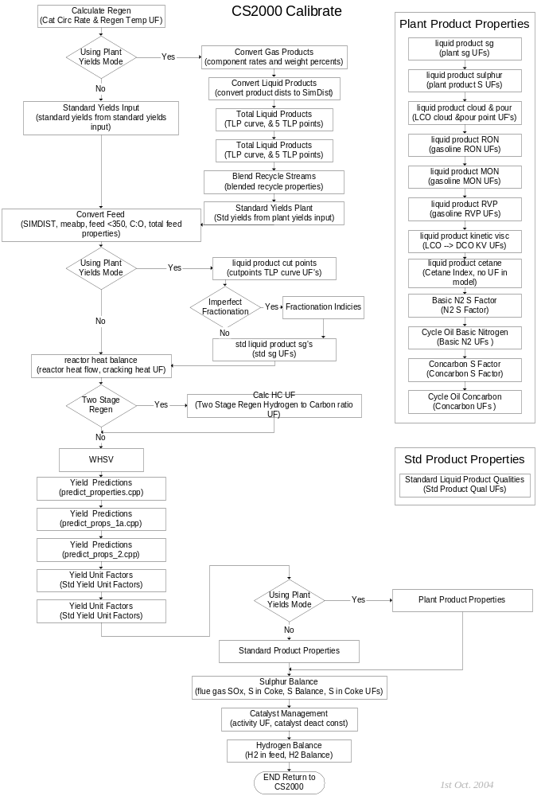
Predict
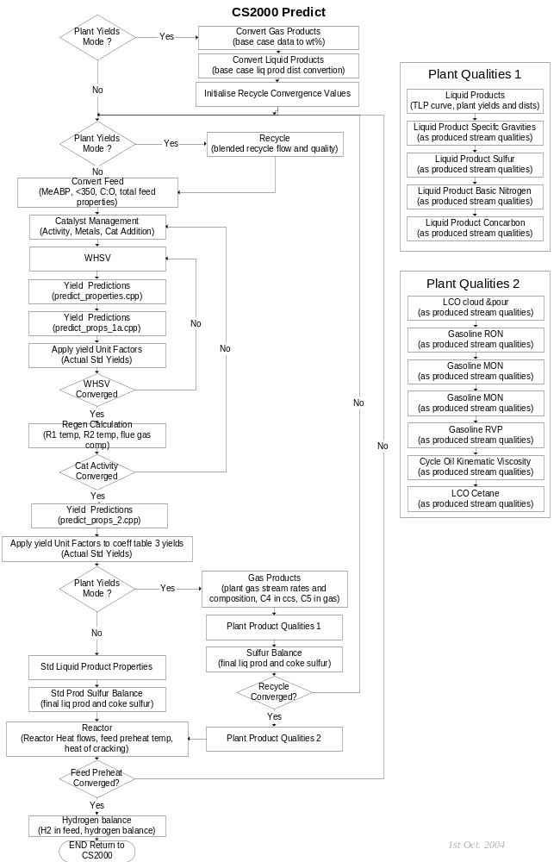

2 HEAT BALANCE

The heat balance consists of a reactor section heat balance and a regeneration section heat balance for both the base case and predict case. The model is capable of simulating a single stage or a two stage regeneration section with the options of having a catalyst cooler, pure oxygen enrichment and torch oil combustion. The heat balance calculation procedures are outlined in the following sections.

2.1 Base Case Single Stage Regenerator Heat Balance
Either the amount of coke burnt in the regenerator or the air rate to the regenerator is calculated depending on what data the user inputs. If flue gas analysis and air rate are input coke yield is calculated, if coke yield and flue gas analysis are input, air rate is calculated. An option was added in version 4.0 to compute regen heat balance from coke make, coke burn ratio, and coke composition.
Hydrogen in coke is calculated from the oxygen balance. The base catalyst circulation rate is calculated from the regenerator heat balance.
Inputs: blower_discharge_temp [°F] Blower discharge temperature
cat_cooler_duty [MBTU/min] Catalyst cooler duty
coke_make [lb/min] Coke make
fluegas_CO_vol [vol%] CO in the regenerator fluegas
fluegas_CO2_vol [vol%] CO2 in the regenerator fluegas
fluegas_O2_vol [vol%] O2 in the regenerator fluegas
fluegas_temp [°F] Fluegas temperature
H2O_in_air [wt/wt] Water content of air
O2_enrichment [lb/min] Oxygen added to regenerator air
O2_temp [°F] O2 enrichment temperature
reactor_temp [°F] Reactor temperature
regen_bed_temp [°F] Regenerator bed temperature
torch_oil_meabp [°F] Torch oil meabp
torch_oil_rate [lb/min] Torch oil rate
torch_oil_sg Torch oil sg
torch_oil_temp [°F] Torch oil temperature
wet_air_rate [lb/min] Wet air rate to regenerator
H_coke_input [wt%] Hydrogen in coke
S_coke_input [wt%] Sulfur in coke
burn_ratio [vol/vol] (CO2+CO)/CO2
enrich_O2_conc [vol%] Enriched oxygen concentration (the rest is N2)
cat_cp_input [BTU/lb/°F] Input cat heat capacity
Constants: AIR_HEAT_CAP 7.07E-6 Air heat cap. MBTU/lbmol/°F
AIR_MW = (O2_IN_AIR*O2_MW+N2_IN_AIR*N2_MW) Air mole weight
C_DESORP_HEAT 0.00145 Coke desorption heat MBTU/lb
C_MW 12.01 Carbon mole weight
CAT_HEAT_CAP 0.265E-6 Cat. heat capacity MBTU/lb/°F
CO_COMBUSTION 0.0476 C to CO combustion MBTU/lbmol
CO_HEAT_CAP 7.34E-6 CO heat cap. MBTU/lbmol/°F
CO2_COMBUSTION 0.1693 C to CO2 combustion MBTU/lbmol
CO2_HEAT_CAP 11.21E-6 CO2 heat cap. MBTU/lbmol/°F
COKE_HEAT_CAP 0.5E-6 Coke heat capacity MBTU/lb/°F
DATUM_TEMP 60.0 Datum temperature °F
H2_COMBUSTION 0.104 H to H2O combustion MBTU/lbmol
H2_MW 2.015 Hydrogen mole weight
H2O_HEAT_CAP 8.85E-6 H2O heat cap. MBTU/lbmol/°F
H2O_MW 18.015 Water mole weight
IDEAL_GAS_VOL 379.0 ft³/lbmol of ideal gas @ STP
N2_HEAT_CAP 7.79E-6 N2 heat cap. MBTU/lbmol/°F
N2_IN_AIR 0.79 Nitrogen vol fraction of air O2_IN_AIR 0.21 Oxygen vol fraction of air
O2_HEAT_CAP 7.61E-6 O2 heat cap. MBTU/lbmol/°F
O2_MW 32.0 Oxygen mole weight
TO_HEAT_CAP 0.75E-6 torch oil heat capacity MBTU/lb/°F
TONNE_TO_LBS 2204.6 Convert tonnes to lbs

2.1.1 Base Coke Calculation: For input air rate and flue gas analysis
fluegas_N2_vol = 100.0 - fluegas_O2_vol - fluegas_CO_vol - fluegas_CO2_vol
dry_air_rate = wet_air_rate / (1 + H2O_in_air) / AIR_MW
dry_fluegas_rate = dry_air_rate * N2_IN_AIR / (fluegas_N2_vol / 100)
fluegas_O2_mol = dry_fluegas_rate * fluegas_O2_vol / 100
fluegas_CO_mol = dry_fluegas_rate * fluegas_CO_vol / 100
fluegas_CO2_mol = dry_fluegas_rate * fluegas_CO2_vol / 100
O2_into_regen = dry_air_rate * O2_IN_AIR + O2_enrichment / O2_MW
O2_from_regen = fluegas_O2_mol + fluegas_CO2_mol + fluegas_CO_mol / 2
H2_burnt_mol = (O2_into_regen - O2_from_regen) * 2
C_burnt_wt = (fluegas_CO_mol + fluegas_CO2_mol) * C_MW
H2_burnt_wt = H2_burnt_mol * H2_MW
Calculation of torch oil hydrogen to carbon ratio:
TO_LSGP = 0.642 + 0.000509 * torch_oil_meabp
TO_LSGA = 0.765 + 0.00115 * torch_oil_meabp
TO_C_Num = 0.7672 + 0.13228 * torch_oil_meabp
TO_H2_P = (2 * TO_C_Num + 2) / (14 * TO_C_Num + 2) * 100
TO_Rings = -0.07107 + 0.0089256 * torch_oil_meabp
TO_H2_A = (2 * TO_Rings + 10) / (50 * TO_Rings + 70) * 100
TO_H2_ Liquid = TO_H2_P + (TO_H2_A - TO_H2_P) * (torch_oil_sg - TO_LSGP) /
(TO_LSGA - TO_LSGP)
TO_H2_burnt = torch_oil_rate * TO_H2_ Liquid / 100
TO_C_burnt = torch_oil_rate * (100 - TO_H2_ Liquid) / 100
H2_from_coke = H2_burnt_wt - TO_H2_burnt
C_from_coke = C_burnt_wt - TO_C_burnt
coke_burnt_wt = C_burnt_wt + H2_burnt_wt - torch_oil_rate
H2_in_coke = H2_from_coke / coke_burnt_wt

2.1.2 Base Coke Calculation: For input coke make and flue gas analysis
Solution of four simultaneous equations describing the molar flow rates of O2, CO, CO2 and N2 in the flue gas are required. The easiest method of solution is by using an inverse matrix.
Volume fraction of components in flue gas:
O2f = fluegas_O2_vol / 100
COf = fluegas_CO_vol / 100
CO2f = fluegas_CO2_vol / 100
The simultaneous equations can be described, in matrix form, as follows:
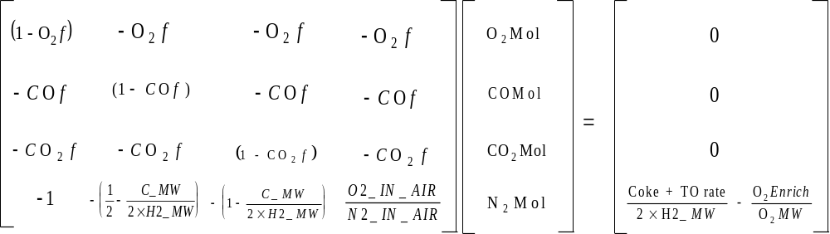
The solution for the molar flow rates of O2, CO, CO2 and N2 in flue gas is given by:
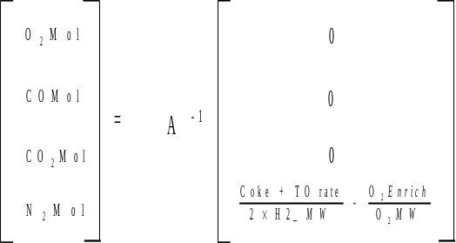
where: A-1 is the inverse matrix of the coefficients matrix.
TIP. An inverse matrix can be found using the ‘MINVERSE’ function in Microsoft Excel.
Calculate other molar flow rates:
H2_burnt_mol = (coke_make + torch_oil_rate - (fluegas_CO_mol + fluegas_CO2_mol) * C_MW) / H2_MW
Calculate torch oil hydrogen and carbon burnt:
TO_LSGP = 0.642 + 0.000509 * torch_oil_meabp
TO_LSGA = 0.765 + 0.00115 * torch_oil_meabp
TO_C_Num = 0.7672 + 0.13228 * torch_oil_meabp
TO_H2_P = (2 * TO_C_Num + 2) / (14 * TO_C_Num + 2) * 100
TO_Rings = -0.07107 + 0.0089256 * torch_oil_meabp
TO_H2_A = (2 * TO_Rings + 10) / (50 * TO_Rings + 70) * 100
TO_H2_Liquid = TO_H2_P + (TO_H2_A - TO_H2_P) * (torch_oil_sg - TO_LSGP) / (TO_LSGA - TO_LSGP)
TO_H2_burnt = torch_oil_rate * TO_H2_Liquid / 100
TO_C_burnt = torch_oil_rate * (100 - TO_H2_Liquid) / 100
Calculate hydrogen in coke:
H2_from_coke = H2_burnt_mol * H2_MW - TO_H2_burnt
C_from_coke = (fluegas_CO_mol + fluegas_CO2_mol) * C_MW - TO_C_burnt
coke_burnt_wt = H2_from_coke + C_from_coke
H2_in_coke = H2_from_coke / coke_burnt_wt * 100
C_burnt_wt = C_from_coke + TO_C_burnt
Calculate oxygen requirements:
O2_4_CO2 = fluegas_CO2_mol
O2_4_CO = fluegas_CO_mol / 2
O2_4_H20 = H2_burnt_mol / 2
O2_4_XSO2 = fluegas_O2_mol
O2_enrichment_Mol = O2_enrichment / O2_MW
O2_Required = O2_4_CO2 + O2_4_CO + O2_4_H20 + O2_4_XSO2 - O2_enrichment_Mol
Calculate air requirements:
Air_Required = O2_Required / O2_IN_AIR
Dry_Air_Required = Air_Required * AIR_MW
wet_air_Required = Dry_Air_Required * (1 + H2O_in_air)

2.1.3 Base Coke Calculation: For input coke make and burn ratio
This option only works with a single regenerator and requires user input of hydrogen and sulphur in coke.
H2_burnt_mol = H_coke_input / 100.0 / H2_MW * coke_make
S_burnt_mol = S_coke_input / 100.0 / S_MW * coke_make
fluegas_CO2_mol = (1.0 - (H_coke_input + S_coke_input) / 100.0 ) / C_MW / burn_ratio * coke_make
fluegas_CO_mol = fluegas_CO2_mol * (burn_ratio - 1.0)
O2_required = 0.5 * H2_burnt_mol + S_burnt_mol + fluegas_CO2_mol + 0.5 * fluegas_CO_mol
O2_enrich_mw = enrich_O2_conc / 100. * O2_MW + (1. - enrich_O2_conc / 100.) * N2_MW
O2_enrich_mol = O2_enrichment / O2_enrich_mw * enrich_O2_conc / 100.
N2_enrich_mol = O2_enrichment / O2_enrich_mw * (1. - enrich_O2_conc / 100.)
O2_required = O2_required - O2_enrich_mol
fluegas_O2_mol = fluegas_O2_vol * (fluegas_CO2_mol + fluegas_CO_mol + S_burnt_mol + N2_enrich_mol + O2_required * N2_IN_AIR / O2_IN_AIR) / (100.0 - fluegas_O2_vol * (1.0 + N2_IN_AIR / O2_IN_AIR))
dry_air_rate = (O2_required + fluegas_O2_mol) / O2_IN_AIR
fluegas_N2_mol = dry_air_rate * N2_IN_AIR + N2_enrich_mol
wet_air_reqd = dry_air_rate * AIR_MW * (1. + H2O_in_air)
dry_fluegas_rate = fluegas_CO2_mol + fluegas_CO_mol + fluegas_O2_mol + fluegas_N2_mol + S_burnt_mol
fluegas_CO2_vol = fluegas_CO2_mol / dry_fluegas_rate * 100.0
fluegas_CO_vol = fluegas_CO_mol / dry_fluegas_rate * 100.0
fluegas_SOx = S_burnt_mol / dry_fluegas_rate * 1.0E6 (units = ppmv)
H2_burnt_wt = H2_burnt_mol * H2_MW
C_burnt_wt = coke_make - H2_burnt_wt
C_from_coke = C_burnt_wt
H2_in_coke = H_coke_input
coke_burnt = coke_make

2.1.4 Base Regenerator Heat Balance
combustion_heat = CO_COMBUSTION * fluegas_CO_mol + CO2_COMBUSTION * fluegas_CO2_mol + H2_COMBUSTION * H2_burnt_mol
coke_heat_content = (reactor_temp - DATUM_TEMP) * coke_burnt_wt * COKE_HEAT_CAP
air_heat_content = (blower_discharge_temp - DATUM_TEMP) * (dry_air_rate * AIR_HEAT_CAP + dry_air_rate * AIR_MW * H2O_in_air / H2O_MW * H2O_HEAT_CAP) + (O2_temp - DATUM_TEMP) * O2_enrichment / O2_MW * O2_HEAT_CAP
TO_heat_content = torch_oil_rate * TO_HEAT_CAP * (torch_oil_temp - DATUM_TEMP)
total_heat_in = combustion_heat + coke_heat_content + air_heat_content + TO_heat_content
fluegas_heat_content = (fluegas_O2_mol * O2_HEAT_CAP + fluegas_CO_mol * CO_HEAT_CAP + fluegas_CO2_mol * CO2_HEAT_CAP + H2_burnt_mol * H2O_HEAT_CAP + fluegas_N2_mol * N2_HEAT_CAP + S_burnt_mol * SO2_HEAT_CAP + dry_air_rate * AIR_MW * H2O_in_air / H2O_MW * H2O_HEAT_CAP) * (fluegas_temp - DATUM_TEMP)
coke_desorption_heat = C_DESORP_HEAT * C_from_coke
regen_heat_loss = 0.04 * combustion_heat
catalyst_heat_content = total_heat_in - fluegas_heat_content - coke_desorption_heat -
regen_heat_loss - cat_cooler_duty
catalyst_circ_rate = catalyst_heat_content / CAT_HEAT_CAP / TONNE_TO_LBS /
(regen_bed_temp - reactor_temp)

2.2 Base Case Two Stage Regenerator Heat Balance
Inputs: blower_discharge_temp [°F] Blower discharge temperature
H2O_in_air [wt/wt] Water content of air
O2_temp [°F] O2 enrichment temperature
r1_coke_make [lb/min] Coke make
r1_fluegas_CO_vol [vol%] CO in the stage 1 regenerator fluegas
r1_fluegas_CO2_vol [vol%] CO2 in the stage 1 regenerator fluegas
r1_fluegas_O2_vol [vol%] O2 in the stage 1 regenerator fluegas
r1_fluegas_temp [°F] Stage 1 fluegas temp
r1_O2_enrichment [lb/min] Oxygen added to stage 1 regenerator air
r1_regen_bed_temp [°F] Stage 1 regenerator bed temp
r1_torch_oil_meabp [°F] Torch oil meabp
r1_torch_oil_rate [lb/min] Torch oil rate
r1_torch_oil_sg Torch oil sg
r1_torch_oil_temp [°F] Torch oil temperature
r1_wet_air_rate [lb/min] Wet air rate to stage 1 regenerator
r2_cat_cooler_duty [MBTU/min] Catalyst cooler duty on stage 2
r2_coke_make [lb/min] Coke make
r2_fluegas_CO_vol [vol%] CO in the stage 2 regenerator fluegas
r2_fluegas_CO2_vol [vol%] CO2 in the stage 2 regenerator fluegas
r2_fluegas_O2_vol [vol%] O2 in the stage 2 regenerator fluegas
r2_fluegas_temp [°F] Stage 2 fluegas temperature
r2_O2_enrichment [lb/min] Oxygen added to stage 2 regenerator air
r2_regen_bed_temp [°F] Stage 2 regenerator bed temperature
r2_torch_oil_meabp [°F] Torch oil MeABP
r2_torch_oil_rate [lb/min] Torch oil rate
r2_torch_oil_sg Torch oil sg
r2_torch_oil_temp [°F] Torch oil temperature
r2_wet_air_rate [lb/min] Wet air rate to stage 2 regenerator
reactor_temp [°F] Reactor temperature

2.2.1 Base R1 (R2) Coke Calculation: for input air rate and flue gas analysis
r1_fluegas_N2_vol = 100.0 - r1_fluegas_O2_vol - r1_fluegas_CO_vol - r1_fluegas_CO2_vol
r1_dry_air_rate = r1_wet_air_rate / (1. + H2O_in_air) / AIR_MW
r1_dry_fluegas_rate = r1_dry_air_rate * N2_IN_AIR / (r1_fluegas_N2_vol / 100.)
r1_fluegas_O2_mol = r1_dry_fluegas_rate * r1_fluegas_O2_vol / 100.
r1_fluegas_CO_mol = r1_dry_fluegas_rate * r1_fluegas_CO_vol / 100.
r1_fluegas_CO2_mol = r1_dry_fluegas_rate * r1_fluegas_CO2_vol / 100.
r1_O2_into_regen = r1_dry_air_rate * O2_IN_AIR + r1_O2_enrichment / O2_MW
r1_O2_from_regen = r1_fluegas_O2_mol + r1_fluegas_CO2_mol + r1_fluegas_CO_mol / 2.
r1_H2_burnt_mol = (r1_O2_into_regen - r1_O2_from_regen) * 2.
r1_C_burnt_wt = (r1_fluegas_CO_mol + r1_fluegas_CO2_mol) * C_MW
r1_H2_burnt_wt = r1_H2_burnt_mol * H2_MW
Calculation of torch oil hydrogen to carbon ratio:
r1_TO_LSGP = 0.642 + 0.000509 * r1_torch_oil_meabp
r1_TO_LSGA = 0.765 + 0.00115 * r1_torch_oil_meabp
r1_TO_C_Num = 0.7672 + 0.13228 * r1_torch_oil_meabp
r1_TO_H2_P = (2 * r1_TO_C_Num + 2) / (14 * r1_TO_C_Num + 2) * 100
r1_TO_Rings = -0.07107 + 0.0089256 * r1_torch_oil_meabp
r1_TO_H2_A = (2 * r1_TO_Rings + 10) / (50 * r1_TO_Rings + 70) * 100
r1_TO_H2_ Liquid = r1_TO_H2_P + (r1_TO_H2_A - r1_TO_H2_P)
* (r1_torch_oil_sg - r1_TO_LSGP) / (r1_TO_LSGA - r1_TO_LSGP )
r1_TO_H2_burnt = r1_torch_oil_rate * r1_TO_H2_ Liquid / 100
r1_TO_C_burnt = r1_torch_oil_rate * (100- r1_TO_H2_ Liquid) / 100
r1_H2_from_coke = r1_H2_burnt_wt - r1_TO_H2_burnt
r1_C_from_coke = r1_C_burnt_wt - r1_TO_C_burnt
r1_coke_burnt_wt = r1_C_burnt_wt + r1_H2_burnt_wt - r1_torch_oil_rate
Repeat the above for R2. Then:
H2_in_coke = (r1_H2_from_coke + r2_H2_from_coke) / (r1_coke_burnt_wt + r2_coke_burnt_wt) * 100

2.2.2 Base R1 (R2) Coke Calculation: for input coke make and flue gas analysis
Solution of four simultaneous equations describing the molar flow rates of O2, CO, CO2 and N2 in the flue gas are required. The easiest method of solution is by using an inverse matrix.
Volume fraction of components in flue gas:
O2f = r1_fluegas_O2_vol / 100
COf = r1_fluegas_CO_vol / 100
CO2f = r1_fluegas_CO2_vol / 100
The simultaneous equations can be described, in matrix form, as follows:
The solution for the molar flow rates of O2, CO, CO2 and N2 in regenerator 1 flue gas is given by:
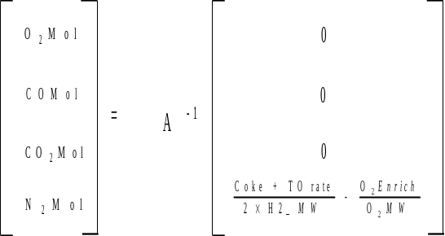
where: A-1 is the inverse matrix of the coefficients matrix.
r1_dry_fluegas_rate = r1_fluegas_O2_mol + r1_fluegas_CO_mol + r1_fluegas_CO2_mol + r1_fluegas_N2_mol
r1_C_burnt_wt = (r1_fluegas_CO_mol + r1_fluegas_CO2_mol) * C_MW
Calculate other molar flow rates:
r1_H2_burnt_mol = (r1_coke_make + r1_torch_oil_rate - (r1_fluegas_CO_mol + r1_fluegas_CO2_mol) * C_MW) / H2_MW
r1_H2_burnt_wt = r1_H2_burnt_mol * H2_MW
Calculate torch oil hydrogen and carbon burnt:
r1_TO_LSGP = 0.642 + 0.000509 * r1_torch_oil_meabp
r1_TO_LSGA = 0.765 + 0.00115 * r1_torch_oil_meabp
r1_TO_C_Num = 0.7672 + 0.13228 * r1_torch_oil_meabp
r1_TO_H2_P = (2 * r1_TO_C_Num + 2) / (14 * r1_TO_C_Num + 2) * 100
r1_TO_Rings = -0.07107 + 0.0089256 * r1_torch_oil_meabp
r1_TO_H2_A = (2 * r1_TO_Rings + 10) / (50 * r1_TO_Rings + 70) * 100
r1_TO_H2_Liquid = r1_TO_H2_P + (r1_TO_H2_A - r1_TO_H2_P) * (r1_torch_oil_sg - r1_TO_LSGP) / (r1_TO_LSGA - r1_TO_LSGP)
r1_TO_H2_burnt = r1_torch_oil_rate * r1_TO_H2_Liquid / 100
r1_TO_C_burnt = r1_torch_oil_rate * (100 - r1_TO_H2_Liquid) / 100
Calculate hydrogen in coke:
r1_H2_from_coke = r1_H2_burnt_mol * H2_MW - r1_TO_H2_burnt
r1_C_from_coke = (r1_fluegas_CO_mol + r1_fluegas_CO2_mol) * C_MW - r1_TO_C_burnt
r1_coke_burnt_wt = r1_H2_from_coke + r1_C_from_coke
r1_H2_in_coke = r1_H2_from_coke / r1_coke_burnt_wt
r1_C_burnt_wt = r1_C_from_coke
Calculate oxygen requirements:
r1_O2_4_CO2 = r1_fluegas_CO2_mol
r1_O2_4_CO = r1_fluegas_CO_mol / 2
r1_O2_4_H20 = r1_H2_burnt_mol / 2
r1_O2_4_XSO2 = r1_fluegas_O2_mol
r1_O2_enrichment_Mol = r1_O2_enrichment / O2_MW
r1_O2_Required = r1_O2_4_CO2 + r1_O2_4_CO + r1_O2_4_H20 + r1_O2_4_XSO2 - r1_O2_enrichment_Mol
Calculate air requirements:
r1_Air_Required = r1_O2_Required / O2_IN_AIR
r1_Dry_Air_Required = r1_Air_Required * AIR_MW
r1_wet_air_Required = r1_Dry_Air_Required * (1 + H2O_in_air)
Repeat the above procedure for R2. Then calculate overall hydrogen in coke:
H2_from coke = r1_H2_from coke + r2_H2_from coke
C_from_coke = r1_C_from coke + r2_C_from coke
coke_burnt_wt = H2_from_coke + C_from_coke
H2_in_coke = H2_from_coke / coke_burnt_wt

2.2.3 Base R1 Heat Balance
r1_combustion_heat = CO_COMBUSTION * r1_fluegas_CO_mol + CO2_COMBUSTION * r1_fluegas_CO2_mol + H2_COMBUSTION * r1_H2_burnt_mol
r1_coke_heat_content = (reactor_temp - DATUM_TEMP) * (r1_coke_burnt_wt + r2_coke_burnt_wt) * COKE_HEAT_CAP
r1_air_heat_content = (blower_discharge_temp - DATUM_TEMP) * (r1_dry_air_rate *
AIR_HEAT_CAP + r1_dry_air_rate * AIR_MW *
H2O_in_air / H2O_MW * H2O_HEAT_CAP) +
(O2_temp - DATUM_TEMP) *
r1_O2_enrichment / O2_MW * O2_HEAT_CAP
r1_TO_heat_content = r1_torch_oil_rate * TO_HEAT_CAP * (r1_torch_oil_temp - DATUM_TEMP)
r1_total_heat_in = r1_combustion_heat + r1_coke_heat_content + r1_air_heat_content + r1_TO_heat_content
r1_fluegas_spheat = r1_fluegas_O2_mol * O2_HEAT_CAP +
r1_fluegas_CO_mol * CO_HEAT_CAP +
r1_fluegas_CO2_mol * CO2_HEAT_CAP +
r1_H2_burnt_mol * H2O_HEAT_CAP +
r1_dry_air_rate * N2_HEAT_CAP * N2_IN_AIR +
r1_dry_air_rate * AIR_MW * H2O_in_air / H2O_MW *
H2O_HEAT_CAP
r1_fluegas_heat_content= r1_fluegas_spheat * (r1_fluegas_temp - DATUM_TEMP)
r1_coke_out_spheat = r2_coke_burnt_wt * COKE_HEAT_CAP
r1_coke_out_heat = (r1_regen_bed_temp + rgt1_correction - DATUM_TEMP) * r1_coke_out_spheat
r1_regen_heat_loss = 0.04 * r1_combustion_heat
r1_coke_desorption_heat = C_DESORP_HEAT * r1_C_from_coke
r1_catalyst_heat_content = r1_total_heat_in - r1_fluegas_heat_content - r1_coke_out_heat - r1_coke_desorption_heat - r1_regen_heat_loss
r1_catalyst_circ_rate = r1_catalyst_heat_content / CAT_HEAT_CAP / TONNE_TO_LBS / (r1_regen_bed_temp + rgt1_correction - reactor_temp)

2.2.4 Base R2 Heat Balance
r2_combustion_heat = CO_COMBUSTION * r2_fluegas_CO_mol + CO2_COMBUSTION * r2_fluegas_CO2_mol + H2_COMBUSTION * r2_H2_burnt_mol
r2_coke_spheat = r2_coke_burnt_wt * COKE_HEAT_CAP
r2_coke_heat_content = (r1_regen_bed_temp + rgt1_correction - DATUM_TEMP) * r2_coke_spheat
r2_air_heat_content = (blower_discharge_temp - DATUM_TEMP) * (r2_dry_air_rate *
AIR_HEAT_CAP + r2_dry_air_rate * AIR_MW *
H2O_in_air / H2O_MW * H2O_HEAT_CAP) +
(O2_temp - DATUM_TEMP) *
r2_O2_enrichment / O2_MW * O2_HEAT_CAP
r2_TO_heat_content = r2_torch_oil_rate * TO_HEAT_CAP * (r2_torch_oil_temp - DATUM_TEMP)
r2_total_heat_in = r2_combustion_heat + r2_coke_heat_content + r2_air_heat_content + r2_TO_heat_content
r2_fluegas_heat_content= (r2_fluegas_O2_mol * O2_HEAT_CAP +
r2_fluegas_CO_mol * CO_HEAT_CAP +
r2_fluegas_CO2_mol * CO2_HEAT_CAP +
r2_H2_burnt_mol * H2O_HEAT_CAP +
r2_dry_air_rate * N2_HEAT_CAP * N2_IN_AIR + r2_dry_air_rate * AIR_MW * H2O_in_air / H2O_MW * H2O_HEAT_CAP) * (r2_fluegas_temp - DATUM_TEMP)
r2_regen_heat_loss = 0.06 * r2_combustion_heat
r2_coke_desorption_heat = C_DESORP_HEAT * r2_C_from_coke
r2_catalyst_heat_content = r2_total_heat_in - r2_fluegas_heat_content - r2_coke_desorption_heat - r2_regen_heat_loss - r2_cat_cooler_duty
r2_catalyst_circ_rate = r2_catalyst_heat_content / CAT_HEAT_CAP / TONNE_TO_LBS / (r2_regen_bed_temp - r1_regen_bed_temp)
The rgt1_correction is performed here as there is typically a temperature variation across the r1 bed, such that this is the most likely place for the correction to apply. The r2 temperature is typically taken from the overflow well and as such accurately represents the temperature of the circulating catalyst to the reactor.
The rgt1_correction is unknown and needs to be calculated such that:
r1_catalyst_circ_rate = r2_catalyst_circ_rate
The catalyst circulation rates can be expressed:
r1_catalyst_circ_rate = (KA1 + KB1 * RGT1) / (RGT1 - RXT)
r2_catalyst_circ_rate = (KA2 + KB2 * RGT1) / (RGT2 - RGT1)
where: RGT1 = r1_regen_bed_temp + rgt1_correction
RGT2 = r2_regen_bed_temp
RXT = reactor_temperature
This can be expressed as a quadratic in RGT1 and solved using the quadratic formula:
RGT12(KB1 + KB2) + RGT1 (KA1 - KB1*RGT2 + KA2 - KB2*RXT) - KA1*RGT2 - KA2*RXT = 0
where:
KA1 = (r1_total_heat_in - r1_fluegas_heat_content - r1_coke_desorption_heat -
r1_regen_heat_loss + DATUM_TEMP * r1_coke_out_spheat) / CAT_HEAT_CAP /
TONNE_TO_LBS
KB1 = (- r1_coke_out_spheat) / CAT_HEAT_CAP / TONNE_TO_LBS
KA2 = (r2_combustion_heat + r2_air_heat_content + r2_TO_heat_content - r2_fluegas_heat_content -
r2_coke_desorption_heat - r2_regen_heat_loss - r2_cat_cooler_duty - DATUM_TEMP * r2_coke_spheat) / CAT_HEAT_CAP / TONNE_TO_LBS
KB2 = r2_coke_spheat / CAT_HEAT_CAP / TONNE_TO_LBS

2.3 Base Case Reactor Heat Balance
The base case reactor heat balance is closed using a heat of cracking unit factor.
Inputs: C4_minus_rate [lb/min] C4 minus rate
Cat_CF catalyst coke factor
catalyst_circ_rate [tonne/min] Catalyst circulation rate
ccs_rate [lb/min] CCS rate
ccs_sg CCS specific gravity
coke_adsorption_heat [MBTU/min] Heat of coke adsorption
coke_burnt_wt [lb/min] Coke yield
coke_heat_content [MBTU/min] Coke heat content
combined_feed_temp [°F] Reactor feed temperature
conversion [wt%] wt% conversion
dco_rate [lbs/min] DCO rate
dco_sg DCO specific gravity
lco_rate [lb/min] LCO rate
lco_sg LCO specific gravity
reactor_temp [°F] Reactor temperature
regen_temp [°F] Regenerator temperature
rot_F [°F] Riser outlet temperature
steam_rate [lb/min] Steam rate
steam_temp [°F] Steam temperature
total_feed_MeABP [°F] Total feed mean average boiling point
total_feed_MW [g/mol] Total feed molecular weight
total_feed_rate [lb/min] Feed rate
total_feed_sg Feed specific gravity
riser_water_rate [ lbs/min ] Water flow to riser
liftgas_rate [ lbs/min ] Lift gas flow to riser
liftgas_temp [°F] Lift gas temperature
liftgas_mw [g/mol] Lift gas molecular weight
liftgas_cp [btu/lbmol-F] Lift gas heat capacity
Constants: BTU_TO_MBTU 1.0E-6 Convert BTU to MBTU
C4MIN_CONSTANT 120 C4 minus adjustment BTU/lb
C4MIN_HEAT_CAP 0.85 C4 minus heat cap. BTU/lb/°F
CAT_HEAT_CAP 0.265E-6 Cat. heat capacity MBTU/lb/°F
DATUM_TEMP 60.0 Datum temperature °F
LIQ_CONSTANT 140 Liquid adjustment BTU/lb
LIQ_FACTOR 1.4 Liquid adjustment
LIQ_HEAT_CAP 0.75 Liquid heat capacity BTU/lb/°F
RX_HEAT_LOSS 2.0E-6 Reactor heat loss factor MBTU/lb
STM_HEAT_CAP 0.5 Steam heat cap. BTU/lb/°F
STM_LATENT_HEAT 1000 Steam adjustment BTU/lb
TONNE_TO_LBS 2204.6 Convert tonnes to lbs
C4_minus_heat = C4_minus_rate * ( C4MIN_HEAT_CAP * reactor_temp - C4MIN_CONSTANT)
ccs_heat = ccs_rate *(LIQ_HEAT_CAP * reactor_temp + LIQ_FACTOR *
api(ccs_sg) - LIQ_CONSTANT)
lco_heat = lco_rate *(LIQ_HEAT_CAP * reactor_temp + LIQ_FACTOR *
api(lco_sg) - LIQ_CONSTANT)
dco_heat = dco_rate *(LIQ_HEAT_CAP * reactor_temp + LIQ_FACTOR *
api(dco_sg) - LIQ_CONSTANT)
steam_heat_out = (steam_rate + riser_water_rate) * (STM_HEAT_CAP * reactor_temp +
STM_LATENT_HEAT)
liftgas_heat_out = liftgas_rate / liftgas_mw * liftgas_cp * reactor_temp
reactor_eff_heat_out = (C4_minus_heat + ccs_heat + lco_heat + dco_heat + steam_heat_out + liftgas_heat_out) * BTU_TO_MBTU
reactor_cat_heat_out = catalyst_circ_rate * TONNE_TO_LBS * (reactor_temp -DATUM_TEMP) * CAT_HEAT_CAP + coke_heat_content
reactor_heat_loss = RX_HEAT_LOSS * total_feed_rate
reactor_heat_out = reactor_eff_heat_out + reactor_cat_heat_out + reactor_heat_loss
Feed enthalpy is a quadratic function above 0 F and linear below. This is done to force enthalpy to be a monotonous function of temperature.
total_feed_api = api(total_feed_sg)
if (feed_preheat_temp_f > 0.0)
feed_heat_in = (0.0003 * combined_feed_temp ^2 + 0.34 * combined_feed_temp - 10.0) * (0.002 * total_feed_api + 0.95) * total_feed_rate;
else feed_heat_in = (0.34 * combined_feed_temp - 10.0) * (0.002 * total_feed_api + 0.95) * total_feed_rate
steam_heat_in = steam_rate * (STM_HEAT_CAP * steam_temp + STM_LATENT_HEAT)
water_heat_in = riser_water_rate * water_enthalpy (Btu/lb at 120 deg F, ref. temp. 60 F)
liftgas_heat_in = liftgas_rate / liftgas_mw * liftgas_cp * liftgas_temp
reactor_cat_heat_in = catalyst_circ_rate * TONNE_TO_LBS * (regen_temp -DATUM_TEMP) *
CAT_HEAT_CAP
reactor_heat_in = ( feed_heat_in +steam_heat_in ) * BTU_TO_MBTU +coke_adsorption_heat + reactor_cat_heat_in
reactor_heat_in = (feed_heat_in + steam_heat_in + liftgas_heat_in + water_heat_in) * BTU_TO_MBTU + reactor_cat_heat_in + coke_adsorption_heat
reaction_heat = reactor_heat_out - reactor_heat_in
volume_conv = 0.968 * conversion + 4.1823
Mol_Exp = volume_conv * (1.3415E-4 * total_feed_MW +5.95E-5 * (rot_F) -0.06654)
prod_mw = (total_feed_rate - coke_burnt_wt) / (total_feed_rate / total_feed_MW *
(1+ Mol_Exp))
cracking_heat = - (8.5 * total_feed_Ca_ndm + 90) * (Cat_CF/1.1)^0.45 *
(1000/prod_mw - 1000/ total_feed_MW) * 0.1
Here and elsewhere total_feed_Ca_ndm is computed using short Ca calculation (sec. 11.2) followed by scaling down by a factor of 1.45. The correlation uses total feed specific gravity and average boiling point which are obtained from blending fresh feed and recycle streams.
cracking_heat_UF = reaction_heat * (1 / BTU_TO_MBTU) / total_feed_rate - cracking_heat

2.4 Base Case Reactor WHSV calculation
Calculation of WHSV requires the pressure at the bottom of the riser. Since this value is not an input to the model it needs to be calculated from a reactor pressure balance. The solution of the pressure balance is iterative and for this reason the base case WHSV is not a once through calculation.
Inputs: cat_cf Catalyst coke factor
cat_skel [lb/ft3] Catalyst skeletal density
catalyst_circ_rate [t/min] Catalyst circulation rate
conversion [wt%] Base 215°C Conversion
dp_tolerance [psia] Riser pressure drop convergence tolerance
freshfeed_Ca Fresh feed Ca NMR
HC_uf Heat of cracking unit factor
reactor_pressure [psig] Reactor pressure
regen_temp [°F] Final Regenerator bed temperature
riser_elev [ft] Riser elevation change
riser_len [ft] Riser length
riser_outlet_temp [°F] Riser outlet temperature
riser_vol [ft³] Riser volume
rxt_area [ft²] Reactor X-Sectional Area
rxt_hold [tons] Reactor catalyst hold up
rxt_stm1 [lb/hr] Total riser steam flow rate
stand_dens [lb/ft³] Regenerated cat stand pipe catalyst density
stand_pres [psig] Regenerated cat stand pipe pressure
total_product [lb/hr] Total product rate
totalfeed_mw Total feed MW
totalfeed_rate [lb/hr] Total feed rate
uf_slip Riser slip factor
whsv_max_iterations Max iterations of pressure drop loop
wt_tpr Weight through put ratio
yield_coke [wt%] Coke yield

2.4.1 Loop Initialisation
Riser Dens = 5.0
Riser Fractional Conv = 0.5
riser_dp_inloop = 0
Total Feed Kin Conv = conversion / (100 - conversion)
coke_tot = yield_coke / 100 * total_product
Calculate inerts coming across from regenerator and hence total molar flow up riser:
rsr_vinrt = (catalyst_circ_rate * STONS_TO_LBS * 60) *(1 / stand_dens - 1 / cat_skel)
rsr_mvinrt = 10.71 * (regen_temp + DEGF_TO_DEGR) / (stand_pres + PSIG_TO_PSIA)
regn_inert = rsr_vinrt / rsr_mvinrt
Molar flow rate in riser = totalfeed_rate / totalfeed_mw + (rxt_stm1 + riser_water_rate) / H2O_MW + liftgas_rate / liftgas_mw + regn_inert

2.4.2 Base WHSV Loop
Conv Vol% = 0.968 * conversion + 4.1823
rsr_mol_exp = Conv Vol% * Riser Fractional Conv * (0.00013415 * totalfeed_mw +
0.0000595 * (riser_outlet_temp) - 0.06654)
rsr_mwprc = (totalfeed_rate - coke_tot) / (totalfeed_rate / totalfeed_mw * (1 + rsr_mol_exp))
Riser HC = (((8.5 * total_feed_Ca_ndm + 90) * (cat_cf / 1.1)^0.45) *
(1000 / rsr_mwprc - 1000 / totalfeed_mw) * 0.1 + HC_uf) * Riser Fractional Conv
rsr_ovhdhc = (totalfeed_rate * (1 + rsr_mol_exp) / totalfeed_mw)
rsr_molgn = rsr_ovhdhc + rxt_stm1 / H2O_MW + regn_inert- Molar flow rate in riser
C:O Ratio = catalyst_circ_rate * STONS_TO_LBS * 60 / totalfeed_rate
mix_deltat = (Riser HC / wt_tpr) / (CAT_HEAT_CAP * 1.E6 * C:O Ratio + 0.75)
mix_temp = riser_outlet_temp + mix_deltat
rsr_tfwt = totalfeed_rate + rxt_stm1 + riser_water_rate + liftgas_rate + regn_inert * INERT_MW
rsr_ptop = reactor_pressure + rxt_hold * (STONS_TO_LBS / (rxt_area * 144))
rxt_pbot = rsr_ptop + riser_dp_inloop + PSIG_TO_PSIA
rsr_mvint = GAS_CONSTANT * ((riser_outlet_temp + 0.6 * (mix_temp - riser_outlet_temp)) + DEGF_TO_DEGR) / ((rsr_ptop + 0.6 * (rxt_pbot - PSIG_TO_PSIA - rsr_ptop)) + PSIG_TO_PSIA)
rsr_mvbot = GAS_CONSTANT * (mix_temp + DEGF_TO_DEGR) /(rxt_pbot)
rsr_mvtop = GAS_CONSTANT * (riser_outlet_temp + DEGF_TO_DEGR) / (rsr_ptop + PSIG_TO_PSIA)
riser_hold = Riser Dens * riser_vol / STONS_TO_LBS
rsr_hfrac = riser_hold / (riser_hold + rxt_hold)
Riser Kin Conv = Total Feed Kin Conv * rsr_hfrac^0.35
Riser Fractional Conv = (Riser Kin Conv / (1 + Riser Kin Conv)) /(Total Feed Kin Conv /
(1 + Total Feed Kin Conv))
rsr_molint = Molar flow rate in riser + (0.75 * Riser Fractional Conv * rsr_molgn)
rsr_moltop = Molar flow rate in riser + (Riser Fractional Conv * rsr_molgn)
rsr_veltop = (rsr_moltop * rsr_mvtop / 3600) / (riser_vol / riser_len)
rsr_velint = (rsr_molint * rsr_mvint / 3600) / (riser_vol / riser_len)
rsr_nsdens = (catalyst_circ_rate * STONS_TO_LBS * 60 + rsr_tfwt) /((rsr_molint * rsr_mvint) +
(catalyst_circ_rate * STONS_TO_LBS * 60 / cat_skel))
Riser Dens = (rsr_nsdens * uf_slip) - (rsr_tfwt / (rsr_molint * rsr_mvint + (catalyst_circ_rate * STONS_TO_LBS * 60 / cat_skel)))
riser_hold = Riser Dens * riser_vol / STONS_TO_LBS
riser_dp = (uf_slip * rsr_nsdens) * (1 + ((catalyst_circ_rate *STONS_TO_LBS * 60 /
(catalyst_circ_rate * STONS_TO_LBS * 60. + rsr_tfwt)) * ((rsr_veltop *
rsr_veltop ) / (2 * G_CONSTANT * riser_elev)))) * (riser_elev / 144)
riser_dp_diff = |(riser_dp_inloop - riser_dp)|
riser_dp_inloop = riser_dp
Check Convergence if the riser_dp_diff is less than the input convergence tolerance then go back to start of calculation with new value for riser_dp_inloop. Otherwise continue with the rest of the WHSV calculations. If the maximum number of loops is reached calculation stops and the model reports the error.

2.4.3 Base WHSV Final Calculations
rxt_whsv = totalfeed_rate / (riser_hold * STONS_TO_LBS + rxt_hold * STONS_TO_LBS)
rxt_tavg = riser_outlet_temp + (mix_temp - riser_outlet_temp) * (0.1 + 0.2 * rsr_hfrac^0.3)
rxt_tc = 60 / (C:O Ratio * rxt_whsv)
rxt_mol_exp = Conv Vol% * (0.00013415 * Totalfeed_mw + 0.0000595 * (riser_outlet_temp) - 0.06654)
rxt_mwprc = (totalfeed_rate - coke_tot) / (totalfeed_rate / Totalfeed_mw * (1 + rxt_mol_exp))
rxt_hr = (8.5 * freshfeed_Ca/1.45 + 90) * (cat_cf / 1.1)^0.45 * (1000 / rxt_mwprc -
1000 / Totalfeed_mw) * 0.1 + HC_uf
rxt_phcin = (rsr_ptop + riser_dp + PSIG_TO_PSIA)
* (totalfeed_rate / Totalfeed_mw) / Molar flow rate in riser - PSIG_TO_PSIA

2.5 Predict Case Single Stage Regenerator Heat Balance
Inputs: afterburn_temp [°F] Temp diff. between (FLUE - BED)
blower_discharge_temp [°F] Blower discharge temperature
cat_cooler_duty [MBTU/min] Catalyst cooler duty
catalyst_circ_rate [tonne/min] Catalyst circulation rate
CO_in_fluegas [vol%] flue gas CO compostion
coke_yield [wt%] Coke yield on total feed
cooler_duty [MBTU/min] Regen cooler duty
H2_coke_ratio [wt ratio] required H2/coke ratio
H2O_in_air [wt/wt] Water content of air
O2_enrichment [lb/min] Oxygen added to regenerator air
O2_in_fluegas [vol%] flue gas O2 compostion
O2_in_pb [vol%] Excess oxygen in partial burn
O2_temp [°F] O2 enrichment temperature
product_rate [lb/min] Total product rate
reactor_temp [°F] Reactor temperature
torch_oil_meabp [°F] Torch oil meabp
torch_oil_rate [lb/min] Torch oil rate
torch_oil_sg Torch oil sg
torch_oil_temp [°F] Torch oil temperature
wet_air_rate [lb/min] Wet air rate to regenerator

2.5.1 With coke make and air rate as inputs - calculate flue gas composition
dry_air_rate = wet_air_rate / (1 + H2O_in_air) / AIR_MW
coke_burnt_wt = coke_yield / 100.0 * product_rate
Calculate hydrogen and carbon contribution of torch oil:
TO_LSGP = 0.642 + 0.000509 * torch_oil_meabp
TO_LSGA = 0.765 + 0.00115 * torch_oil_meabp
TO_C_Num = 0.7672 + 0.13228 * torch_oil_meabp
TO_H2_P = (2 * TO_C_Num + 2) / (14 * TO_C_Num + 2) * 100
TO_Rings = -0.07107 + 0.0089256 * torch_oil_meabp
TO_H2_A = (2 * TO_Rings + 10) / (50 * TO_Rings + 70) * 100
TO_H2_ Liquid = TO_H2_P + (TO_H2_A - TO_H2_P) * (torch_oil_sg - TO_LSGP) /
(TO_LSGA - TO_LSGP )
TO_H2_burnt = torch_oil_rate * TO_H2_ Liquid / 100
TO_C_burnt = torch_oil_rate * (100 - TO_H2_ Liquid) / 100
H2_burnt_wt = H2_coke_ratio * coke_burnt_wt
C_burnt_wt = coke_burnt_wt - H2_burnt_wt
total_ H2_burnt_wt = H2_burnt_wt + TO_H2_burnt
total_ C_burnt_wt = coke_burnt_wt - H2_burnt_wt + TO_C_burnt
O2_into_regen = dry_air_rate * O2_IN_AIR + O2_enrichment / O2_MW
O2_required = total_C_burnt_wt / C_MW + total_H2_burnt_wt / (2 * H2_MW)
fluegas_N2_mol = N2_IN_AIR * dry_air_rate
fluegas_H2O_mol = total_H2_burnt_wt / H2_MW + dry_air_rate * AIR_MW * H2O_in_air /
H2O_MW
Assume full burn:
fluegas_CO2_mol = total_C_burnt_wt / C_MW
fluegas_CO_mol = 0.0
fluegas_O2_mol = O2_into_regen - total_H2_burnt_wt / (2 * H2_MW) - total_C_burnt_wt / C_MW
dry_fluegas_rate = fluegas_CO2_mol + fluegas_O2_mol + fluegas_N2_mol +fluegas_CO_mol
If O2 in is less than required fluegas (fluegas_O2_mol / dry_fluegas_rate*100 < O2_in_pb) it must be in partial burn:
dry_fluegas_rate = (total_C_burnt_wt / C_MW+fluegas_N2_mol) / (1 - O2_in_pb / 100)
fluegas_CO2_mol = 2 * (O2_into_regen - dry_fluegas_rate * O2_in_pb / 100 -
total_H2_burnt_wt / (2 * H2_MW) - total_C_burnt_wt / (2 * C_MW))
fluegas_CO_mol = total_C_burnt_wt / C_MW - fluegas_CO2_mol
fluegas_O2_mol = dry_fluegas_rate * O2_in_pb / 100
fluegas_N2_mol = N2_IN_AIR * dry_air_rate

2.5.2 With coke make and flue gas composition as inputs - calculate air rate
coke_burnt_wt = coke_yield / 100 * product_rate
Calculate hydrogen and carbon burnt from coke:
H2_burnt_wt = coke_burnt_wt * H2_coke_ratio / 100
H2_burnt_mol = H2_burnt_wt / H2_MW
C_burnt_wt = coke_burnt_wt - H2_burnt_wt
C_burnt_mol = C_burnt_wt / C_MW
Calculate hydrogen and carbon burnt from torch oil:
TO_LSGP = 0.642 + 0.000509 * torch_oil_meabp
TO_LSGA = 0.765 + 0.00115 * torch_oil_meabp
TO_C_Num = 0.7672 + 0.13228 * torch_oil_meabp
TO_H2_P = (2 * TO_C_Num + 2) / (14 * TO_C_Num + 2) * 100
TO_Rings = -0.07107 + 0.0089256 * torch_oil_meabp
TO_H2_A = (2 * TO_Rings + 10) / (50 * TO_Rings + 70) * 100
TO_H2_Liquid = TO_H2_P + (TO_H2_A - TO_H2_P) * (torch_oil_sg - TO_LSGP) / (TO_LSGA - TO_LSGP)
TO_H2_burnt = torch_oil_rate * TO_H2_Liquid / 100
TO_C_burnt = torch_oil_rate * (100 - TO_H2_Liquid) / 100
Calculate total hydrogen and carbon burnt:
total_H2_burnt_wt = H2_burnt_wt + TO_H2_burnt
total_H2_Burnt_Mol = total_H2_burnt_wt / H2_MW
total_C_burnt_wt = C_burnt_wt + TO_C_burnt
total_C_burnt_mol = total_C_burnt_wt / C_MW
O2_Enrich_Mol = O2_enrichment / O2_MW
Calculate coefficients:
A = fluegas_CO_vol / 100 * (1 + N2_IN_AIR / O2_IN_AIR) / (1 + fluegas_CO_vol / 100 * N2_IN_AIR / (2 * O2_IN_AIR))
B = fluegas_CO_vol / 100 * (total_C_burnt_mol * (1 + N2_IN_AIR / O2_IN_AIR) + total_H2_Burnt_Mol * N2_IN_AIR / (2 * O2_IN_AIR) - O2_Enrich_Mol * N2_IN_AIR / O2_IN_AIR) / (1 + fluegas_CO_vol / 100 * N2_IN_AIR / (2 * O2_IN_AIR))
C = -1 * fluegas_O2_vol / 100 * N2_IN_AIR / (2 * O2_IN_AIR) / (1 - fluegas_O2_vol / 100 * (1 + N2_IN_AIR / O2_IN_AIR))
D = fluegas_O2_Vol / 100 * (total_C_burnt_mol * (1 + N2_IN_AIR / O2_IN_AIR) + total_H2_Burnt_Mol * N2_IN_AIR / (2 * O2_IN_AIR) - O2_Enrich_Mol * N2_IN_AIR / O2_IN_AIR) / (1 - fluegas_O2_Vol / 100 * (1 + N2_IN_AIR / O2_IN_AIR))
fluegas_O2_mol = (C * B + D) / (1 - A * C)
fluegas_CO_mol = (A * D + B) / (1 - A * C)
fluegas_CO2_mol = total_C_burnt_mol - fluegas_CO_Mol
Calculate oxygen requirements:
O2_4_CO2 = fluegas_CO2_mol
O2_4_CO = fluegas_CO_Mol / 2
O2_4_H20 = total_H2_Burnt_Mol / 2
O2_4_XSO2 = fluegas_O2_Mol
O2_Required = O2_4_CO2 + O2_4_CO + O2_4_H20 + O2_4_XSO2 - O2_Enrich_Mol
Calculate air requirements and other required values:
Air_Required = O2_Required / O2_IN_AIR
dry_air_rate = Air_Required * AIR_MW
wet_air_rate = dry_air_rate * (1 + H2O_in_air)
fluegas_N2_mol = Air_Required * N2_IN_AIR
dry_fluegas_rate = fluegas_CO2_mol + fluegas_O2_mol + fluegas_N2_mol + fluegas_CO_mol
fluegas_CO2_vol = fluegas_CO2_mol / dry_fluegas_rate

2.5.3 With burn ratio and coke composition
coke_burnt_wt = coke_yield / 100.0 * product_rate
H2_burnt_mol = H_coke_input / 100.0 / H2_MW * coke_burnt_wt
S_burnt_mol = S_coke_input / 100.0 / S_MW * coke_burnt_wt
fluegas_CO2_mol = (1.0 - (H_coke_input + S_coke_input) / 100.0 ) / C_MW / burn_ratio * coke_burnt_wt
fluegas_CO_mol = fluegas_CO2_mol * (burn_ratio - 1.0)
O2_required = 0.5 * H2_burnt_mol + S_burnt_mol + fluegas_CO2_mol + 0.5 * fluegas_CO_mol
O2_enrich_mw = enrich_O2_conc / 100. * O2_MW + (1. - enrich_O2_conc / 100.) *N2_MW
O2_enrich_mol = O2_enrichment / O2_enrich_mw * enrich_O2_conc / 100.
N2_enrich_mol = O2_enrichment / O2_enrich_mw * (1. - enrich_O2_conc / 100.)
O2_required = O2_required - O2_enrich_mol
fluegas_O2_vol = O2_in_fluegas
fluegas_O2_mol = fluegas_O2_vol * (fluegas_CO2_mol + fluegas_CO_mol + S_burnt_mol + N2_enrich_mol + O2_required * N2_IN_AIR / O2_IN_AIR) / (100.0 - fluegas_O2_vol * (1.0 + N2_IN_AIR / O2_IN_AIR))
dry_air_rate = (O2_required + fluegas_O2_mol) / O2_IN_AIR
fluegas_N2_mol = dry_air_rate * N2_IN_AIR + N2_enrich_mol
total_H2_burnt_wt = H2_burnt_mol * H2_MW
C_burnt_wt = coke_burnt_wt - total_H2_burnt_wt
dry_fluegas_rate= fluegas_CO2_mol + fluegas_CO_mol + fluegas_O2_mol + fluegas_N2_mol + S_burnt_mol
wet_air_reqd = dry_air_rate * AIR_MW * (1. + H2O_in_air)
// the equation below applied since it was done this way historically
H2_burnt_mol = total_H2_burnt_wt / H2_MW + dry_air_rate * AIR_MW
* H2O_in_air / H2O_MW

2.5.4 Calculate Regenerator Bed Temperature
combustion_heat = CO_COMBUSTION * fluegas_CO_mol + CO2_COMBUSTION * fluegas_CO2_mol + H2_COMBUSTION * total_H2_burnt_wt / H2_MW +S_COMBUSTION * S_burnt_mol
coke_heat_content = (reactor_temp - DATUM_TEMP) * coke_burnt_wt * COKE_HEAT_CAP
air_heat_content = (blower_discharge_temp - DATUM_TEMP) * (dry_air_rate * AIR_HEAT_CAP+ dry_air_rate * AIR_MW * H2O_in_air / H2O_MW * H2O_HEAT_CAP) + (O2_temp - DATUM_TEMP) * O2_enrichment / O2_MW * O2_HEAT_CAP
coke_desorption_heat = C_DESORP_HEAT * C_burnt_wt
regen_heat_loss = 0.04 * combustion_heat
spent_cat_heat_content = catalyst_circ_rate * TONNE_TO_LBS * CAT_HEAT_CAP * (reactor_temp - DATUM_TEMP)
TO_heat_content = torch_oil_rate * TO_HEAT_CAP * (torch_oil_temp - DATUM_TEMP)
total_heat_in = combustion_heat + coke_heat_content + air_heat_content + spent_cat_heat_content - regen_heat_loss - coke_desorption_heat - cat_cooler_duty + TO_heat_content
catalyst_heat_content = catalyst_circ_rate * TONNE_TO_LBS * CAT_HEAT_CAP
fluegas_heat_content = fluegas_O2_mol * O2_HEAT_CAP + fluegas_CO_mol * CO_HEAT_CAP + fluegas_CO2_mol * CO2_HEAT_CAP + fluegas_H2O_mol * H2O_HEAT_CAP + fluegas_N2_mol * N2_HEAT_CAP + S_burnt_mol * SO2_HEAT_CAP
regen_bed_temp = (total_heat_in + afterburn_temp * fluegas_heat_content) / (catalyst_heat_content + fluegas_heat_content) + DATUM_TEMP

2.6 Predict Case Two Stage Regenerator Heat Balance
For a two stage regenerator system the CO2/CO ratio is predicted as is the percentage coke burnt. To change from calculating coke burnt based on air rate to calculating air rate based on coke burnt would require the user to input the % coke burnt in R1. This is not a sensible user input, so for the R2R situation the air rate is always an input for R1, and the air rate back calculation option available for a single stage regenerator is only available for R2.
Inputs: blower_discharge_temp [°F] Blower discharge temperature
catalyst_circ_rate [tonne/min] Catalyst circulation rate
H2O_in_air [wt/wt] Water content of air
O2_in_pb [vol%] Excess oxygen in partial burn
O2_temp [°F] O2 enrichment temperature
product_rate [lb/min] Total product rate
r1_afterburn_temp [°F] Temp diff. bed - stage 1 fluegas
r1_fluegas_CO_vol [vol%] Predicted stage 1 regen fluegas CO
r1_fluegas_CO2_vol [vol%] Predicted stage 1 regen fluegas CO2
r1_fluegas_O2_vol [vol%] Predicted stage 1 regen fluegas O2
r1_O2_enrichment [lb/min] Oxygen added to stage 1 regen air
r1_torch_oil_meabp [° F] Regen 1 Torch oil meabp
r1_torch_oil_rate [lb/min] Regen 1 torch oil rate
r1_torch_oil_sg Regen 1 Torch oil sg
r1_torch_oil_temp [°F] Regen 1 Torch oil temperature
r1_wet_air_rate [lb/min] Wet air rate to regenerator stage 1
r2_afterburn_temp [°F] Temp diff. bed - stage 2 fluegas
r2_cat_cooler_duty [MBTU/min] Catalyst cooler duty
r2_O2_enrichment [lb/min] Oxygen added to stage 2 regen air
r2_torch_oil_meabp [°F] Regen 1 Torch oil meabp
r2_torch_oil_rate [lb/min] Regen 2 torch oil rate
r2_torch_oil_sg Regen 1 Torch oil sg
r2_torch_oil_temp [°F] Regen 1 Torch oil temperature
r2_wet_air_rate [lb/min] Wet air rate to regenerator stage 2
reactor_temp [°F] Reactor temperature
required_H2_coke_ratio[wt ratio] Input H2/coke ratio
total_coke_yield [wt%] Total coke yield
To solve the R2R heat balance in the predict case, the amount of coke burnt in the first regenerator must be predicted. The equations are based on E-cat Vanadium level which promotes the CO -> CO2 reaction, and have been generated using data from Kwinana and published literature.

2.6.1 R1 Flue Gas Composition Prediction
Three conditions have to be considered when predicting the R1 flue gas prediction, the case when R1 is in partial burn, the case when R1 is in full burn and the transition between the two. These regions can be seen on the following plot:
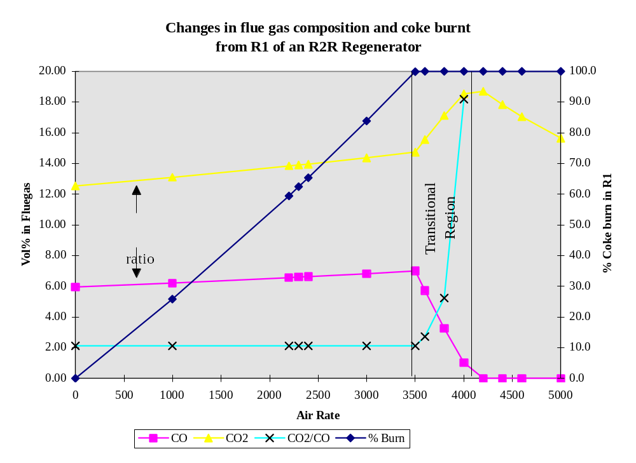

2.6.1.1 Condition 1: Partial Burn (Coke burned in R1 < Total Coke)
NOA1 + Coke burnt in R1 = K1 H2O + K2 CO2 + K3 CO + K4 O2
where: NOA1 = New Oxygen In R1 (lbmoles/min)
K1 = H2O in R1 Flue Gas (lbmoles/min)
K2 = CO2 in R1 Flue Gas (lbmoles/min)
K3 = CO in R1 Flue Gas (lbmoles/min)
K4 = O2 in R1 Flue Gas (lbmoles/min)
N2 = N2 in R1 Flue Gas (lbmoles/min)
CO2/CO (vol%) = exp(-1.7559) * ECat V ^ 0.2988
CO2/CO = K2 / K3 = A
K2= A K3 (The CO2/CO ratio unit factor (A) is multiplicative)
H/C (wt/wt) = HC_uf - (HC_uf - (100 * H/Cbase)) * (fraction of burn in R1) = X
Fraction of burn in R1 = NOA1 (lb moles/min)/ (O2 required to burn all coke in R1 in partial burn (lb moles/min) at predicted CO2/CO ratio)
The H/C wt ratio unit factor modifies the intercept of the line (H/C burnt in R1 vs. fraction of burn in R1) to ensure the overall H/C wt ratio remains the same as the base case. The H/C ratio is the overall ratio for the first regenerator including total coke yield and torch oil in R1.
ie. H/C predict = UF - (UF - (100*H/Ctotal)) * (fraction of burn in R1)
H/C molar = X * 12 * 2 / 2.02
Excess O2 vol% (O2_in_pb) is specified by user (B).
K4 / (K4 + K3 + K2 +N2) = B (Note: N2 = NOA1 * 0.79 / 0.21)
K4 = B * (K3 + K2 + N2) / (1 – B) (Equation 1)
Perform oxygen balance:
NOA1 = K1 /2 + K2 + K3 /2 + K4
Substitute K2 = A * K3
NOA1 = K₁/2 + K3 (A + 0.5) + K₄
Substitute into Equation 1:
NOA1 = K₁/2 + K3 (A + 0.5) + B (K3 + AK3 + N2 ) / (1-B) (Equation 2)
Perform hydrogen balance:
H/C = 2* K₁ / (K₂ + K₃) = 2 * K₁ / (K₃ (A + 1)) = X * 12 * 2 / 2.02
K₁ = 12 * X * K3 (A + 1) / 2.02
Substitute into Equation 2:
NOA1 = 6 * X * K3 * (A + 1) / 2.02 + K3* (A + 0.5) + K3 (B + A * B) / (1 - B) + B * N2 / (1 - B)
NOA1 - B * N2 / (1 – B) = K3 * [6 * X * (A + 1) / 2.02 + (A + 0.5) + (B+ A * B) / (1 - B)]
Hence all the four constants can be calculated:
K3 = (NOA1 - B * N2 / (1 - B)) / [6X * (A + 1) / 2.02 + (A + 0.5) + (B + AB) / (1 - B)]
K2 = A* K3
K4 = B (K3 + AK3 + N2) / (1 - B)
K1 = 12 * X * K3 * (A + 1) / 2.02
These can be converted to vol% in flue gas by dividing by (K2 + K3 + K4 + N2)

2.6.1.2 Condition 2: Partial Burn (Coke burned in R1 = Total Coke)
NOA1 + Coke burnt in R1 = K1 H2O + K2 CO2 + K3 CO + K4 O2
When R1 air rate is sufficient to burn all the coke in partial burn then the CO2/CO prediction used above cannot be used. Any additional air greater than that required will convert CO to CO2. First determine the point at which this occurs by calculating the O2 required to burn all the coke to CO2, CO (in the predicted ratio) and H2O and maintain the specified O2 vol% flue gas level.
NOA1PB + Total Coke = K_{1PB} H2O + K_{2PB} CO2 + K_{3PB} CO + K_{4PB} O2
Total carbon mols to be burned = (coke yield / 100 * products out)/(1 + H/C wt/wt) / 12
Total moles Carbon = K_{2PB} + K_{3PB}
K_{2PB} = A * K_{3PB}
K_{3PB} = Total moles Carbon / (A + 1)
As in condition 1:
K_{1PB} = 12 * X * K_{3PB} * (A + 1) / 2.02 = Total moles H2
B = K_{4PB} / (K_{4PB} + K_{3PB} + K_{2PB} + N_{2PB})
N2PB = NOA1PB * 0.79 / 0.21 = (K4PB + K3PB/2 + K2PB + K1PB/2) * 0.79 / 0.21
Combining:
B = K4PB / (K4PB + K3PB + K2PB + (K4PB + K3PB/2 + K2PB+ K1PB/2) * 0.79 / 0.21)
Rearranging:
K4PB = B * [K2PB + K3PB + 0.79 / 0.21 * (K3PB/2 + K2PB + K1PB/2)] / (1-B-0.79 / 0.21 * B)
NOA1PB = (K_{4PB} + K_{3PB} / 2 + K_{2PB} + K_{1PB} / 2)
XS O2 = NOA1 - NOA1PB
If XS O2 > 0
K1 = K1PB = Total moles H2
K4 = B * (K2PB + K3PB + N2) / (1- B)
K2 = K2PB + 2 * (XS O2 - (K4 - K4PB))
K3 = K3PB – 2 * (XS O2 - (K4 - K4PB))

2.6.1.3 Condition 3: Full Burn (Coke burned in R1 = Total Coke)
Determine the amount of O2 required for full combustion of the coke to CO2
NOA1FB + Total Coke = K1FB H2O + K2FB CO2 + K4FB O2
NOA1FB = lb moles/min O2 in R1 required to burn all coke to CO2 (with base excess O2 in flue gas)
K2FB = Total moles carbon
K1FB = K1PB = 12 * X * K2 / 2.02 = Total moles H2
B = K4FB / (K4FB + K2FB + N2FB)
N2FB = NOA1FB * 0.79 / 0.21 = (K4FB + K2FB + K1FB/2) * 0.79 / 0.21
Combining and rearranging:
K4FB = B * [K2FB + 0.79/0.21 * (K2FB + K1FB / 2)] / (1 - B - 0.79 / 0.21 * B)
NOA1FB = (K4FB + K2FB + K1FB / 2)
XS O2FB = NOA1 - NOA1FB
If XS O2FB > 0
K1 = K1FB
K2 = Total moles carbon (inc R1 torch oil carbon)
K3 = 0
K4 = K4FB + XS O2FB

2.6.2 R1 Coke & flue gas calculation
Calculate R1 torch oil composition using same method as in base case regenerator calculations:
r1_dry_air_rate = r1_wet_air_rate / (1 + H2O_in_air) / AIR_MW
r1_dry_fluegas_rate = r1_dry_air_rate * N2_IN_AIR * 100.0 / (100.0 - r1_fluegas_CO_vol - r1_fluegas_O2_vol - r1_fluegas_CO2_vol)
r1_O2_into_regen = r1_dry_air_rate * O2_IN_AIR + r1_O2_enrichment / O2_MW
r1_fluegas_CO2_mol = r1_fluegas_CO2_vol * r1_dry_fluegas_rate / 100
r1_fluegas_CO_mol = r1_fluegas_CO_vol * r1_dry_fluegas_rate / 100
r1_fluegas_O2_mol = r1_fluegas_O2_vol * r1_dry_fluegas_rate / 100
r1_fluegas_N2_mol = r1_dry_air_rate * N2_IN_AIR
r1_O2_required = r1_fluegas_CO2_mol + r1_fluegas_CO_mol / 2.0 + r1_fluegas_O2_mol
r1_fluegas_H2O_mol = (r1_O2_into_regen - r1_O2_required) * 2.0 + r1_dry_air_rate * AIR_MW * H2O_in_air / H2O_MW
r1_C_burnt_wt = (r1_fluegas_CO2_mol + r1_fluegas_CO_mol) * C_MW
r1_H2_burnt_wt = r1_fluegas_H2O_mol * H2_MW
r1_coke_burnt_wt = r1_C_burnt_wt + r1_H2_burnt_wt - r1_torch_oil_rate

2.6.3 R2 Coke & flue gas calculation (Air rate input)
Calculate R2 torch oil composition using same method as in base case regenerator calculations:
total_coke_burnt_wt = total_coke_yield /100.0 * product_rate + r1_torch_oil_rate + r2_torch_oil_rate
r2_dry_air_rate = r2_wet_air_rate / (1 + H2O_in_air) / AIR_MW
r2_H2_burnt_wt = required_H2_coke_ratio * total_coke_burnt_wt + r2_TO_H2_burnt + (r1_torch_oil_rate * r1_TO_H2_liquid / 100.) - r1_H2_burnt_wt
r2_coke_burnt_wt = total_coke_burnt_wt - r1_coke_burnt_wt - r1_torch_oil_rate - r2_torch_oil_rate
r2_C_burnt_wt = r2_coke_burnt_wt + r2_torch_oil_rate - r2_H2_burnt_wt
r2_O2_into_regen = r2_dry_air_rate * O2_IN_AIR + r2_O2_enrichment / O2_MW
r2_O2_required = r2_C_burnt_wt / C_MW + r2_H2_burnt_wt / (2.0 * H2_MW)
If in full burn (r2_O2_into_regen >= r2_O2_required):
r2_fluegas_CO2_mol = r2_C_burnt_wt / C_MW
r2_fluegas_CO_mol = 0.0
r2_fluegas_O2_mol = r2_dry_air_rate * O2_IN_AIR - r2_H2_burnt_wt / (2.0 * H2_MW) - r2_C_burnt_wt / C_MW
If in partial burn:
r2_fluegas_CO2_mol = 2.0 * (r2_dry_air_rate * O2_IN_AIR - r2_H2_burnt_wt /
(2.0 * H2_MW) - r2_C_burnt_wt / (2.0 * C_MW))
r2_fluegas_CO_mol = r2_C_burnt_wt / C_MW - r2_fluegas_CO2_mol
r2_fluegas_O2_mol = 0.0
Calculate flue gas composition:
r2_fluegas_N2_mol = r2_dry_air_rate * N2_IN_AIR
r2_fluegas_H2O_mol = r2_H2_burnt_wt / H2_MW + r2_dry_air_rate * AIR_MW * H2O_in_air / H2O_MW
r2_dry_fluegas_rate = r2_fluegas_N2_mol + r2_fluegas_O2_mol + r2_fluegas_CO2_mol + r2_fluegas_CO_mol
r2_fluegas_CO2_vol = r2_fluegas_CO2_mol / r2_dry_fluegas_rate * 100.0
r2_fluegas_CO_vol = r2_fluegas_CO_mol / r2_dry_fluegas_rate * 100.0
r2_fluegas_O2_vol = r2_fluegas_O2_mol / r2_dry_fluegas_rate * 100.0
r2_fluegas_N2_vol = r2_fluegas_N2_mol / r2_dry_fluegas_rate * 100.0
H2_from_coke = r1_H2_burnt_wt + r2_H2_burnt_wt - r1_TO_H2_liquid / 100. *
r1_torch_oil_rate - r2_TO_H2_liquid / 100. * r2_torch_oil_rate
r1_frac_coke_burn = r1_coke_burnt_wt / overall_coke_yield

2.6.4 R2 Coke & flue gas calculation (Calculate air rate)
The calculations are similar to single regenerator case (cf. 2.5.2) exept carbon and hydrogen burnt in R1 are subtracted out from the coke yield.

2.6.5 R1 Heat Balance
r1_combustion_heat = CO_COMBUSTION * r1_fluegas_CO_mol + CO2_COMBUSTION *r1_fluegas_CO2_mol + H2_COMBUSTION * r1_fluegas_H2O_mol
r1_coke_heat_content = (reactor_temp - DATUM_TEMP) * total_coke_yield / 100.0 * product_rate * COKE_HEAT_CAP
r1_air_heat_content = (blower_discharge_temp - DATUM_TEMP) * (r1_dry_air_rate * AIR_HEAT_CAP + r1_dry_air_rate * AIR_MW * H2O_in_air / H2O_MW * H2O_HEAT_CAP) + (O2_temp - DATUM_TEMP) * r1_O2_enrichment / O2_MW * O2_HEAT_CAP
r1_spent_cat_heat_content= catalyst_circ_rate * TONNE_TO_LBS * CAT_HEAT_CAP * (reactor_temp - DATUM_TEMP)
r1_regen_heat_loss = 0.04 * r1_combustion_heat
r1_coke_desorption_heat= C_DESORP_HEAT * (r1_C_burnt_wt - r1_torch_oil_rate * (100. - r1_TO_H2_liquid) / 100.)
r1_TO_heat_content = r1_torch_oil_rate * TO_HEAT_CAP * (r1_torch_oil_temp -DATUM_TEMP)
r1_total_heat_in = r1_combustion_heat + r1_coke_heat_content + r1_air_heat_content + r1_spent_cat_heat_content - r1_regen_heat_loss - r1_coke_desorption_heat + r1_TO_heat_content
r1_fluegas_heat_content= r1_fluegas_O2_mol * O2_HEAT_CAP +
r1_fluegas_CO_mol * CO_HEAT_CAP + r1_fluegas_CO2_mol * CO2_HEAT_CAP + r1_fluegas_H2O_mol * H2O_HEAT_CAP + r1_fluegas_N2_mol * N2_HEAT_CAP
r1_catalyst_heat_content= catalyst_circ_rate * TONNE_TO_LBS * CAT_HEAT_CAP
r1_coke_out_heat_content= r2_coke_burnt_wt * COKE_HEAT_CAP
r1_regen_bed_temp = (r1_total_heat_in + r1_afterburn_temp * r1_fluegas_heat_content) / (r1_catalyst_heat_content + r1_fluegas_heat_content + r1_coke_out_heat_content) + DATUM_TEMP

2.6.6 R2 Heat Balance
r2_combustion_heat = CO_COMBUSTION * r2_fluegas_CO_mol + CO2_COMBUSTION *r2_fluegas_CO2_mol + H2_COMBUSTION * r2_fluegas_H2O_mol
r2_coke_heat_content = (r1_regen_bed_temp - DATUM_TEMP) * r2_coke_burnt_wt *
COKE_HEAT_CAP
r2_air_heat_content = (blower_discharge_temp - DATUM_TEMP) * (r2_dry_air_rate * AIR_HEAT_CAP + r2_dry_air_rate * AIR_MW * H2O_in_air / H2O_MW * H2O_HEAT_CAP) + (O2_temp - DATUM_TEMP) * r2_O2_enrichment / O2_MW * O2_HEAT_CAP
r2_spent_cat_heat_content= catalyst_circ_rate * TONNE_TO_LBS * CAT_HEAT_CAP * (r1_regen_bed_temp - DATUM_TEMP)
r2_regen_heat_loss = 0.06 * r2_combustion_heat
r2_coke_desorption_heat= C_DESORP_HEAT * (r2_C_burnt_wt - r2_torch_oil_rate * (100. - r2_TO_H2_liquid) / 100.)
r2_TO_heat_content = r2_torch_oil_rate * TO_HEAT_CAP * (r2_torch_oil_temp - DATUM_TEMP)
r2_total_heat_in = r2_combustion_heat + r2_coke_heat_content + r2_air_heat_content + r2_spent_cat_heat_content - r2_regen_heat_loss - r2_coke_desorption_heat - r2_cat_cooler_duty + r2_TO_heat_content
r2_fluegas_heat_content= r2_fluegas_O2_mol * O2_HEAT_CAP +
r2_fluegas_CO_mol * CO_HEAT_CAP + r2_fluegas_CO2_mol * CO2_HEAT_CAP + r2_fluegas_H2O_mol * H2O_HEAT_CAP + r2_fluegas_N2_mol * N2_HEAT_CAP
r2_catalyst_heat_content= catalyst_circ_rate * TONNE_TO_LBS * CAT_HEAT_CAP
r2_regen_bed_temp = (r2_total_heat_in + r2_afterburn_temp * r2_fluegas_heat_content) / (r2_catalyst_heat_content + r2_fluegas_heat_content) + DATUM_TEMP

2.7 Predict Case Reactor Heat Balance
Inputs: C4_minus_rate [lb/min] C4 minus rate
Cat_CF Catalyst coke factor
catalyst_circ_rate [tonne/min] Catalyst circulation rate
ccs_rate [lb/min] CCS rate
ccs_sg CCS specific gravity
coke_adsorption_heat [MBTU/min] Heat of coke adsorption
coke_burnt_wt [lb/min] coke yield
coke_heat_content [MBTU/min] Coke heat content
conversion [wt%] wt% conversion
cracking_heat_UF [BTU/lb] Heat of cracking unit factor
dco_rate [lb/min] DCO rate
dco_sg DCO specific gravity
lco_rate [lb/min] LCO rate
lco_sg LCO specific gravity
reactor_temp [°F] Reactor temperature
recycle_rate [lb/min] Recycle rate
recycle_sg Recycle specific gravity
regen_temp [°F] Regenerator temperature
rot_F [°F] Riser outlet temperature
steam_rate [lb/min] Steam rate
steam_temp [°F] Steam temperature
total_feed_MeABP [°F] Total feed MeABP
total_feed_MW g/mol Total feed molecular weight
total_feed_rate [lb/min] Feed rate
total_feed_sg Feed specific gravity
riser_water_rate [ lbs/min ] Water flow to riser
liftgas_rate [ lbs/min ] Lift gas flow to riser
liftgas_temp [°F] Lift gas temperature
liftgas_mw [g/mol] Lift gas molecular weight
liftgas_cp [btu/lbmol-F] Lift gas heat capacity
C4_minus_heat = C4_minus_rate * ( C4MIN_HEAT_CAP * reactor_temp - C4MIN_CONSTANT)
ccs_heat = ccs_rate *(LIQ_HEAT_CAP * reactor_temp + LIQ_FACTOR *
api(ccs_sg) - LIQ_CONSTANT)
lco_heat = lco_rate *(LIQ_HEAT_CAP * reactor_temp + LIQ_FACTOR *
api(lco_sg) - LIQ_CONSTANT)
dco_heat = dco_rate *(LIQ_HEAT_CAP * reactor_temp + LIQ_FACTOR *
api(dco_sg) - LIQ_CONSTANT)
steam_heat_out = (steam_rate + riser_water_rate)* (STM_HEAT_CAP * reactor_temp + STM_LATENT_HEAT)
liftgas_heat_out = liftgas_rate / liftgas_mw * liftgas_cp * reactor_temp
reactor_eff_heat_out = (C4_minus_heat + ccs_heat + lco_heat + dco_heat + steam_heat_out + liftgas_heat_out) * BTU_TO_MBTU
reactor_cat_heat_out = catalyst_circ_rate * TONNE_TO_LBS * (reactor_temp - DATUM_TEMP) * CAT_HEAT_CAP + coke_heat_content
reactor_heat_loss = RX_HEAT_LOSS * total_feed_rate
volume_conv = 0.968 * conversion + 4.1823
Mol_Exp = volume_conv * (1.3415E-4 * total_feed_MW +5.95E-5 * (rot_F) -0.06654)
prod_mw = (total_feed_rate - coke_burnt_wt) /
(total_feed_rate / total_feed_MW * (1+ Mol_Exp))
cracking_heat = (8.5 * total_feed_Ca_ndm + 90) * (Cat_CF/1.1)^0.45 * (1000/prod_mw - 1000/ total_feed_MW) * 0.1
reaction_heat = (cracking_heat + cracking_heat_UF) * total_feed_rate * BTU_TO_MBTU
reactor_heat_out = reactor_eff_heat_out + reactor_cat_heat_out + reactor_heat_loss - reaction_heat
reactor_steam_heat_in = steam_rate * (STM_HEAT_CAP * steam_temp + STM_LATENT_HEAT) * BTU_TO_MBTU
reactor_cat_heat_in = catalyst_circ_rate * TONNE_TO_LBS * (regen_temp -DATUM_TEMP) * CAT_HEAT_CAP
reactor_heat_in = reactor_steam_heat_in + reactor_cat_heat_in + coke_adsorption_heat
reactor_feed_heat_in = reactor_heat_out - reactor_heat_in
Now, feed enthalpy is a quadratic/linear function of feed temperature (see sec. 2.3), so
a = 0.0003
b = 0.34
c = -10 - (reactor_feed_heat_in * 1E6 / total_feed_rate * (0.002 * api(total_feed_sg) + 0.95) ) combined_feed_temp = (-b + sqrt(b * b - 4 * a * c)) / (2 * a)
if (c < 0.0)
feed_preheat_temp = (-b + sqrt(b * b - 4.0 * a * c)) / (2.0 * a)
else
feed_preheat_temp = -1.0 * c / 0.34

2.8 Predict Case Reactor WHSV calculation
The WHSV calculation is identical to the base case calculation. The WHSV calculation requires coke make and conversion as inputs. However, the predictive equations for coke and conversion both require WHSV, requiring an iterative calculation. Because of this loop the model can be operated in two modes: with iteration “On” or “Off”.
If WHSV iteration is switched off then the calculation of WHSV uses the base case coke and conversion values, thus insuring predict will equal base. The benefit of switching this loop off is in maintaining a once through calculation procedure, however there is a small drop in model accuracy.
If the WHSV loop is switched on then the WHSV calculation uses the calculated values for conversion and coke make and an iterative loop is established that converges to these values.

2.9 Feed preheat calculation
To facilitate the model having a once through calculation, catalyst circulation rate is an input in the predict case. Hence the heat balance on the unit is closed using feed preheat temperature. In order to allow the user to input a feed preheat temperature, a solution procedure is required to find the correct catalyst circulation rate.
A Newton-Raphson type method is used to solve for the input feed preheat temperature. The procedure is repeated until the convergence tolerance is less than the input tolerance, or the input number of maximum iterations is reached:
Convergence tolerance = |(Calculated Preheat- Input Preheat)| / Input Preheat
The user should be aware that there are not enough degrees of freedom in the model for any value of feed preheat to be valid, thus a solution is not always possible (which is also the case on the commercial unit – not all feed preheats are obtainable).

3 PREDICTION OF STANDARD YIELDS
The model gives the user the option of entering either raw plant data or standardised data. The model predicts the yields of all gas components from hydrogen to C4 as well as the three standard liquid cuts: C5 to 221Error: Reference source not foundC Gasoline, 221Error: Reference source not foundC to 350Error: Reference source not foundC LCO, and 350Error: Reference source not foundC+ DCO. The model can also predict total C5 (gas and liquid).

3.1 Calculation of Standard Yields from Plant Data
If the user enters data on a raw plant basis, this must be converted to the standard yield form for calibration of the models yield equations. The procedure used to do this is as follows:
1. All liquid product distillations which are not entered on a Simdis (wt%) basis are converted according to the conversion methods detailed in Section 10. All of the Simdis (wt%) liquid product distillations are then blended into one total liquid product distillation.
2. The wt% of material boiling less than 221°C is calculated by linear interpolation of the total liquid product distillation.
- Procedure 2 is repeated for material boiling less than 350°C.
- If the individual analyses of the plant gas streams are input on a mol% basis, the model first converts these to wt%. The wt% of each component (C1, C2,.. ,C5+) in these streams is multiplied by the mass flow of each stream to give a weight of every gas component in each stream. The weight of components from hydrogen to C5+ in each stream is added up to obtain a total weight of these gaseous components.
5. The user enters the wt% of C4's in gasoline stream 1. The model assumes that the weight ratio of the C4's (iC4, nC4, C4=) in the gasoline stream is the same as the ratio in the C4 product stream. The weight of iC4, nC4 and C4= in the gasoline stream is added to the weight of these components in these gas streams.

6. The total weight of C5-221°C is calculated as:
weight C5-221°C = weight < 221°C (from 2) - wt C4 in CCS1 + weight C5 in gas streams
The wt% of the following standard products are calculated as the weight of that product divided by the total weight of all products
Hydrogen (H2) Hydrogen Sulphide (H2S)
Methane (C1) IsoButylene (iC4=)
Ethane (C2+) Normal Butylene (nC4=)
Ethylene (C2=) Butadiene (C4==)
Propane (C3+) C5-221 Error: Reference source not foundC Gasoline
Propylene (C3=) 221-350°C LCO
Isobutane (iC4+) 350+°C DCO
Normal Butane (nC4+) Coke

3.2 Standard Yield Prediction
The model uses the pilot plant based product yield equations as the basis for the prediction of standard yields. The standard yield equations used in the model are:
Fresh Feed Kinetic Conversion (all feed terms are for fresh material)
X/(1-X) = (c/o)^0.6 * exp(-4845/ROT) * (phc)^0.1 * WHSV^-0.2 * CF
* exp(0.0011 ABP) * exp(-2.7 * SG) * (1/[1+0.00324 * Basic N2])^0.4
* exp ( - 0.028 (Ca - RAMS)) * exp ( 0.4 * exp (- Ca /4)) * exp ( -0.15 VF 1000 F +)
* exp(8.569) * (1/([1 + 0.46 * CRC])
Recycle Kinetic Conversion (all feed terms are for recycle material)
X/(1-X) = (c/o)^0.6 * exp(-4845/ROT) * (phc)^0.1 * WHSV^-0.2 * CF *
exp(0.002529 * MeABP) *exp(-8.409 * SG) * (1/[1+0.0036 * Basic N2])^0.0191 * exp(11.45) * (1/([1 + 0.46 * CRC])
Fresh Feed Coke Make (all feed terms are for fresh material)
Coke yield = 0.584 * Con_Carb + 0.0006 * Basic N2 + Additive
5.5 * H2 yield -0.1 + Catalytic metals
[1.8 * exp(0.622) * phc^0.25 * WHSV^- 0.3 * c/o^0.7
* exp (1000 / ROT) * CF * 0.0315 * exp(3.6 * SG) * (1/[1 + 0.46 * CRC])*0.25] Kinetic
Recycle Coke Make (all feed terms are for recycle material)
Coke yield = 0.584 * Con_Carb +0.0006 * Basic N2 +
[0.0018 * phc^0.25 * WHSV^- 0.3 * c/o ^0.7* exp (1000 / ROT) * CF *
TBP_50%_Point * (1/[1 + 0.46 * CRC])]
____________________________________________________________________________________
H2 yield = 0.252 * exp(0.00233 * MeABP) * exp(6.095 * SG) * Phc^0.43 * WHSV^- 0.12 * c/o^0.3 * CF * MAT H2^0.74 * exp(-5650/ROT)
MAT H2= 0.0077 * (100 + EqNi)^0.43 * exp(7 * CAR / Invent)
where EqNi = Ni – 4/3 Sb + V/4 if Sb/Ni < 0.5 (Sb saturation level)
& EqNi = 1/3 Ni + V/4 if Sb/Ni > 0.5 (see section 7)
CH4 yield = 0.7 * exp(-14394/ROT) * (time_trans)^0.7431 * exp(0.001655 * MeABP) *
CF * 0.2 * exp(-3500/RGT) * exp(20.89)
C2= yield = 1.3 * exp(-14195/ROT) * (time_trans)^0.4447 * exp(0.001032 * MeABP) *
CF * exp(0*SG) * 0.2 * exp(-3500/RGT) * exp(20.67)
C2+ yield = 0.7 * exp(-12861/ROT) * (time_trans)^0.9359 * exp(0.002996 * MeABP) *
CF * 0.2 * exp(-3500/RGT) * exp(17.93)
Tot C3 yield = (X/1-X)^0.5057 * exp(-3698/ROT) * exp(-0.001228 * MeABP) *
CF * exp(6.689)
C3= yield = Predict Total C3 yield - C3+ yield
C3+ yield = (Predict Total C3 yield)^1.0212 * CF * (Phc)^0.8530 * exp(-1.997)
Tot C4 yield = (X/1-X)^0.5735 * exp(-0.001189 * MeABP) * CF * exp (2.529)
nC4+ yield = (X/1-X)^0.8021 * exp(2000/ROT) * (Phc)^0.7333 * exp(-0.002673 * MeABP) *
exp(3.433 * sg) * CF * exp(-4.708)
iC4+ yield = (X/1-X)^1.0124 * exp(4000/ROT) * (Phc)^0.4948 * exp(-0.004542 * MeABP) *
exp(3.759 * sg) * CF * exp(-5.064)
Total C4= = Total C4 yield - nC4+ yield - iC4+ yield
iC4= yield = Predicted Total C4= * CF * (C4=/TotC4)^1.829 * Press ^0.447 * exp(-1.057)
C4diene yield = (X/1-X)^-0.3970 * exp(-16851/ROT) * exp(0.005408 * MeABP) *
CF * exp(0*SG) * exp(14.6)
nC4= yield = Total C4= - iC4= yield - C4= = yield
DCO yield = (100-X)^1.652 * exp(-0.0168 * fd<350) * CF * exp(-2.891)
H2S yield = 1.2 * (Fd Sulphur)^1.1 * exp(-4500/ROT) * rxt_tc^0.0368 * exp(4.32) (1-0.0035 * feed_hydro)
Total C5 = (X/(100-X))^0.652 * exp(800/ROT) * exp(-0.00144 * MeABP) * CF * exp(1.74)
Ratio C5sat/C5unsat = (X/(100-X))^0.4172 * exp(5400/ROT) * exp(-0.00293 * MeABP) * exp(-5.75)
C5unsat = Total C5 / (1.0 + C5sat/C5unsat)
C5sat = Total C5 - C5unsat
nC5ane = 0.135 * C5sat
iC5ane = C5sat - nC5ane
nC5ene = 0.418 * C5unsat
C5diene = 2.7 * C5unsat / Total C4= * (C4diene + 1.0E-4)
iC5ene = C5unsat - nC5ene - C5diene
where:
ABP = Average Boiling Point (Error: Reference source not foundF)
Basic N2 = Feed Basic Nitrogen Content (ppmw)
Ca = CsubA NMR
CAR = Catalyst Addition Rate (tonnes/day)
Cat_Coke_Fact = Catalyst Coke Factor
CCR = Catalyst Circulation Rate (tonnes/min)
c/o = Cat. to oil ratio (wt/wt)
Con_Carb = Feed Conradson Carbon Content (wt%)
Fd Sulphur = Feed Sulphur Content (wt%)
fd<350 = Feed boiling less than 350 C (wt%)
Invent = Catalyst Inventory (tonnes)
MeABP = Feed Mean Average Boiling Point (K)
Ni = Ecat Nickel Content (ppmw)
phc = Hydrocarbon Partial Pressure (barA)
Press = Reactor Pressure (barA)
RAMS = Ramsbottom Carbon (wt%)
RGT = Regen Bed Temperature (K)
ROT = Riser Outlet Temperature (K)
rxt_tc = Catalyst residence time (min)
Sb = Ecat Antimony Content (ppmw)
SG = Feed Specific Gravity
TBP_50%_Point= 50% distillation point (Error: Reference source not foundC)
time_trans = oil residence time (sec)
WHSV = Weight Hourly Space Velocity
V = Ecat Vanadium Content (ppmw)
VF 1000F + = Volume Fraction of material boiling above 1000Error: Reference source not foundF (540Error: Reference source not foundC)
X/(1-X) = Kinetic Conversion (wt%)
All feed qualities are for the combined feed, except for the conversion and coke equations.

3.2.1 Current Catalyst Factors
In the equations CF represents a catalyst factor which may be different for each yield equation. The catalyst factors currently used in the model are:
Yield | Catalyst Factor | Yield | Catalyst Factor
X/100-X | KM^0.55 | Total C4 yield | 1.1394
Kinetic Coke | KM^0.4 | nC4+ yield | 0.7728
 |  | iC4+ yield | 0.7647
MAT H2 | 1.0 | iC4= yield | 1.1039
H2 yield | 0.6796 | C4== yield | 0.7211
CH4 yield | 1.4959 | DCO yield | 1.0
C2+ yield | 1.6031
C2= yield | 1.6498 | Total C5 yield | 0.8401
 |  | nC5+ yield | 0.533
Total C3 yield | 1.1483 | iC5+ yield | 0.5674
C3+ yield | 1.0 | iC5= yield | 1.1675

Where: KM = kinetic MAT = (E-cat MAT)/(100 - E-cat MAT)
The catalyst factors for each yield were developed by regressing each yield against kinetic MAT using the pilot plant data base, and then substituting the average pilot plant data base kinetic MAT of 2.2787.

3.3 Calculation of Yield Unit Factors
In the base case unit factors are generated for each one of the above standard yields by taking the ratio of the actual standard to the predicted standard yield (except coke yield).
Unit Factor = Actual Yield / Predicted Yield
In the predict case each yield prediction equation is multiplied by the corresponding unit factor (except the yields calculated by difference) to give the predict case standard yield.
The coke yield unit factor is only applied on the catalytic coke part of the equation. In the base case the actual kinetic coke yield is assumed to be the difference between the actual coke yield and the predicted additive coke yield.

4 FRACTIONATION & PREDICTION OF PLANT YIELDS

4.1 Construction of TLP Curve
In the base case the first step is to construct a full product distillation. Liquid Product curves are input at %age points 0.5, 5, 10, 20, 30, 40, 50, 60, 70, 80, 90, 95, 99.5 as SIMDIS, D86, TBPVOL or D1160. All liquid product input distillations are converted to SIMDIS. SIMDIS curves are spline fitted between 5 wt% and 95 wt% and then expanded to the whole range of Catsim narrow fractions (0% at -30Error: Reference source not foundC to 100% at 1000Error: Reference source not foundC) by exponentially extrapolating beyond IBP and FBP which are taken to be 0.5 wt% and 99.5 wt% respectively. Should the spline predict a value that does not lie inside the range of the currently bounding values, or it predicts a value that does not correctly ascend, the point will be abandoned. Instead linear interpolation will be used to predict the new value based on the previously predicted point and the next bounding value.
A narrow fraction array is used to describe Liquid Product curves. The intervals of the narrow fractions start at -30C and go up in steps of 5C to 600C, steps of 10ºC to 700ºC, then 750ºC, 800ºC, 900ºC and 1000ºC. These are the end temperatures of the narrow fractions. Every TLP narrow fraction wt% is computed by blending TBPs of all liquid products. This curve is then deemed to be the base case total liquid product (TLP) distillation curve. To maintain a mass balance, the array will always start at 0% at -30ºC and end at 100% at 1000ºC, no matter what value is read from the curve.
The 50Error: Reference source not foundC, 100Error: Reference source not foundC, 150Error: Reference source not foundC, 190Error: Reference source not foundC, 221Error: Reference source not foundC ( standard conversion), 260Error: Reference source not foundC, 300Error: Reference source not foundC, 350Error: Reference source not foundC (standard DCO), 400Error: Reference source not foundC, 450Error: Reference source not foundC, 500Error: Reference source not foundC, and 550Error: Reference source not foundC are considered to be the key points. In the predict case the TLP is built based on the new predicted values of the key points by linear stretching of the base curve in each temperature interval between the key points (ArrayFitY function in the code). This procedure preserves the shape of the base curve and does not cause artifacts associated with splines.

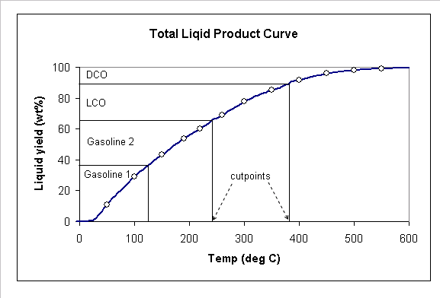
The TLP curve represents the combined distillations of all of the product streams and can be ‘cut up’ or fractionated into individual distillations; one for each of the liquid products. The model supports two methods for performing this fractionation - perfect and imperfect fractionation.

4.2 Perfect Fractionation
The cut point for each of the plant liquid products is determined by interpolating the temperature on the TLP curve at the cumulative mass flow of each product. The distillation curve for each product is simply the portion of the TLP curve between the streams front end and back end cut points.
This fractionation method means that there is no overlap between liquid products and thus none of the product distillations have tops and tails. These perfect distillations are used in all of the product quality narrow fraction summations. However, in order to match the input distillation curves a factor for each distillation point is used. This factoring is for user acceptance of the product distillations and in the predict case the displayed distillations will not always blend into the TLP curve.

4.3 Imperfect Fractionation
This option generates overlapping product distillations for use in product quality narrow fraction summations. This it simulates more accurately the effects of cut point changes and fractionation efficiency on these qualities.
The separation of the TLP curve into plant products is achieved by fractional distillation. How good the separation is depends on the number of plates in the column and the reflux ratio. For a given separation, it is possible to calculate how many plates would be necessary to perform the separation at total reflux. We call this number the Fractionation Index (FI). By assuming this FI is constant we can produce a simple shortcut distillation model.
The Fenske equation describes the distribution of component (i) relative to a reference component r, where the relative volatility α_{ir} is assumed constant:
y_{i} /x _{i} = α_{ir}^{N} * y_{r}/x_{r}
where: y, x are the mol fractions of components in the overheads and bottoms
N is the fractionation index (FI).
If there are D mols of overhead and B mols of bottoms then:
Dy_{i}/Bx _{i} = α_{ir}^{N} * Dy_{r}/Bx_{r}
The reference component can be defined as a component which is equally distributed between the distillate and bottoms, so:
Dy_{i}/Bx _{i} = α_{ir}^{N}
For feed F, mol fraction z_{i},
Fz_{i} = Dy_{i} + Bx _{i}
Fz_{i} = Bx_{i *} (α_{ir}^{N} + 1)
Bx_{i} = Fz_{i} / (α_{ir}^{N} + 1)
Dy_{i} = Fz_{i} - Bx _{i}
Notice that the equation describes the ratio of the amount in the feed to the amount in the bottoms so it is irrelevant what the actual units are. The model uses weight units as the TLP curve is based on weight.
Within the model, two cut points are referred to:
The yield cut point (YCP) is read from a plot of tbp wt% versus temperature of the feed to the separation. It is the temperature coinciding with the wt% yield of the two products. This is the cut point described in the perfect fractionation case.
The effective cut point (ECP) is the boiling point of the component, or an interpolation, which is present in equal amounts in the two products (ie. the mid point of the narrow fraction that distributes evenly between the overhead product and the bottom product in the separation).
The model uses two FIs to describe a single separation. This is to handle the effect that the components lighter than the reference component are mainly in the upper (rectifying) section of the column and the heavier components in the lower (stripping) section, each section having its own FI. When calculating the distribution of narrow fractions, the changeover from the stripping FI to rectifing FI occurs at the effective cut point (ECP).
Given a feed stream described as weight amounts of standard narrow fractions (ie the TLP curve) a stripping and rectifying FI and an ECP, the distillation of the two products from the separation can be calculated.
The relative volatility of the i^{th} narrow fraction component relative to the ECP can be calculated from:
log₁₀(α_{ir}) = 4.60 * (1 - T_{i}/ ECP)
T_{i} ECP in K. T_{i} is the mid boiling point of the narrow fraction component. This equation was derived for the heritage Amoco “CDG” cutting tool.
It is thus possible to calculate the bottoms amount of each narrow fraction from:
Bx_{i} = Fz_{i} / (α_{ir}^{N} + 1)
The value of N depends on the FI method selected. The first method changes N from the stripping FI to the rectifying FI at the ECP. For the second method we find the highest boiling and lowest boiling components (narrow fractions) which distribute between the two products in significant amounts. A value for N is interpolated based on the two FIs and the position of the current narrow fraction being split between these high and low boiling significant components.
The shortcut fractionation method described above allows us to generate a distillation for each of the plant product streams. For this a series of binary separations is performed starting from the TLP curve and first splitting out the DCO distillation, then the HCO distillation, and so on, until we are left with the distillation of the lightest gasoline stream.
In addition, a cut point and fractionation indexes are computed for separation of C4s and C5s between gas and gasoline streams. Predicted values for C5 yields are used as C5s in gasolines are not inputs to the model.

4.3.1 Calculation of Fractionation Indices and Effective Cut points
There are a number of ways to calculate values for FI’s. However, an FI can be regarded as a fitting factor that attempts to match a known product distillation. For this reason the method of calculation is secondary to the primary need to best match a known distillation.
The shortcut fractionation method outlined above will not provide a perfect match of the measured product distillations. This is because it is a mathematical method and hence it will tend to return very smooth distillation curves. This difference between the measured and actual distillations means that the ECP will have to change slightly so that the plant product yields match the measured values.
The above two statements mean that a loop within a loop method is required to solve the base case fractionation calibration. This process will identify the FI’s that produce distillations that most accurately match the measured distillations and ECP’s that yield the correct plant liquid product flow rates.
The optimisation routine to calculate the FI’s was taken from “FICalc”, the heritage BP FI finder linked to the “Ppefa” crude cutting tool.

4.3.2 Imperfect Fractionation Distillation Product Quality Calibration
For each product stream there is a measured value for the bulk quality. There is also a predicted quality distribution curve, assigning a quality of each distillation narrow fraction. A bulk quality value can be calculated from a narrow fraction summation of the product distillation curve and the quality distribution curve.
Due to the generic, non-unit specific approach to the prediction of a quality distribution curve this bulk value is normally different from the measured value. Thus the quality distribution curve needs to be tuned so that the predicted value is the same as the measured value. This tuning process is described below, the example given is based around a system that blends by weight and has multiplicative unit factors (eg. sulphur), however, the process described can be applied to any system, and to systems that use additive unit factors instead of multiplicative ones.

4.3.2.1 Quality Curve Tuning
Consider a system of n product streams with n measured bulk qualities and n predicted bulk qualities. This requires a system of n equations to be solved and will yield n calibration factors, one for each of the product streams.
In an imperfect fractionation system the total liquid product curve is cut into individual product streams. Due to the nature of imperfect fractionation there are temperature ranges where the product streams overlap. To ensure that the tuned quality distribution curve is continuous we can only have one calibration factor for each temperature. Thus for the overlapping regions, the calibration factors need to be blended for the overlapping streams. This blending is performed on the same basis as the base quality blends. For example, sulphur is blended by weight, RON by volume, and viscosity by blending index.
This means that for each narrow fraction, the percent of that narrow fraction that is stream 1, stream 2 through to stream n, needs to be calculated and the calibration factors blended based on these percentages.
Example - Blending Calibration Factors in a Two Stream System:
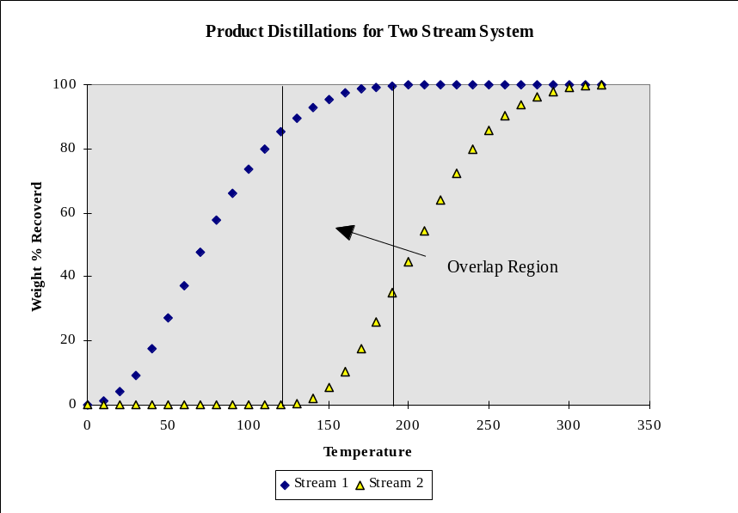
As the plot above shows there is a region where the streams overlap. From these product distillations and the flow rates of each of the product streams, the percent of each narrow fraction that is stream 1 and the percent that is stream 2 can be calculated.
For the narrow fraction with mid point at T = 155° (NF₁₅₅):
 | Stream 1 | Stream 2
% of stream in NF₁₅₅ | 1.91 | 4.88
Total Mass flow rate of stream | 100 | 80
Mass of stream in NF₁₅₅ | = 1.91/100 * 100  = 1.91 | = 4.88/100 * 80  = 3.91
Frac of NF₁₅₅ that is stream n | = 1.91/(1.91 + 3.91)  = 0.33 | = 3.91 / (1.91 + 3.91)  = 0.67
The plot below shows these values for the whole temperature range:
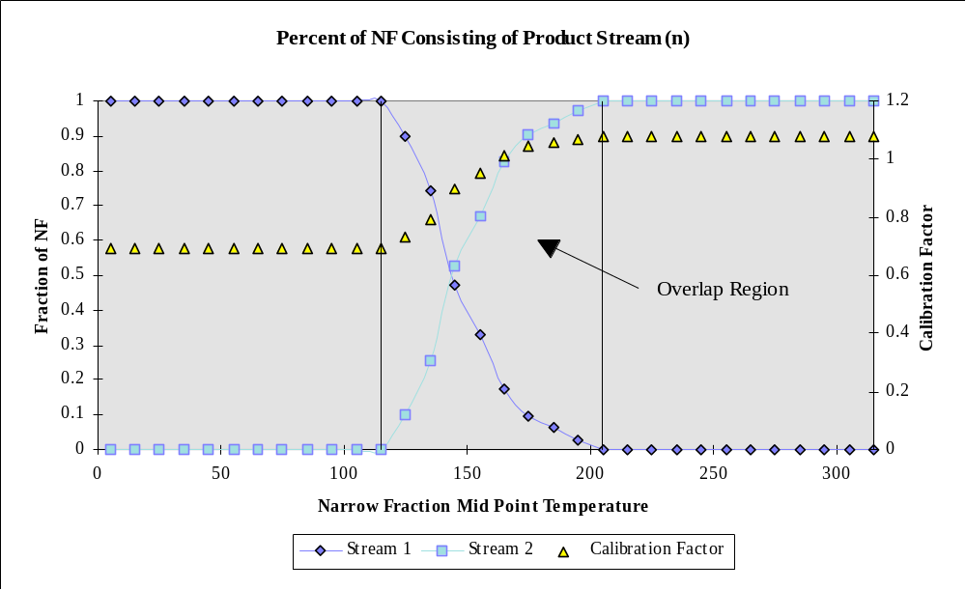
This plot also shows the resulting calibration factor and how it distributes with temperature. In the region where there is only stream 1 (0 - 110°C) the calibration factor is equal to that of stream 1 (Z1 = 0.69) and where there is only stream 2 (210 - 330°C) it is equal to the calibration factor of stream 2 (Z2 = 1.08). In the overlap region, the calibration factor Z is a weight based blend of Z1 and Z2:
Z_{i} = Z1 * F1_{i} + Z2 * F2_{i}
where: F1_{i} are F2_{i} are the fractions of stream 1 and stream 2 that compose narrow fraction with mid temp i°C.
The tuned product quality curve is then a function of the predicted curve and this calibration factor curve, either multiplicative or additive. An example of a multiplicative factor using the calibration factors is shown below:
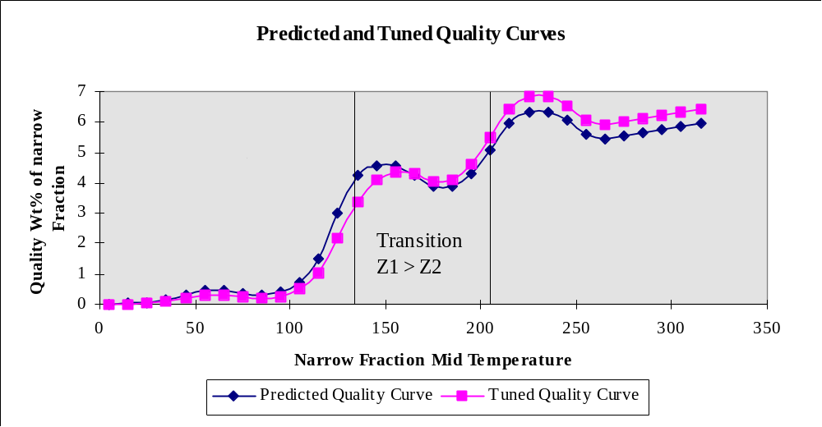

4.3.2.2 Solving for the Calibration Factors
The tuned quality curve is a function of the calibration factors for each stream and how the product streams distribute with temperature. The easiest way to approach the calculation of calibration factors is by algebraically working through an example similar to the that used in the previous section.
The calibration factors for the two streams can be blended based on the weight of each stream in a narrow fraction. The calibration factor for a narrow fraction with mid temp i° is given by:
Z_{i} = Z1 x F1_{i} + Z2 x F2_{i} (Equation 1)
where: Z_{i} = Calibration factor for narrow fraction i
Z1 = Calibration factor for stream 1
Z2 = Calibration factor for stream 2
F1_{i} = Fraction of Narrow fraction i composed of stream 1
F2_{i} = Fraction of Narrow fraction i composed of stream 2
Example. Narrow fraction (i = 130°) is composed of 4.2 kg of stream 1 and 0.47 kg of stream 2:
F1₁₃₀ = 4.21/(4.21 + 0.47) and F2₁₃₀ = 0.47/(4.21 + 0.47)
For a system with n streams equation 1 can be written as:
Z_{i} = Z1 * F1_{i} + Z2 * F2_{i} + ............. + Zn * Fn_{i} (Equation 2)
where: Zn = Calibration factor for stream n.
Fn_{i} = Fraction of Narrow fraction i composed of stream n.
A narrow fraction summation of the tuned quality curve and product distillation for any stream must yield the measured bulk property. For a multiplicative system the tuned quality curve for any narrow fraction is given by:
TP_{i} = P_{i} x Z_{i} (Equation 3)
where: TP_{i} = Tuned property of narrow fraction i
P_{i} = Predicted property of narrow fraction i
Z_{i} = Calibration factor for narrow fraction i
The narrow fraction summation for a product stream can be represented as:
(Equation 4)
where: Pn = Predicted bulk quality for stream n.
Wn_{i} = Weight Fraction of Stream n in narrow fraction i.
TP_{i} as before.
ibp = The initial boiling point of the stream.
fbp = The final boiling point of the stream.
NOTICE: Wn_{i} is only a function of the streams distillation not of the narrow fraction composition. It is quite different to Fn_{i}. If we had a very finely cut stream that only existed in two narrow fractions ( i = 50° and i=60°) we might find Wn₅₀ = 0.6 and Wn₆₀ = 0.4 so Wn₅₀ + Wn₆₀ = 1
Substituting TP_{i} from Error: Reference source not found into this equation gives:
(Equation 5)
Substituting of Z_{i} from Error: Reference source not found gives:
(Equation 6)
By replacing the n in this equation with a stream number you can derive an equation for each stream in the system.
Example. Two Stream System
Stream 1 Error: Reference source not found
Stream 2 Error: Reference source not found
These two equations can be expanded to give:

In these equations P1 and P2 are the measured product qualities for the bulk streams, P_{i} is the predicted property for each narrow fraction, W1_{i} & W2_{i} can be calculated from the product distillations and F1_{i} & F2_{i} can be calculated from the product distillations and product flow rates. The only unknowns in these two equations are the value of Z1 and Z2. Two simultaneous equations and two unknowns can be solved to give the values of Z1 & Z2.
The same process can be used to find the calibration factors for any system with any number of product streams. The model can support up to seven product streams. With this number of streams a rearrangement type solution is not sensible, and for this reason an inverse matrix solution method is used by the model to find the calibration factor values.

4.3.2.3 Calibration factors, Unit Factors & Blend Factors
Throughout the above discussion the term Unit Factor (UF) has not been used. This is because a unit factor can only be described in two ways either:
UF =Actual - Predicted or UF = Actual / Predicted
Neither of these descriptions matches how the above calibration factors are calculated. However, the two unit factor descriptions can be applied to this system. A narrow fraction summation of the predicted (uncalibrated) quality curve and the product distillation can be performed. This summation will yield a predicted bulk property value for a product stream. This value can then be used to calculate a unit factor.
Comparing the calibration factors and unit factors, the values are often quite similar. The reason for this can be see on the plot below, which shows a predicted quality curve, the tuned quality curve, and two curves showing what the curve would look like with straight unit factors applied.
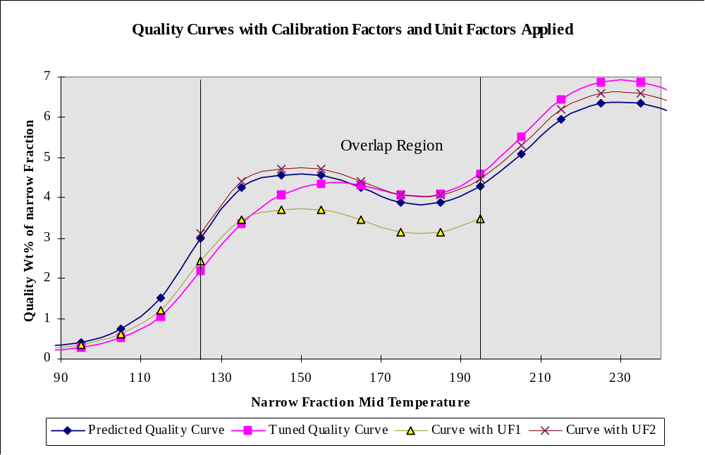
In the overlapping region the tuned curve is higher than the curve where unit factor one is applied. In order for a narrow fraction summation for stream one to be equal to the measured value the difference between these two curves in the overlapping region has to be counteracted in the region prior to the overlap.
Example. In the above case the tuned curve is higher than the unit factored curve in the overlap region, hence it must be lower than the unit factor curve outside this region. The stream one calibration factor of Z1 = 0.69 is lower than the unit factor value of UF1 =0.81. This process can also be seen for stream 2 where. Z2 = 1.08 and UF2 = 1.04.
Both of the overall calibration factors (Z) appear to be adjusted values of the unit factors. This adjustment is due to imperfect fractionation and the overlapping region that it creates. As fractionation improves and the size of the overlap decreases the difference between the calibration factors and the unit factors decreases until, when fractionation becomes perfect and there is no overlap, the calibration factors and the unit factors become equal.
The adjustment required due to imperfect fractionation and the subsequent blending of the calibration factors can be calculated as:
Blend Factor (BF) = Calibration Factor (Z) / Unit Factor (UF)

4.4 Plant Yield Prediction

Base Case Calculation
In order to predict the yields of liquid products at any given cut point it is necessary to construct a total liquid product distillation curve. This is achieved in the model by predicting twelve points on the total distillation curve and then fitting a curve (see section 4.1) to these points. The twelve points used are 50Error: Reference source not foundC, 100Error: Reference source not foundC, 150Error: Reference source not foundC, 190Error: Reference source not foundC, 221Error: Reference source not foundC (standard gasoline), 260Error: Reference source not foundC, 300Error: Reference source not foundC, 350Error: Reference source not foundC (standard DCO), 400Error: Reference source not foundC, 450Error: Reference source not foundC, 500Error: Reference source not foundC, and 550Error: Reference source not foundC.
The 221°C and the 350°C distillation points are related to the C5-221°C standard gasoline and the 350°C+ standard DCO yield predictions:
221°C distillation point = ‘C5-221°C gasoline’ + C4s in gasoline – C5s to gas
350°C distillation point = Total liquid – ‘350°C+DCO’
Total liquid = 221°C distillation point + ‘221-350°C LCO’ + ‘350°C+DCO’
All other TLP key point predictions are based on the ratios. This essentially guaranties that the predicted TLP is monotonous, provided that the correlations are always positive. Before the ratios are computed gasoline C4s are subtracted and C5s from plant gas streams are added. So, basically, the key point predictions are for the C5+ TLP curve.
ratio_190 = TLP_190C/(TLP_221C - TLP_190C)
ratio_150 = TLP_150C/(TLP_190C - TLP_150C)
ratio_100 = TLP_100C/(TLP_150C - TLP_100C)
ratio_50 = TLP_50C/(TLP_100C - TLP_50C)
ratio_400 = (TLP_400C - TLP_350C)/(100.0 - TLP_400C)
ratio_450 = (100.0 - TLP_450C)/(TLP_450C - TLP_400C)
ratio_500 = (100.0 - TLP_500C)/(TLP_500C - TLP_450C)
ratio_550 = (100.0 - TLP_550C)/(TLP_550C - TLP_500C)
ratio_260 = (TLP_350C - TLP_260C)/(TLP_260C - TLP_221C)
ratio_300 = (TLP_350C - TLP_300C)/(TLP_300C - TLP_260C)
The unit factors are computed as following:
TLP_190C_uf = ratio_190 / pred_TLP_190 (and similar for other ratios),
where pred_TLP_190 is a model prediction.
The predictions are based on approximately 200 data points from Sunburry pilot plant.
pred_TLP_190 = (0.5585 + 1.8267 * kinconv + 1.7412 * kindco + 0.00333 * feed_meabp);
pred_TLP_150 = (1.4432 + 0.5735 * kinconv + 0.2620 * kindco + 0.00116 * feed_meabp);
pred_TLP_100 = (0.7823 + 0.2282 * kinconv + 0.0438 * kindco + 80.34 / feed_meabp);
pred_TLP_50 = (0.1105 + 0.0117 * kinconv + 0.0467 * kindco + 0.000345 * feed_meabp);
The following trick is used to avoid negative predictions at very high Meabp
pred_TLP_400 = (0.001 + fcn * (0.5 + 0.5 * tanh(100*(fcn - 0.01)))), where
fcn= ((0.0 + 0.09409 / kinconv + 4.983 / *yield_dco + 0.0153 * (800.0 - feed_meabp) / (1.0 + exp(0.01 * (814.0 - feed_meabp)))) / (100.0001 - totalfeed_400) * (100.0 - totalfeed_350))
pred_TLP_450 = (exp(2.910 + 0.388 * kinconv + 0.0426 * *yield_dco - 0.007488 * feed_meabp) / (totalfeed_450 - totalfeed_400) * (100.001 - totalfeed_450) )
pred_TLP_500 = (exp(-2.953 - 0.0003 * kinconv + 0.01066 * *yield_dco + 0.003596 * feed_meabp) / (100.001 - totalfeed_450) * (100.001 - totalfeed_500))
pred_TLP_550 = (exp(-5.981 + 0.367 * kinconv + 0.0294 * *yield_dco + 0.00535 * feed_meabp) / (100.001 - totalfeed_500) * (100.001 - totalfeed_550))
pred_TLP_260 = (-0.2124 + 1.5856 / kinconv + 5.6828 / *yield_dco + 476.2 / feed_meabp)
pred_TLP_300 = (0.1210 + 0.2396 / kinconv + 0.4809 * kindco + 555.5 / feed_meabp)
When the base case feed input is based on mean average boiling point, different correlations are used for 400 and higher TLP points:
pred_TLP_400 = (0.001 + fcn * (0.5 + 0.5 * tanh(100*(fcn - 0.01)))), where
fcn= ((0.0284 + 0.1517 / kinconv + 5.709 / *yield_dco + 0.0223 * (788.0 - feed_meabp) / (1.0 + exp(0.0069 * (869.0 - feed_meabp)))))
pred_TLP_450 = (exp(-7.027 - 0.0842 * kinconv + 0.0068 * *yield_dco + 0.00937 * feed_meabp))
pred_TLP_500 = (exp(-6.565 + 0.0989 * kinconv + 0.0204 * *yield_dco + 0.00727 * feed_meabp))
pred_TLP_550 = (exp(4.073 + 0.298 * kinconv + 0.0260 * *yield_dco - 0.00817 * feed_meabp))
Multiplicative unit factors for these equations are generated in the base case in the same manner as for the standard yield equations, and are transferred to the predict case, e.g.
tlp_uf[C190] = TLP_190C/(TLP_221C - TLP_190C) / pred_ratio_190
The input of C4s in gasoline and C5s in gas is used to compute fractionation indices and effective cut point (ECP) between gas and liquid. Each component (C4 and C5 normal and iso paraffins and olefins, and dienes) is distributed according to the Fenske equation. The FI changes at the cut point, a stripping FI for the lighter C4 components and a rectifying FI for the heavier C5 components. An iterative procedure is used to find the ECP, stripping and rectifying FIs that matches the calculated gas/gasoline C4 and C5 flow in the combined liquid with the input amounts. As there are 3 unknowns but only two equations, a crude optimisation is carried out to select the ECP which gives FIs whose sum is the minimum. For the distribution of the C4/C5 components in the gasoline streams, the cutpoints and FIs of the gasoline streams have already been determined however using these does not lead to the correct amounts of total C4 in the streams. A unit factor is applied which adjusts the rate predicted from the ECP to the input C4 value. This is applied to the first two gasoline streams. The 3rd will be correct by difference. The C5s are distributed without correction.

Predict Case Calculations
C4s and C5s in the gas/gasoline streams are distributed using the ECPs/FIs and C4 unit factors from the base case.
The product gas stream compositions are calculated by assuming that the split of each component between gas streams is the same as in the base case.
The standard gasoline and DCO are predicted, i.e. 221°C and the 350°C points. Then, the remaining ten C5+ TLP points are predicted using the above correlations and unit factors are applied to the predicted ratios, e.g.
pred_ratio_190 = TLP_190C/(TLP_221C - TLP_190C) * tlp_uf[C190]
TLP_190C = TLP_221C / (1.0 + 1.0 / pred_ratio_190)
Pre_ratio_190 = TLP_190C / (TLP_221C - TLP_190C) / TLP_UF[C190]
TLP_190C = TLP_221C / (1.0 + 1.0 / (TLP_UF[C190] * pre_ratio_190))
那么依次算出TLP_150C、TLP_100C、TLP_50C，TLP_260C、TLP_300C、TLP_400C、TLP_450、TLP_500C
After that, C5s to gas are subtracted and C4s in liquid are added.
In order to better predict the effect of C4s on gasoline distillation, an extra TLP point is created at 20°C.
Wt% of TLP corresponding to the simdis ibp of gasoline1 in the base case (ibp_tlp_wtpc) is interpolated; this is going to be the definition of TLP and gasoline1 IBPs. Then Ybase=wt% of TLP at 20 C (most volatile C5) by interpolation of the TLP curve.
IF (C4predict wt% of TLP)>=(C4base wt% of TLP), then Ypred=Ybase+ (C4predict-C4base), i.e. 20 C point moves up as much as C4 in liquid does,
ELSE Ypred changes (decreases if an input is consistent) to become “ibp_tlp_wtpc” at C4pred=0 (essentially, according to our definition of the TLP IBP, simdis ibp of gasoline1 goes to 20 C)
Ypred= ibp_tlp_wtpc +(Y- ibp_tlp_wtpc)/C4base*C4pred
Now all the key TLP points are used to generate a complete TLP curve as described in section 4.1.
Firther, cut points between each plant liquid product, and the FI’s if in imperfect fractionation mode, passed from the base case or supplied by user are utilized to generate the distillation and yield of each product stream.

5. PRODUCT QUALITY PREDICTION
The model is capable of predicting product qualities for standard liquid cuts as well as for liquid cuts of variable cut point. The user has the option of entering data on a standardised basis or on a raw plant yield basis. If the standardised product option is chosen, the product qualities entered by the user are used to calibrate a set of pilot plant based standard quality equations. These calibrated quality equations are then used for the forward predictions. If the raw plant data option is chosen, the model generates a set of product quality curves for each of the predicted qualities. These quality curves together with the total liquid product distillation curve are used to predict the various qualities of any liquid cut specified by the user.

5.1 Standard Product Quality Predictions
The model uses the pilot plant based product quality equations as the basis for the prediction of standard qualities. The standard quality equations used in the model are:
CCS RON = -2.2 + 0.07470 * ROT + 0.38 * (X/1-X) - 0.015 * MeABP + 48 * SG - 0.2 * freshfeed_naphtha
CCS MON = 38.45 + 0.02008 * ROT + 0.5 * (X/1-X) - 0.01620 * MeABP +
36 * SG + 1.1351 * Press - 0.15 * freshfeed_naphtha
Note that in the above equations naphtha in the fresh feed is assumed to be straight and is computed from the feed distillation as the amount of material boiling below 221C on a weight basis. It is set to zero if Meabp and feed<350C input option is used.
CCS API = -0.0002 * (Conv - 30.0) * (ROT(deg F) -925.0) + 49.82 + (0.187 - 0.000854 * Conv) * Conv + 15.0387 - 2.4756 * CA_ndm + 0.15165 * CA_ndm^2 - 0.00479288 * CA_ndm^3 + 0.0000584572 * CA_ndm^4
CCS SG = 141.5 / (131.5 + CCS API)
LCO SG = - 0.3034 + 0.001724 * Conv - 0.0001483 * MeABP + 1.4085 * SG - 0.024565 * Press
DCO SG = -1.227 + 0.003679 * Conv - 0.0003365 * MeABP + 2.332 * SG +0.05316 * Press
CCS Sulphur = 482 * Press * (Fd Sulphur)^0.59 * (X/(1-X))^-0.22 * exp(-5.102 * 10^-5) * (Ni – 4 * Sb/3 +V/4) * (1-0.008 * feed_hydro)
LCO Sulphur = Fd Sulphur * (0.1837 * Fd Sulphur + 0.2764 * (X/(1-X)) + 0.0007966 * ROT)
DCO Sulphur = Fd Sulphur * (0.5309 * (X/(1-X)) + 0.001092 * ROT) * (1 + 0.008168 * feed_hydro)
LCO Cloud = -152.3 + 0.184 * T₅₀ + 0.221 * T₉₀ + 0.673 * API
LCO Pour = LCO Cloud - 2.778
DCO KV@50 = (X/(1-X))^0.847 * exp(-10123/ROT) * exp(24.38 * SG) *
exp(0.00496 * MeABP) * CF * exp(-9.229)
DCO Concarb = 14.37 * SG + 1.42 * Con_Carb - 12.502
DCO Bas_N2= 951 * SG + 0.300 * Basic N2 - 827.37
where:
API = LCO API gravity
Basic N2 = Feed Basic Nitrogen Content (ppmw)
Con_Carb = Feed Conradson Carbon Content (wt%)
feed_hydro = Degree of feed hydrotreatment (sulphur reduction in wt%)
Fd Sulphur = Feed Sulphur Content (wt%)
MeABP = Feed Mean Average Boiling Point (K)
Press = Reactor Pressure (barA)
ROT = Riser Outlet Temperature (K)
SG = Feed Specific Gravity
T₅₀ = D86 50% point
T₉₀ = D86 90% point
TBP_50%_Point= 50% distillation point (Error: Reference source not foundC)
X/(1-X) = Kinetic Conversion
Conv = 221°C Conversion (wt%)
All feed qualities are for the combined feed.
The only product quality catalyst factor currently used in the model is:
DCO KV @50 CF = 1.0
In the base case, unit factors are generated for each of the above standard qualities. Product quality unit factors can be multiplicative or additive:
 | Multiplicative or Additive?
CCS RON | A
CCS MON | A
CCS SG | A
LCO SG | A
DCO SG | A
CCS Sulphur | M
LCO Sulphur | M
DCO Sulphur | M
LCO cloud | A
LCO Pour | A
DCO KV@50 | M
In the predict case each standard quality prediction equation is adjusted by the corresponding base case unit factor (either by multiplication or addition as appropriate) to give the predict case standard yield.

5.2 Plant Product Quality Predictions
To predict the quality of any specified liquid cut, the model uses a narrow fraction summation procedure together with the liquid product distillation curve and the relevant quality versus boiling point curve. Each quality curve, as well as the distillation curve, is divided into 10Error: Reference source not foundC narrow fractions between the cut point temperatures for each liquid product. The quality of each narrow fraction is estimated as the average of the interpolated qualities at the IBP and the FBP of the narrow fraction. Once the quality and wt% of each narrow fraction is estimated, the quality of the whole liquid product is calculated by linearly blending together all of the narrow fractions on a weight or volume basis as appropriate.
Qualities that blend linearly on a weight basis use the quality curve and the liquid distillation curve in the following narrow fraction summation routine to calculate the quality of the whole liquid product:

Qualities that blend on a volume basis require the liquid distillation curve to be on a vol% basis rather than a wt% basis. For these qualities the wt% distillation curve must first be converted to a vol% curve by using the SG curve. The narrow fractions can then be blended on a volume basis according to:

For qualities that do not blend linearly an appropriate blending index is used.
Each quality curve (as well as the distillation curve) is typically generated by fitting a cubic spline to several predicted points on the quality curve. If the liquid cutpoints are outside of the range for interpolation (i.e. they do not fall between the predicted points for the spline curves) then the splines are linearly extrapolated from the end points (extrapolation of cubic splines is generally not robust). The following sections detail how each quality curve is generated as well as the basis for blending of each quality. For more information on splines see Section 9.
The descriptions above hold for both perfect and imperfect fractionation. The difference is in how the distillation used in the narrow fraction summation is generated:
- For perfect fractionation the total liquid distillation curve (TLP) is used. The section of this curve between a products front and back end cut points is taken as the product distillation.
- For imperfect fractionation the products actual distillation as generated by the fractionation algorithm is used in the narrow fraction summation.

5.2.1 Specific Gravity

Base Case Calculation
The first requirement in the calculation procedure is to estimate standard liquid cut SG’s from the measured plant liquid SG’s. The specific gravity calculations of standard cut gasoline (C5 to 221ºC), and standard cut LCO (221 to 350 ºC) as well as DCO (350 ºC+) are different. Experimental work has found that SG distributes with boiling point in an approximately linear relationship. A series of data points of SG versus boiling point is calculated by allocating each measured plant liquid SG to a temperature midway between the cut point temperatures for that liquid. Thus for LCO and DCO, their SGs are obtained through this SG curve.
For example, if the LCO SG was measured to be 0.95 and the LCO cut points were 220 to 350 C then the SG vs boiling point data point for the plant LCO stream would be (0.95, (220+350)/2). From these raw plant SG points , the SG’s at (IBP + 221)/2, (221 + 350)/2 and (350 + FBP)/2 are linearly interpolated. Therefore, for LCO and DCO, their SG points are estimated as being the base case standard liquid SG's.
For Standard gasoline, however, its SG is obatined by a more detailed material balance calculation. The weights within standard cut boiling point range of each plant streams are summed up. Then the C4s contained in each plant stream are subtracted from it while C5s in gas stream are added. The following is the equation to do this calculation.
sum_wt = wt of [LCN+ICN+HCN - C4s in (LCN+ICN+HCN) + C5s in (AOG+PP+BB) - wt>221C in (LCN+ICN+HCN)+ wt<221C in (LCO1+LCO2+HCO+DCO) + wt<221C in (LCO1_recycle+LCO2_recycle+HCO_recycle+DCO_recycle)]
sum_vol = Vol of [LCN+ICN+HCN - C4s in (LCN+ICN+HCN) + C5s in (AOG+PP+BB) - wt>221C in (LCN+ICN+HCN + wt<221C in (LCO1+LCO2+HCO+DCO) + wt<221C in (LCO1_recycle+LCO2_recycle+HCO_recycle+DCO_recycle)]
SG of standard gasoline = sum_wt/sum_vol
Standard SG unit factors are then obtained by taking the difference between the three calculated values and the standards SG's predicted by the pilot plant prediction equations:

CCS API = -0.0002 * (Conv - 30.0) * (ROT(deg F) -925.0) + 49.82 + (0.187 - 0.000854 * Conv) * Conv + 15.0387 - 2.4756 * CA_ndm + 0.15165 * CA_ndm^2 - 0.00479288 * CA_ndm^3 + 0.0000584572 * CA_ndm^4
CCS SG = 141.5 / (131.5 + CCS API)
LCO SG = - 0.3034 + 0.001724 * Conv - 0.0001483 * MeABP + 1.4085 * SG - 0.024565 * Press
DCO SG = -1.227 + 0.003679 * Conv - 0.0003365 * MeABP + 2.332 * SG +0.05316 * Press
A SG spline curve is then set up by using these standard liquid SG's (as calculated from the plant SG’s), placed at (IBP + 221)/2, (221 + 350)/2 and (350 + FBP)/2 respectively, plus the SG of C4s and C5s in the front. See the Figure below.
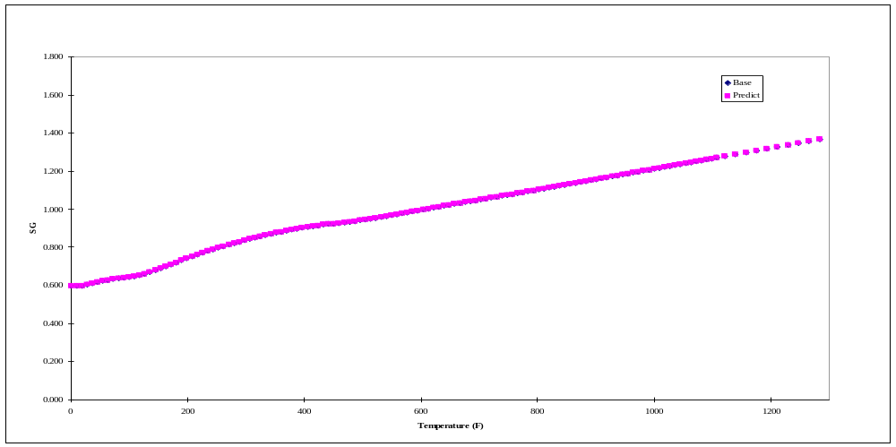
C4s concentrations are calculated from the input while C5s concentrations are calculated from the input of total C5s and the species prediction. As a result, the front point of the SG curve will be restricted in between maximum SG and minimum SG of C4s and C5s species and no other adjustment sould be applied. To smoothen the curve between this restricted front point and the rest of the liquid, the standard gasoline is cut into two parts. The sum of bulk SG of these two parts is equal to the SG of standard gasoline. However, the first part has small or zero unit factor (small or no adjustment) so that the adjustment will be mainly applied to the second part. The connection between the first part and the second part will be smoothened out through the blending. This spline is used to interpolate the SG of each 10Error: Reference source not foundC narrow fraction. The SG’s of the narrow fractions are blended on a volume basis to obtain the SG of the plant streams.
Unit factors for the plant product SG's are then obtained by taking the difference between the measured SG for each of the liquid products and the SG calculated from the narrow fraction summation for each product.

Predict Case Calculation
In the predict case, the standard SG’s are first calculated (at the new conditions) using the above standard SG equations. The standard SG unit factors, obtained in the base case, are then added to each prediction to give three ‘actual’ standard SG’s. A spline curve is then generated by fitting a spline to these three SG’s placed at (IBP + 221)/2, (221 + 350)/2 and (350 + FBP)/2 and the SG points of C4s and C5s. Again, the standard gasoline is divided into two parts to smooth the connection. This spline curve together with the new total liquid product distillation curve is used to calculate the SG of each plant liquid product by 10°C narrow fractions in the same way as in the base case. The unit factors for the plant liquid SG’s are then added to these to give the predicted SG for each plant liquid product.

5.2.2 Sulphur

Base Case Calculation
The wt% of sulphur in standard CCS (C5 - 221°C), LCO (221 -350°C) and DCO (350+°C) are predicted at the base case conditions using the pilot plant based equations:
CCS Sulphur = 482 * Press * (Fd Sulphur)^0.59 * (X/(1-X))^-0.22 *
exp(-5.102 * 10^-5) * (Ni – 4 * Sb/3 +V/4) * (1-0.008 * Fd_H)
LCO Sulphur = Fd Sulphur * (0.1837 * Fd Sulphur + 0.2764 * (X/(1-X)) + 0.0007966 * ROT)
DCO Sulphur = Fd Sulphur * (0.5309 * (X/(1-X)) + 0.001092 * ROT) * (1 + 0.008168 * Fd_H)
The standard yields have previously been calculated in the base case yield calculations. From these two pieces of information, the weight of sulphur in each of the standard cuts is then calculated by multiplication:
(wt% S in each cut) * (wt of cut) / 100
In order to obtain the desired sulphur curve shape using the cubic spline method, three separate splines are used over the following ranges:
Temperature Range 1: 90 - 215°C
Temperature Range 2: 215 - 390°C
Temperature Range 3: 390°C – FBP
Below 90°C the sulphur level decreases by a factor of 2 every 25°C.
If splined curve stretches below zero the negative values are replaced with the values obtained by linear interpolation between spline key points which are always positive.
From pilot plant and commercial data the distribution of the sulphur in the total liquid product has been estimated as follows:
 | Temperature (°C) | wt% Sulphur
Spline 1 | 90 - 100 | 3% of Std CCS S
 | 140 - 150 | 6.7% of Std CCS S
 | 170 -180 | 5% of Std CCS S
 | 195 - 205 | 8.4% of Std CCS S
Spline 2 | 195 - 205 | 8.4% of Std CCS S
 | 210 - 220 | 18% of Std CCS S
 | 235 - 245 | 0.8 %* Std LCO S
 | 260 - 270 | 0.9 %* Std LCO S
 | 285 -295 | 0.8% * Std LCO S
 | 355 - 365 | 1.0 %* Std DCO S
 | 385 -395 | 0.85 %* Std DCO S
Spline 3 | 385 -395 | 0.85% * Std DCO S
 | fbp | ??? Std DCO S
The weight of gasoline in the each of the above ranges is then calculated using the liquid product distillation curve. Each of the liquid product streams is divided into 10°C narrow fractions. The appropriate sulphur curve is used to interpolate the wt% sulphur of each narrow fraction. The total wt% sulphur in each liquid stream is then calculated by narrow fraction summation on a weight basis. A unit factor for each liquid product stream is then calculated as:
Sulphur UF = Actual product sulphur / Predicted product sulphur

Predict Case Calculation
The predict case calculations proceed in the same way as the base case calculations, except using the pilot plant standard sulphur predictions at the new conditions and the new liquid product distillation curve. The wt% sulphur in each plant product stream is calculated according to the same narrow fraction summation multiplied by the unit factors obtained from the base case.

5.2.3 LCO Cloud Point
The model calculates the cloud point of LCO based on its d86 distillation and API:
LCO Cloud = -152.3 + 0.184 * T₅₀ + 0.221 * T₉₀ + 0.673 * API
The predict case calculations proceed in the same way as the base case calculations, using the predicted plant LCO distillation(s) and API(s). The base case unit factors are added to the predicted cloud point(s) to obtain the predict case LCO cloud point(s).

5.2.4 LCO Pour Point
The pour point of LCO is predicted as a function of the LCO cloud point:
LCO Pour Point (°C) = Cloud Point (°C) - 2.778
The unit factor for LCO pour point then becomes:
Pour Point UF = Actual Pour Point - Predicted Pour Point

5.2.5 LCO Cetane Index
The model calculates the Cetane Index of LCO based on ASTM D976:
Cetane Index = 0.016 * API * API + 0.192 * API * log10(ASTM 50%) + 65.01 * {log10(ASTM 50%)} ^ 2 - 0.0001809 * ASTM 50% ^ 2 - 420.34
The 50% point is based on D86 distillation. It should be noted that the Cetane Index is directly calculated from the product distillation and API. No unit factor is calculated or applied for Cetane Index. Any Cetane Index input as part of the base case data is ignored.

5.2.6 Gasoline RVP
The RVPs of plant gasoline streams are estimated as a function of the C₄ content (iC₄, nC₄, C₄-), the C₅ content (iC₅, nC₅, C₅-) and the C₆+ content of the gasoline.
In the base case, the concentrations of total C4s of each gasoline streams are input by the user. The C4s and C5s breakdown and their distribution in gasolines stream are calculated as described in section 4.4.
The RVP of the gasoline stream can be calculated as :
Blend RVP(LS) = Σ (y_{i} * BRVP_{i} / SG_{i})
Where: y_{i} = the weight fraction of component i
BRVP_{i =} component blending index
SG_{i =} component specific gravity
i = iC4+, nC4+, iC4=, nC4=, C4==, iC5+, nC5+, iC5=, nC5=, C5==, C6+
LS = gasoline 1, gasoline 2, gasoline3.
The unit factor for the gasoline RVP (kPa) then becomes:
RVP UF = Actual RVP - Blend RVP
Component | SG | BRVP
iC4+ | 0.5629 | 92
nC4+ | 0.584 | 65
iC4= | 0.6013 | 79
nC4= | 0.6134 | 75
C4== | 0.6425 | 70
iC5+ | 0.6247 | 22
nC5+ | 0.6311 | 17
iC5= | 0.6525 | 20
nC5= | 0.6525 | 20
C5== | 0.6525 | 20
C6+(LCN) | 0.67 | 7
C6+(ICN) | 0.73 | 3
C6+(HCN) | 0.83 | 1
Predict
C4s and C5s in gasoline streams are computed as described in section 4.4. The RVP is calculated in the same manner, with the unit factor added to the RVP calculated from the component blending, to obtain the predicted gasoline RVP.

5.2.7 Gasoline RON
The first stage in the prediction of gasoline RON is the development of a RON distribution curve, which gives the gasoline RON as a function of gasoline boiling point. This RON curve is developed as a function of some key components in the gasoline. These gasoline components are predicted as follows:
Gasoline C6 Paraffin = (X/(1-X))^0.4353 * exp(-2.700 x SG) * exp(5859/ROT) * exp(-3.55) + (0.18 * freshfeed_naphtha –0.18)
Gasoline C9 Paraffin = (X/(1-X))^-0.1071 * exp(-2.660 x SG) * exp(0.002 x MeABP) * exp(8013/ROT) * exp(-8.0925) + (0.06 * freshfeed_naphtha –0.06)
Gasoline C9 Aromatic = (X/(1-X))^0.1228 * exp(2.602 x SG) * exp(-1193/ROT) *
exp(-0.00231 x MeABP) * exp(2.7273)
The RON distribution curve is a cubic spline fitted to the following five points:
Temperature (°C) | RON
20 | 96.1
60 | (96.1 + 95.0 - 1.08*C6 paraffin)/2
90 | 95.0 - 1.08*C6 paraffin
170 | 1.25*C9 aromatic - 3.48*C9 paraffin + 92.3
250 | 1.25*C9 aromatic - 3.48*C9 paraffin + 92.3 -2.5 –1.2*freshfeed_naphtha
Gasoline RON blends on a volume basis (when no lead is added). Gasoline 5°C narrow fractions from 20°C to 220 °C are blended on a volume basis to calculate the standard cut gasoline RON. The standard gasoline RON calculated by this method is compared to that predicted by the pilot plant prediction equation for standard cut gasoline RON:
CCS RON = -2.2 + 0.07470 * ROT + 0.38 * (X/1-X) - 0.015 * MeABP + 48 * SG - 0.2 * freshfeed_naphtha
The pilot plant prediction equation is based on a wide base of pilot plant operation and feed and so it is likely to be the more accurate of the two prediction methods. Any difference between the two predictions is designated as the overall bias in the gasoline octane distribution curve. If a bias exists, the octane curve has to be adjusted to offset this bias. From analytical work on numerous gasoline samples from different units at different feed and operating conditions, it was found that the differences between the curves were most significant at the higher boiling points. The variations between the different curves were small at the lower boiling point ranges, with no significant differences up to about 90 °C.
The method used to adjust the octane curve for the bias involves the use of a cumulative octane-volume curve. No adjustment is made to this cumulative octane-volume curve up to 60 °C. After 60 ºC, a power law adjustment is applied up to 220°C. Linear adjustment turned out to be not suitable since relatively small difference between standard RON prediction and the curve based on species led to significant swings of the back of the octane curve due to over-adjustment. Assuming the adjustment equation is A*sqrt(T(i)-60). T(i) is the middle temperature of narrow fraction i, then the meaning of the adjustment is represented in the following equation:
Σ(from 60ºC to 220ºC) Vol_nf(i)*A*sqrt(T(i)-60) = Total bias of stardard gasoline
Therefore, from the above equation, the adjustment coefficent A can be determined.
For example, the cumulative octane-volume curve at 150°C is:
Ron at 150 ºC (adjusted) = Ron at 150 ºC (from spline curve) + A*sqrt(150-60)
With this adjustment, a new octane curve is obtained. From this curve, the predicted RON of each narrow fraction is generated.
The next stage is to calculate the octane of the plant product gasoline stream(s). The user can get reference from section of 4.3.2 (Imperfect Fractionation Distillation Product Quality Calibration) to understand how it is done.
The following is a graphical representation of the first stage of the procedure:

Graph 1 Graph 2
Graph 1 shows a RON distribution curve resulting from a cubic spline fitted to the five RON spline points. Graph 2 shows part (the C5-220°C section) of the total liquid product distillation curve. These two curves are divided into 5°C narrow fractions up to 220°C and the narrow fractions are blended on a volume basis to get a standard cut gasoline RON. For this example a value of 93.0 is obtained. The pilot plant prediction equation is then used to predict the standard cut gasoline RON. A value of 93.5 is predicted in this case. This results in an octane bias of 0.5.
Next to determine the adjustment of the curve, assuming the volume of the standard gasoline is 65, so the total bias of standard gasoline is 0.5*65=32.5. From the equation,
Σ(from 60ºC to 220ºC) Vol_nf(i)*A*sqrt(T(i)-60) = 32.5
the coefficient A is found to be 0.1, So the adjustment equation is 0.1*sqrt(T(I)-60). The adjustment is shown in Graph 3.
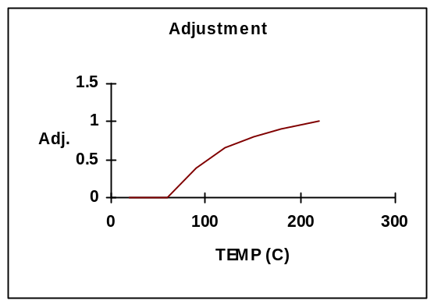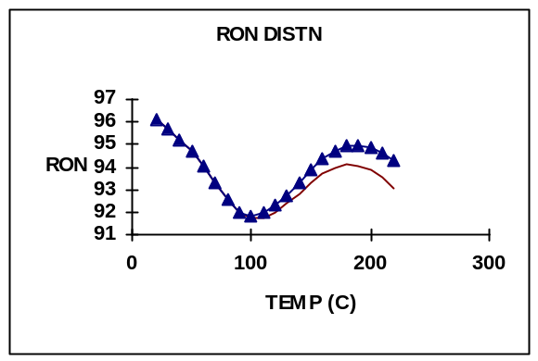
Graph 3 Graph 4
Since the pilot plant prediction is higher than the RON from the five-point-curve, the adjustment shall move the adjusted curve up as shown in Graph 4.
The thin solid line shows the original RON curve. The triangel line shows the adjusted RON curve. At 220°C this has been adjusted up by 1.3. At 60°C and lower it remains the same and in between 60°C and 220°C it is adjusted up in linear proportion. From this adjusted RON curve the RON of any cut of liquid which this range can be interpolated.
The unit factor for the plant gasoline octane is then calculated as the difference between the actual and predicted plant gasoline octane.
This procedure is used for both of the base case and prediction case calculations.

5.2.8 Gasoline MON
The calculation procedure for MON is identical to that of RON. The difference is in the points used for the cubic spline curve and the pilot plant prediction equation. For MON the points used to fit the MON distribution curve with gasoline boiling point are:
Temperature (°C) | MON
20 | 82.5
60 | (82.5 + 82.1 -0.49*C6 paraffin) / 2
90 | 82.1 - 0.49*C6 paraffin
170 | 0.93*C9 aromatic - 2.83*C9 paraffin + 82.7
220 | 0.93*C9 aromatic - 2.83*C9 paraffin + 82.7 - 1.3 – 0.7*freshfeed_naphtha
The pilot plant prediction equation for the standard cut gasoline MON is:
CCS MON = 38.45 + 0.02008 * ROT + 0.5 * (X/1-X) - 0.01620 * MeABP +
36 * SG + 1.1351 * Press - 0.15 * freshfeed_naphtha

5.2.9 Viscosity Calculation
Analytical work has shown that the viscosity blending index distributes linearly as a function of boiling point of the product material. A standard viscosity blending index (VBI) vs. boiling point function has been developed:
VBI = -28.1666 + 0.1533 * T
where: VBI = 23.097 + 33.468*LOG10(LOG10(KV @ 50°C+0.8))
T = Boiling point (°C)
Since the VBI distributes linearly with boiling point , the VBI of any liquid cut can be estimated by substituting the 50% boiling point of the cut into the above equation. In addition to this VBI distribution equation a pilot plant based equation has been developed for standard cut (350°C +) DCO:
DCO KV@50 =(X/(1-X))^0.847 * exp(-10123/ROT) * exp(24.38 * SG)
* exp(0.004096 * MeABP) * CF * exp(-9.229)
The first step in the calculation is to determine the standard cut DCO viscosity by substituting into the VBI distribution equation. This is then compared to the VBI calculated from the pilot plant based equation. Any difference between the two is used to adjust the VBI distribution function as follows:
VBI = -28.1666 + DELTA + 0.1533 * T
where: DELTA is the difference between the original VBI equation value and the pilot plant prediction equation value.
The VBI of any cut of cycle oil is calculated by narrow fraction summation on a weight basis. The calculated VBI of the cut is then converted back to kinematic viscosity by the above equation and a unit factor calculated as actual viscosity/predicted viscosity.

5.2.10 Concarbon

Base Case Calculation
The Conradson Carbon content of a standard DCO (350+Error: Reference source not foundC) is predicted at base case conditions using the following equation derived from pilot plant data:
DCO CCR = 14.37 * SG + 1.42 * Con_Carb - 12.502
Distribution of Concarbon with boiling point is assumed to follow a fixed distribution curve:
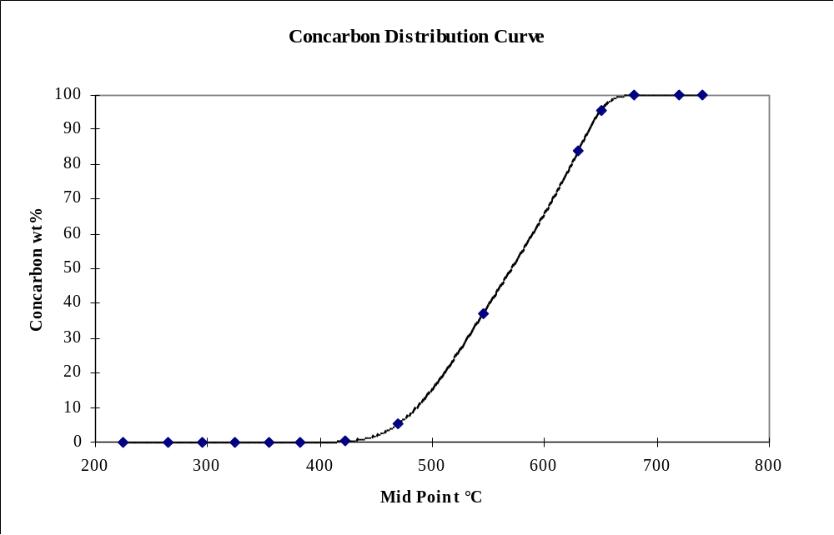
The points on this curve are defined using the following spline points derived from a narrow fraction analysis of a NEREFCO total liquid product sample:
Midpoint (Error: Reference source not foundC) | Concarbon (wt%)
455 | 1
465 | 3
475 | 6
495 | 14.8
515 | 23.6
535 | 32.4
555 | 41.2
575 | 50
595 | 58.8
615 | 67.6
635 | 76.4
655 | 85.2
675 | 94
685 | 97
695 | 99
705 | 100
735 | 100
765 | 100
795 | 100
Below 455 C the Concarbon decreases by a factor of 3 every 10 deg C.
An estimation of the standard (350+Error: Reference source not foundC)DCO CCR is made using narrow fraction summation of this curve combined with the total liquid product boiling point curve. The points on the narrow fraction curve are obtained from the defined curve and adjusted by an S factor using the formula:
p_t [i] = ccrdegc [i] + Concarb_S * ccrwt [i]
p_w [i] = ccrwt [i]
The S factor is the value which adjusts the curve so that the 350+ integration of the curve concarbon matches the DCO concarbon predicted using the pilot plant equation:
DCO CCR = 14.37 * SG + 1.42 * Con_Carb - 12.502
The S factor is NOT a unit factor in the conventional sense of calibrating a predictive equation against observed unit behaviour. Also, it is multiplicative rather than additive, since all FCC product concarbon curves measured to date show CCR of zero until ca.400Error: Reference source not foundC then rise rapidly with a small variation of slope.
If recycle stream CCR data are available in the base case, a recycle stream concarbon unit factor can be calculated. This is done by using the curve (as modified by the S scaling factor calculated above) to predict the CCR of the recycle stream specified for the base case at base case conditions, then subtracting this from the observed value of CCR for that stream:
Recycle CCR UF = Observed CCR for base RCY Stream - Predicted CCR for base RCY stream
If no recycle stream CCR is available, this UF is set to zero (which may result in less accurate recycle stream property predictions and hence less accurate yield/quality predictions).

Predict Case Calculation
In the same way as the base case, a S-factor is calculated at the predict case conditions in order to scale the CCR curve so that it agrees with the Std DCO CCR prediction. Once this has been done, the curve is used to calculate a predicted CCR for the recycle stream. The Recycle CCR UF calculated in the base case is then added to this predicted value.

5.2.11 Basic Nitrogen

Base Case Calculation
The basic nitrogen content of a standard DCO (350+Error: Reference source not foundC) is predicted at base case conditions using the following equation derived from pilot plant data:
DCO BN = 951 * SG + 0.300 * Basic N2 - 827.37
Distribution of total nitrogen with boiling point is assumed to follow a fixed distribution:
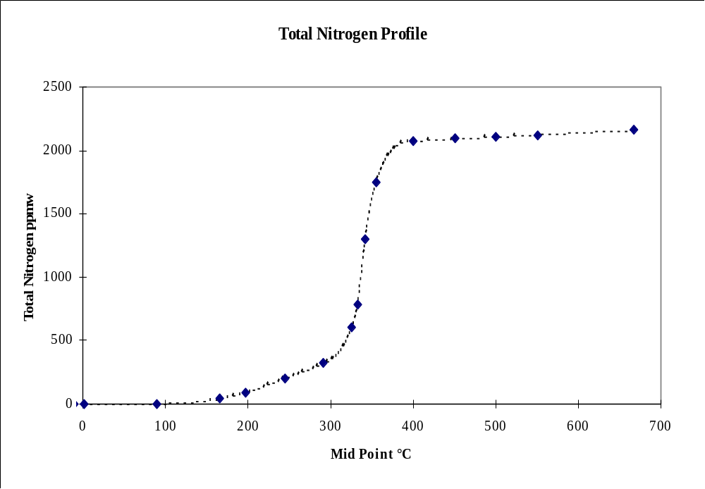
The points on this curve are defined using the following spline points derived from a narrow fraction analysis of a NEREFCO total liquid product sample:
Midpoint (Error: Reference source not foundC) | Total Nitrogen (ppmw)
-10 | 0
1 | 0
90 | 4
165 | 40
197.2 | 90
244.3 | 205
291 | 320
325 | 600
332.1 | 790
341.5 | 1300
355 | 1750
400 | 2073
450 | 2092
500 | 2106
550 | 2124
667.22 | 2160
Below 90 C the basic nitrogen decreases by a factor of 10 every 70 deg C.
An estimation of the standard (350+Error: Reference source not foundC) DCO Total Nitrogen is then made using narrow fraction summation of this profile combined with the total liquid product distillation curve. The points on the narrow fraction curve are obtained from the defined curve and adjusted by an S factor using the formula:
p_t [i] = n2degc [i]
p_w [i] = n2ppm [i] / basicn2_S
The S factor is the value which adjusts the curve so that the 350+ integration of the curve basic nitrogen matches the DCO basic nitrogen predicted using the pilot plant equation:
DCO BN = 951 * SG + 0.300 * Basic N2 - 827.37
[Note that this assumes that basic nitrogen distributes in an identical way to total nitrogen with respect to boiling point, an assumption as yet unverified by experiment.]
If recycle stream BN data are available in the base case, a recycle stream BN unit factor can be calculated. This is done by using the curve (as modified by the S scaling factor calculated above) to predict the basic nitrogen of the recycle stream specified for the base case at base case conditions, then subtracting this from the observed value of basic nitrogen for that stream:
Recycle BN UF = Observed BN for base RCY Stream - Predicted BN for base RCY stream
If no recycle stream basic nitrogen is available this UF is set to zero (which may result in less accurate recycle stream property predictions and hence less accurate yield/quality predictions).

Predict Case Calculation
In the same way as the base case, a S-factor is calculated at the predict case conditions in order to scale the basic nitrogen profile so that it agrees with the Standard DCO basic nitrogen prediction. Once this has been done, the profile is used to calculate a predicted basic nitrogen for the recycle stream. The recycle basic nitrogen UF calculated in the base case is then added to this predicted value.

5.2.12 Molecular Weight Curve Prediction
The model computes molecular weights of each narrow fraction from specific gravity and MeABP (in degrees Rankine) using an API correlation:
MW = 20.486 * exp(1.165E-4 * MeABP - 7.78712 * SG + 1.1582E-3 * MeABP * SG) * (MeABP^1.26007) * (SG^4.98308)

5.2.13 Gasoline Composition Prediction
The model gives the user the option of entering gasoline FIA, PONA, or C5 - C11 PIONA data for each gasoline stream.

C5 - C11 Gasoline PIONA equations
The equations are of the following form:
Yield (vol% FF) = Multiplier * PVF * FQF * CAF
where the multiplier is a constant, PVF is a process variable factor, FQF a feed quality factor, and CAF a catalyst factor:
PVF = a + b * (ROT - 950) + c * (WHSV - 48) + d * (C/O - 8)
FQF = 1 + e * (Total N2 - 0.15) + f * (API - 19.5) + g * (ABP - 885) + h * (Fd Sulphur - 2.65) + i * (Ca_ndm - 13.93)
CAF = 1 + j * (RMA - 124)
where a-j are constants for each component and:
API = Feed API gravity
ABP = Average Boiling Point (ºF)
Ca_ndm = CsubA, calculated using the ndm method (wt%)
C/O = Catalyst to oil ratio (wt/wt)
Fd Sulphur = Feed sulphur (wt%)
RMA = Relative micro activity of the catalyst
ROT = Riser Outlet Temperature (ºF)
Total N2 = Total feed nitrogen (wt%)
WHSV = Weight hourly space velocity (h⁻¹)
Note: the C5 equations presented here are replaced with C5 equations listed in section 3.2. Also, C6 paraffin, C9 paraffin, and C9 aromatics are predicted using equations from section 5.2.7.
The conversion between vol% and wt% is carried out using a set of standard SG’s for each component. These, and the coefficients of the equations are detailed below:

C5 - C11 gasoline PIONA coefficients
Standard component SG’s, Multiplier and Process Variable Factor (PVF) coefficients:
COMPONENTS |  | SG | MULTIPLIER | CONST (a) | ROT (b) | WHSV (c) | C/O (d)
 | NPS . C5 | 0.6317 | 1.24 | 0.32 | 0.001 | 0 | 0.02
 | NPS . C6 | 0.6651 | 1.52 | 0.28 | 0.0005 | 0 | 0.0276
 | NPS . C7 | 0.6902 | 0.91 | 0.22 | 0.0005 | 0 | 0.0121
 | NPS . C8 | 0.7073 | 0.99 | 0.17 | 0 | 0 | 0
 | NPS . C9 | 0.7220 | 0.67 | 0.14 | -0.0002 | 0 | 0
 | NPS .C10 | 0.7342 | 0.72 | 0.1 | -0.0001 | 0 | 0
 | NPS .C11 | 0.7439 | 1.36 | 0.05 | 0 | 0 | 0
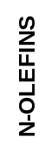 | NPU . C5 | 0.6681 | 0.95 | 2.5 | 0.015 | 0 | 0.08
 | NPU . C6 | 0.6971 | 0.82 | 1.71 | 0.01 | 0 | 0.08
 | NPU . C7 | 0.7015 | 0.83 | 1 | 0.001 | 0 | -0.0497
 | NPU . C8 | 0.7381 | 1.06 | 0.445 | 0 | 0.0014 | -0.0445
 | NPU . C9 | 0.7357 | 0.99 | 0.26 | -0.0007 | 0.001 | -0.0377
 | NPU .C10 | 0.7464 | 0.98 | 0.15 | -0.0002 | 0 | -0.019
 | NPU .C11 | 0.7368 | 0.71 | 0.1 | -0.00015 | 0 | -0.0125
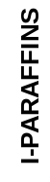 | IPS . C5 | 0.6265 | 1.06 | 2.3 | 0.0 | 0 | 0.1
 | IPS . C6 | 0.6618 | 1.04 | 3.1 | -0.00436 | -0.0123 | 0.168
 | IPS . C7 | 0.6910 | 0.69 | 2.65 | -0.00436 | -0.0071 | 0.119
 | IPS . C8 | 0.7139 | 0.60 | 2.12 | -0.0063 | 0 | 0.085
 | IPS . C9 | 0.7331 | 0.83 | 1.2 | -0.0063 | 0 | 0.048
 | IPS .C10 | 0.7416 | 0.84 | 0.96 | -0.0063 | 0 | 0.027
 | IPS .C11 | 0.7439 | 0.72 | 0.74 | -0.005 | 0 | 0.01
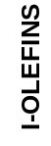 | IPU . C5 | 0.6597 | 0.98 | 2.75 | 0.01833 | 0 | 0.1
 | IPU . C6 | 0.7165 | 1.03 | 3.24 | 0.011 | 0 | 0.1
 | IPU . C7 | 0.7150 | 1.03 | 2.5 | 0.0015 | 0.0032 | 0
 | IPU . C8 | 0.7149 | 0.86 | 1.95 | -0.003 | 0.0039 | -0.0891
 | IPU . C9 | 0.7712 | 1.00 | 1.25 | -0.0045 | 0.0036 | -0.095
 | IPU .C10 | 0.7610 | 0.71 | 0.77 | -0.003 | 0.0031 | -0.0647
 | IPU .C11 | 0.7610 | 0.48 | 0.478 | -0.002 | 0 | -0.0445
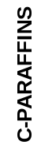 | NAPS. C5 | 0.7502 | 1.32 | 0.04 | 0.00025 | 0 | 0.005
 | NAPS. C6 | 0.7682 | 0.82 | 0.91 | 0.0015 | -0.0024 | 0.0709
 | NAPS. C7 | 0.7792 | 0.75 | 1.72 | -0.002 | -0.0039 | 0.0925
 | NAPS. C8 | 0.7826 | 0.80 | 1.49 | -0.006 | 0 | 0.0497
 | NAPS. C9 | 0.8114 | 0.73 | 1.05 | -0.0045 | 0 | 0
 | NAPS.C10 | 0.8306 | 0.70 | 0.53 | -0.0037 | 0 | -0.01
 | NAPS.C11 | 0.8600 | 0.56 | 0.45 | -0.0026 | 0 | -0.01
 | NAPU. C5 | 0.7928 | 0.77 | 0.3 | 0.0009 | 0 | 0
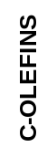 | NAPU. C6 | 0.7928 | 1.01 | 0.96 | 0.00427 | 0 | -0.056
 | NAPU. C7 | 0.8007 | 0.96 | 1.33 | 0.004 | 0 | -0.0929
 | NAPU. C8 | 0.8022 | 0.52 | 1.17 | -0.001 | 0.0027 | -0.0896
 | NAPU. C9 | 0.8165 | 0.41 | 0.68 | -0.002 | 0.0034 | -0.045
 | NAPU.C10 | 0.8530 | 0.32 | 0.3 | -0.0014 | 0 | -0.045
 | NAPU.C11 | 0.8600 | 0.53 | 0.196 | -0.0007 | 0 | -0.028
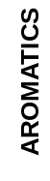 | AROM. C6 | 0.8832 | 1.04 | 0.223 | 0.00178 | 0 | 0.02
 | AROM. C7 | 0.8741 | 1.27 | 1.26 | 0.00583 | -0.0022 | 0.0592
 | AROM. C8 | 0.8654 | 1.31 | 2.83 | 0.013 | -0.0049 | 0.1385
 | AROM. C9 | 0.8655 | 1.30 | 3.3 | 0.011 | -0.0053 | 0.1402
 | AROM.C10 | 0.8577 | 0.80 | 4.324 | 0.00806 | -0.0081 | 0.0937
 | AROM.C11 | 0.8624 | 1.50 | 2.4 | 0 | 0 | 0
Feed Quality Factor (FQF) and Catalyst Factor (CAF) coefficients:

COMPONENTS |  | Total N2 (e) | API/10⁻² (f) | ABP/10⁻³ (g) | S/10⁻¹ (h) | Ca/10⁻² (i) | RMA/10⁻²
 | NPS . C5 | -0.642 | 7.50 | 2.20 | 0.00 | 0.00 | 0.258
 | NPS . C6 | -0.642 | 7.50 | 2.20 | 0.00 | 0.00 | 0.258
 | NPS . C7 | -0.9592 | 7.50 | 2.10 | -0.523 | 0.00 | 0.307
 | NPS . C8 | -0.5713 | 5.00 | 1.95 | -0.568 | 0.00 | 0.176
 | NPS . C9 | -1.00 | 4.50 | 1.20 | -1.559 | 0.00 | 0.00
 | NPS .C10 | -1.00 | 4.25 | 0.50 | -2.098 | 0.00 | -0.193
 | NPS .C11 | 0.00 | 4.00 | 0.00 | -2.439 | 0.00 | -0.304
 | NPU . C5 | -1.50 | 4.50 | 1.50 | 0.873 | 0.00 | -0.445
 | NPU . C6 | -1.50 | 4.00 | 2.50 | 0.873 | 0.00 | -0.445
 | NPU . C7 | 0.00 | 2.00 | 2.10 | 0.455 | 0.00 | -0.79
 | NPU . C8 | 0.00 | 0.00 | 2.00 | 0.782 | -0.50 | -1.127
 | NPU . C9 | 0.00 | 0.00 | 1.80 | 1.017 | -0.50 | -1.127
 | NPU .C10 | 0.00 | 0.00 | 1.67 | 1.658 | 0.00 | -1.143
 | NPU .C11 | 0.00 | 0.00 | 1.17 | 1.559 | 0.00 | -1.213
 | IPS . C5 | -1.53 | 6.50 | 0.85 | 0.00 | 0.00 | 0.824
 | IPS . C6 | -1.53 | 6.50 | 0.78 | 0.00 | 0.00 | 0.824
 | IPS . C7 | -2.223 | 3.02 | 0.75 | -0.955 | -0.96 | 0.88
 | IPS . C8 | -2.064 | 2.27 | 0.73 | -0.808 | -0.89 | 0.452
 | IPS . C9 | -1.90 | 0.00 | 0.75 | -0.989 | -1.57 | 0.22
 | IPS .C10 | -1.781 | 0.00 | 0.78 | -0.624 | -1.63 | 0.00
 | IPS .C11 | -1.00 | 0.00 | 0.60 | -0.638 | 0.00 | 0.00
 | IPU . C5 | -1.15 | 5.85 | 1.74 | 1.071 | 0.00 | 0.00
 | IPU . C6 | -0.5123 | 4.00 | 2.00 | 1.071 | 0.00 | 0.00
 | IPU . C7 | -0.70 | 2.00 | 2.20 | 0.90 | 0.00 | -0.367
 | IPU . C8 | 0.00 | 0.00 | 2.08 | 0.782 | 0.00 | -0.783
 | IPU . C9 | 0.50 | 0.00 | 1.90 | 1.10 | 0.00 | -0.983
 | IPU .C10 | 0.90 | 0.00 | 1.83 | 0.824 | 0.00 | -1.127
 | IPU .C11 | 1.10 | 0.00 | 1.89 | 0.805 | 0.00 | -1.169
 | NAPS. C5 | -2.20 | -1.00 | 0.00 | -2.059 | -4.50 | 0.434
 | NAPS. C6 | -2.97 | -1.00 | 0.00 | -2.059 | -4.50 | 0.434
 | NAPS. C7 | -2.75 | -5.00 | -0.50 | -2.642 | -5.00 | 0.20
 | NAPS. C8 | -2.584 | -8.00 | -0.70 | -2.249 | -6.50 | -0.024
 | NAPS. C9 | -2.20 | -7.00 | -1.00 | -1.093 | -6.50 | -0.283
 | NAPS.C10 | -1.80 | -7.09 | -1.30 | -2.145 | -6.50 | -0.453
 | NAPS.C11 | -1.681 | -7.05 | -1.40 | -2.138 | -5.17 | -0.478
 | NAPU. C5 | 0.0201 | 0.00 | 0.00 | 0.00 | -1.00 | 0.495
 | NAPU. C6 | 0.0201 | -2.00 | 1.00 | 0.00 | -2.20 | -0.495
 | NAPU. C7 | 0.00 | -4.50 | 0.00 | 0.00 | -3.50 | -0.67
 | NAPU. C8 | 0.00 | -5.00 | 0.00 | 0.00 | -3.80 | -0.828
 | NAPU. C9 | 1.322 | -4.00 | 0.00 | 0.00 | -3.00 | -0.90
 | NAPU.C10 | 2.00 | -4.00 | 0.00 | 0.00 | -3.00 | -0.95
 | NAPU.C11 | 2.00 | -2.00 | 0.00 | 0.664 | -2.80 | -1.00
 | AROM. C6 | -2.205 | 0.00 | -1.75 | -1.568 | -4.18 | 1.916
 | AROM. C7 | -1.40 | -2.00 | -0.50 | -1.268 | -2.00 | 0.714
 | AROM. C8 | -1.30 | -2.00 | -0.50 | -0.297 | -1.78 | 0.78
 | AROM. C9 | -1.25 | -2.00 | -0.50 | -0.404 | -1.93 | 0.344
 | AROM.C10 | -1.179 | -3.28 | -0.80 | -0.891 | -1.50 | 0.00
 | AROM.C11 | -0.80 | -3.30 | -0.80 | 0.00 | -1.00 | 0.00
Predicted PIANO species are scaled so that their sum is equal to the C5+ gasoline cut ending at 212 deg C. C5s, C6 paraffins, C9 paraffins, and C9 aromatics are excluded from the scaling.
If the input data is in the form of a PIONA a multiplicative unit factor is calculated. If full PIONA data is not available, then the unit factor is assumed to be unity.

Prediction of gasoline composition (PIANO input)
The input to the base case is wt% of C5-C11 fraction of the stream boiling between 20 and 212 deg C (adds up to 100%). To calculate totals an estimate of the amount of PIANO components that go to light cycle oil is computed. The species in LCO are assumed to be distributed by temperature as follows
C5front=20 deg C
C5end=53 deg C
C6end=85 deg C
C7end=115 deg C
C8end=143 deg C
C9end=169 deg C
C10end=192 deg C
C11end=212 deg C
Then, e.g.
C6s_flowrate[lco1] = lco1_flowrate * wt_fraction_lco1_53_to_85C (from simdis)
Each carbon number is combined from lilght cycle oil streams and broken down into piano species proportionally to corresponding total gasoline composition. For C5s gas stream species are also added.
Then the total of each component is obtained and piano yield UFs are computed. For every component the shortcut fractionation (see Sec. 4.3) is performed using the following boiling point assignments (deg C):
 | NPS | NPU | IPS | IPU | NAPS | NAPU | AROM
C5 | 36.1 | 34.1 | 27.9 | 28.4 | 49.2 | 44.2
C6 | 68.7 | 65.9 | 60.7 | 60.4 | 80.7 | 83.1 | 80.1
C7 | 98.4 | 96.7 | 86.9 | 83.9 | 99.5 | 114.2 | 110.6
C8 | 125.7 | 123.3 | 112.3 | 111.5 | 121.7 | 142.8 | 139.3
C9 | 150.8 | 146.8 | 136.7 | 145.1 | 149.2 | 162.8 | 164.9
C10 | 174.1 | 170.4 | 158.7 | 167.1 | 181.5 | 170.5 | 184.6
C11 | 195.5 | 194.8 | 178.7 | 187.1 | 203.2 | 195.5 | 219.2
Species distribution UFs are calculated for each gasoline/gasoline and gasoline/LCO splits. There is an additional set of similar UFs for C5 species distribution between gas and gasoline. The distribution UFs are essentially the difference between tabulated component boiling points and boiling points computed from these components splits using Fenske equation and corresponding effective cut points (ECP).
Finally PONA and FIA are computed from PIANO of gasolines.
In the predict case PIANO species are calculated by executing the correlations and applying the yield unit factors. Then the species are distributed between liquid streams (and for C5s the gas streams) using fractionation distribution unit factors.
PONA and FIA are computed from PIANO of gasolines as in the base case.

Prediction of gasoline composition (FIA input)
PONA based input/output is not yet implemented in the code.
To develop narrow fraction curves for each of the major components (paraffins, olefins, naphthenes and aromatics) an average boiling temperature is assigned to each carbon number, from C5 to C11.
Example. The ABP for C6 is set to 80ºC - hence the olefinicity at 80ºC is equal to the C6 olefinicity:
Olefins content of gasoline at 80ºC = (iC6 olefin + nC6 olefin + cyclic C6 olefin ) * 100
total C6
For FIA analysis, the curves are calculated on a vol% basis.
The average boiling points assigned to each carbon number are:
Carbon number | Average boiling point (ºC)
4 | 0
5 | 45
6 | 80
7 | 110
8 | 139
9 | 165
10 | 185
11 | 219
Note: these values were previously used to construct PONA curves in Catsim (v.1 to v.3) spreadsheets. They differ slightly from the component temperatures used in PIANO since there was no attempt made to reconcile them.
Aromatics curve is set to zero below C6.
The splines are used to create full range property curves from the key points. To extend the curves above gasoline range the olefins are decreased exponentially from 219C onwards, by a factor of 2 every 40C, and aromatics are increased to exponentially approach 95%, by a factor of 1.5 every 40C.
Olefins and aromatics curves are then treated the same as other property curves.
Saturates in each narrow fraction are computed by difference.

Standalone benzene prediction
There is a separate input(calibrate)/output(predict) for benzene in gasoline streams. The same PIANO equation for total benzene yield is used
p_yield_benzene (wt% ff)= 1.035 * {0.223 + 0.00178 * (riser_outlet_temp(F) - 950) + 0.0 * (rxt_whsv - 48) + 0.02 * (cat_oil_ratio - 8)} * {1 - 2.205 * (3. * totalfeed_basic_N2/10000. - 0.15) + 0.0 * (totalfeed_API - 19.5) - 0.00175 * (totalfeed_abp - 885) - 0.1568 * (totalfeed_S - 2.65) - 0.0418 * (CA_ndm - 13.93)} * {1 + 0.01916 * (RMA - 124)} * 0.8832 / *feed_sg
and benzene is fractionated in a similar way. The difference is that here the yields are not scaled to match combined C5-C11 to the standard gasoline yield. That is why this prediction of benzene concentration will be slightly different from the prediction when full PIANO input is used.

6 PRODUCT RECYCLE PREDICTION
This technology allows any of the cycle oil streams, or any blend of these streams, to be recycled. The recycled streams are blended into one total recycle cycle oil stream and this is used as the recycle feed. This methodology may give a strange distillation if an unusual mix of streams is recycled and for this reason the user must be careful when deciding what to recycle (e.g. Recycling a mix of 0.5 tonnes of LCO with 10 tonnes of DCO may be inadvisable)
The recycle model works by:
- Calculating kinetic coke and kinetic conversion for recycle and fresh feed.
- Combining these values to get the overall conversion and coke yield.
- Blending the flow rate and qualities of the recycled feed with the fresh feed, creating a total combined feed.
- Predicting the other yields and qualities based on total combined feed qualities, the calculated overall conversion and the subsequent model equations.
- De-blending recycled material from gross products to get net product yields.
This process is shown graphically below:
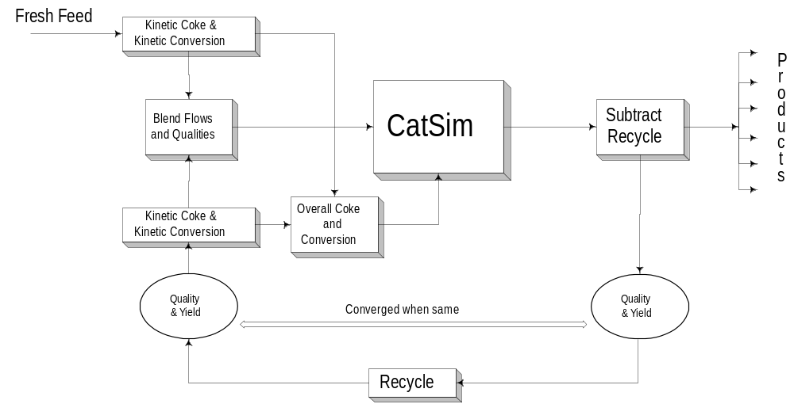
When material is recycled the yield and quality of the recycled material changes as the model goes through an iteration. These iterations continue until the predicted yield and qualities of the recycled material are the same as those being blended with the fresh feed, at this point the model is said to be converged.
Within the DLLs direct substitution of the input qualities with the predicted qualities is used as the convergence method. At present the solver is used within Excel to solve situations where the user requires cut points to be changed to give specified recycle flow rates. A DLL solution method to allow this functionality could be developed as a future modification.
At present there are no internal checks on the material balance for recycle. This means that if the user attempts to recycle more product that he/she is producing the model will report a negative plant flow rate for that product.

Dual Calibration of the Recycle Model
When the model is calibrated on a single test run data set, a unit factor is calculated for the kinetic conversion and kinetic coke. Because the model has two equations for each of these predictions but only one set of calibration data the same unit factor is attributed to each of the equations.
This situation may not be ideal and by examining multiple test runs, with and without recycle, it may be possible to identify an average unit factor for the recycle or fresh feed equations. For this reason there are base case inputs available for kinetic conversion and kinetic coke unit factors.
Inputting a unit factor for the recycle kinetic coke or conversion will fix the error associated with the equations for the recycle material. Thus all of the error between the predicted and actual conversion/coke will be attributed to the fresh feed equations and a unit factor will be calculated.
Similarly if unit factors are entered for the fresh feed equations, values will be calculated for the recycle equations unit factors.
If both are entered, the recycle unit factors are ignored.

7 Catalyst Management Calculations
There are two calculation procedures in the catalyst management section of the model. The first is the metals calculation which relates the E-cat metals level to the feed metals level and catalyst addition rate. The second calculation relates the E-cat metals level to the catalyst activity.
The relationship between feed metals and E-cat metals is given by a metals balance according to:
Feed Metals = (Ecat Metals - Fresh Cat Metals) * Catalyst Addition Rate / Feed Rate
Fresh catalyst metals (Ni, V and Na) are calculated off-line to take into account sodium on fresh catalyst and any nickel and vanadium on flushing catalyst.
The relationship between E-cat metals and activity is given by the following:
where : E-cat KMat = E-cat MAT / (100 - E-cat MAT)
Fresh KMat = Fresh MAT / (100 - Fresh MAT)
VT% = Vanadium trap percent on inventory
RGT = Regenerator temperature (K)
Error: Reference source not found = Catalyst addition rate / inventory
k₁,k₂,k₃,k₄,k₅ = Constants tuned to a specific catalyst
Na = Sodium on E-cat (wt%)
V = Vanadium on E-cat (ppm)
UF = Unit factor generated from base case data
Fresh catalyst activity and total CAR are calculated off-line when flushing catalyst is in use.
The model can be used in two modes - with or without hydrothermal deactivation, depending on the values of the user-input deactivation constants:
Using the model without hydrothermal deactivation the following values of k should be used:
k₁ = -1.36 E-2
k₂ = 1.05 E-5 / ((TPUR * VT%)/100 + 1)
k₃ = 7.24 E-2
k₄ ₌ ₀
k₅ ₌ _{5 E-4}
where : TPUR = vanadium trap pick up rate
Using the model with hydrothermal deactivation the following values of k should be used:
k₁ = -0.02172
k₂ = 1.05 E-5 / ((TPUR * VT%)/100 + 1)
k₃ = 7.24 E-2
k₄ ₌ ₂₄₆₃
k₅ ₌ ₁₂₂₈₂
Using the above two equations , given any two of the following allows the other two to be calculated:
Feed Metals
E-cat Metals
Catalyst addition rate
E-cat activity and Fresh-cat activity
For sensible results, the term (k1 + k2 * V + K3 * Na) in the above catalyst deactivation equation must be greater than 0. If not, the equation will predict the E-cat KMat as greater than the Fresh KMat, which is clearly incorrect.

MAT H2 Yield Calculation
Hydrogen yield from an FCC is affected by the metals level on the catalyst. The impact of metals on the hydrogen yield can vary from catalyst to catalyst. In order to represent the effect of metals on hydrogen yield whilst avoiding the problem of different metals sensitivities from different catalysts, the hydrogen yield has been represented as a function of MAT H2 rather than E-cat metals level. This generic MAT H2 yield equation can then be tailored to any specific catalyst operation by having specific equations to predict the MAT H2 yield for a given catalyst operation.
The prediction of MAT H2 yield can also include a term for the effect of antimony passivation of nickel. The model predicts the effect of antimony passivation as a linear reduction in the activity of nickel up to a certain saturation level of antimony, beyond which the nickel activity remains at its lowest level. This is represented graphically:

The antimony saturation level and the nickel activity at that saturation level are two inputs that can be tuned to a specific catalyst operation to represent the effect of antimony. In order to construct the above graph, the value of k must be calculated as a function of the antimony saturation level and the minimum nickel effectiveness:

For Sb/Ni < saturation level:
The equation of the line is:

where: Min_Ni_Act = minimum nickel activity
Sb_sat = Sb/Ni saturation level
re-arranging the above equation gives:

For the above graph where Min_Ni_act= 1/3 & Sb_sat = 0.5, which leads to a k value of 4/3.
Finally,

For Sb/Ni > saturation level:
The equation of the line is:

re-arranging the above equation gives:
A model option exists to include MAT H2 as a base case input into the model. If MAT hydrogen is specified in the database, a MAT H2 unit factor is calculated and output, using the models MAT H2 correlation. (UF = Actual / Predict). A user input MAT hydrogen unit factor is then applied to the MAT H2 correlation in the predict case.

If no MAT H2 is input in the base case, the MAT H2 is calculated with the base case unit factor equal to 1. Changing the predict MAT H2 unit factor will change the predict MAT H2 in the usual way.

8 ELEMENTAL BALANCES

8.1 Sulphur Balance

Base Case Calculations
The model calculates a sulphur balance from the base case feed sulphur and product sulphurs (including flue gas SO_{x}) as:
Sulphur Balance % = Sulphur in Products / Sulphur in Feed * 100
If SO_{x} data is not entered by the user, the wt% sulphur in coke is estimated as being:
Sulphur in Coke (wt%) = exp(1.172) * feed_sulfur^0.9 * (100.01 - feed_hydro)^-0.3 *
exp(2.0 * (ecat_Fe - *fresh_cat_Fe))
If flue gas SO_{x} data is entered by the user this is used to calculate the sulphur in coke. A unit factor for sulphur in coke is then generated as:
Sulphur in Coke UF = Actual wt% sulphur in coke/predicted wt% sulphur in coke

Predict Case Calculations
In the predict case the sulphur content of the products is adjusted such that the predict case sulphur balance is the same as the base case:
Predict Sulphur in Coke = equation * UF (if applicable)
Predict sulphur in products as outlined in section 4.1 and 4.2 (product quality predictions).
Calculate the sulphur balance.
Adjust the wt% sulphur in each product (including flue gas SO_{x} but excluding H₂S) proportionately such that the predict case sulphur balance is the same as the base case. For example the new sulphur in gasoline would become:
New Sulphur in CCS = Predict Sulphur in CCS - (Predicted Sulphur in CCS / (sulphur in products - H₂S) ) * Sulphur Balance error
The reason that H₂S is not adjusted results from the models calculation of CCS yield. CCS is calculated by difference in the model. If the H₂S yield were to be adjusted, this would affect the CCS yield, which would in turn affect the gasoline sulphur content , which would cause the sulphur balance to change and result in a complex iteration loop. Hence, to avoid iteration all product sulphurs except H₂S are adjusted to satisfy the sulphur balance.

Recycle Considerations
Recycle adds some additional complexity to the sulphur balance. This complexity arises because we need to ensure two statements are true:

- The sulphur of the recycle material is equal to that of the material being recycled.
Example. If 100% DCO.is being recycled. Then recycle sulphur = DCO sulphur.
The sulphur being recycled is not subject to the sulphur balance. i.e. 100% of the sulphur being recycled is found in the products.
As discussed before the sulphur balance normalises the product sulphurs to maintain the required sulphur balance between feed and products. If statement one is to remain true material is recycled after this normalisation has taken place, else in our example it would be possible that 100% recycled DCO material would have a different sulphur content to the product DCO material.
Statement two indicates that the recycled material should not be included in the sulphur balance. The reasoning for this is best illustrated with an example:
Example. Take a base case with no recycle, a sulphur balance of 90% and 100t of feed sulphur. This gives us products containing a total of 90t of sulphur. Now introduce recycle: the recycle material contains 10t of sulphur. Subject this sulphur to the 90% sulphur balance and it is reduced to 9t in the products. Now there is only 89t of sulphur in the products.
So by subjecting the recycle material to the sulphur balance sulphur can be either created or destroyed depending on whether the sulphur balance is above or below 100%.
Adhering to these two statements when the model is operating with recycle means that the sulphur balancing needs to be performed in a slightly different way.
In the base case the sulphur balance is determined by the amount of sulphur in the fresh feed and the amount of sulphur in the net products, i.e. after recycle.
Sulphur Balance % = Sulphur in Net Products / Sulphur in Fresh Feed * 100
In the predict case the normalisation still takes place but the sulphur content of the gross products is normalised so that:

Recycle forces the model to become iterative and the amount of recycle sulphur is calculated from the material that was recycled at the beginning of the iteration. Thus the sulphur of the recycle material may change slightly and the model needs to iterate until is converges.
If recycle is zero the above two equations simplify to the standard sulphur balance equations.

8.2 Hydrogen Balance
As a check on the quality of the input data in the base case and of the predictions in the predict case, the model carries out a hydrogen balance for both the base and the predict cases.
The hydrogen content of the coke is calculated from a flue gas oxygen balance in the base case and is assumed to remain the same in the predict case. The hydrogen content of the gas streams are calculated directly from the molecular composition of each stream.
The hydrogen content of the feed and liquid product streams are predicted from the physical properties (SG and MeABP). An attempt is made to estimate the specific gravity of the limiting (maximum hydrogen content) paraffin and aromatic molecule at the MeABP of the stream. From the SG the carbon number (paraffins) and number of rings (aromatic) are estimated. The hydrogen contents of the paraffin and aromatic can then be calculated directly. The liquid hydrogen content is calculated by:
Limiting Paraffin SG (SGP) = 0.642 + 0.000509 * MeABP(°C)
Limiting Aromatic SG (SGA) = 0.765 + 0.00115 * MeABP(°C)
Carbon Number = 0.7672 + 0.13228 * MeABP(°C)
H2 in Paraffin = (2 * n + 2) / (14 * n + 2) * 100
Number of Rings =- 0.07107 + 0.0089256 * MeABP(°C)
H2 in Aromatic = (2 * r + 10) / (50 * r + 70) * 100
H2 in Liquid = H2 in P + (H2 in A - H2 in P) * (liq prod sg - sgp) / ( sga - sgp)

9 CUBIC SPLINE FUNCTIONS
Let (x1,y1) , (x2,y2) ... (xn,yn) be a set of known data points. Suppose you wish to fit a curve that passes through these points in order to interpolate values at unknown points. If the curves that join together all of the points are continuous and are polynomial functions, then the set of curves is known as a spline function. In general a spline function is given by a different polynomial function between each pair of points, however, the definition does not require this.
The simplest method of interpolating between points is by connecting them by straight lines. This is in fact a spline function of degree 1. Whilst this method will give a continuous function and hence allow interpolation at any point, if you require the interpolated curve to be smooth, you will need to use a higher order spline. A spline of degree 3 is the most common choice as it results in a visually smooth curve and is unlikely to result in oscillatory behaviour as higher order splines are prone to. This third order spline will result in a third order polynomial function between each of the known points, and is commonly referred to as a cubic spline. Hence, if you have five data points, a cubic spline function will result in four cubic polynomial functions between each interval. The term ' spline function' is intended to suggest that the graph of such a function is similar to a curve drawn by a mechanical spline such as a French curve. As a close approximation, the curve plotted by a mechanical spline is a cubic spline function.
Between each pair of known data points (xi,yi), (xi+1,yi+1) the cubic spline is of the form:
- (1)
where: 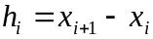. The values of can be determined by solving the set of n-2 equations:
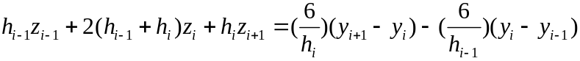 - (2)
for : . Note that z1 = zn = 0.
As an example of the method, the following is a detailed description of how to fit a cubic spline to the three standard SG prediction values, in order to interpolate values at non-standard points.
Temperature (°C) | SG
125.5 - x1 | 0.75 - y1
285.5 - x2 | 0.93 - y2
445 - x3 | 1.05 - y3

The first step is to calculate the values of h. In this case h1 = x2-x1 = 160 ; and h2 = x3-x2 =159.5.
The next step is to solve the set of n-2 equations as given by (2) above. Since there are only three points this results in only the one equation to solve (for i=2).
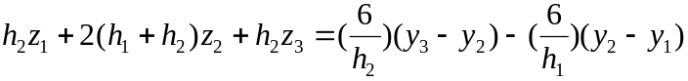
Note that in this case z1 = z3 = 0. Substituting into the equation the values for the x's , y's and h's gives a value for z2 = 2.84e-6. Substituting all of the values into equation (1) above gives:

Hence to interpolate a value for SG at 300 °C, the equation S2(x) would be used (since 300 is between x2 and x3) resulting in an interpolated SG of 0.945.

10 DISTILLATION CONVERSION METHODS

10.1 D1160 @ 10MM Hg to TBP Vol% @ 10 mm HG
The method used to convert from D1160 to TBP vol% at 10mm HG is based on the 1986 API method which is described in section 3A2.1 in the 1986 API data book. The method in the API book is a graphical method. The method calculates the temperature difference between each pair of D1160 points and then uses a graph to relate this to an equivalent TBP vol% difference. The curves work on temperature differences between the 0&10 % points , the 10 & 30 % points and the 30 & 50 % points. Temperatures at the 50 % point and above are estimated as the same for both distillation methods. The correction curve for 10-30% and 30-50% is the same , hence the result is two curves. The two correction curves have been estimated by polynomial expressions as taken from PPEFA. The two polynomials used are:
0 to 10 %:
DIFF OUT = (((-7.42308413E-7*DIFF IN + 2.22095232E-4)*DIFF IN - 2.88790713E-2)
*DIFF IN + 2.27019576) * DIFF IN - 7.4961674E-2
where: DIFF OUT = temperature difference between the 0 % and 10 % TBP vol% points.
DIFF IN = temperature difference between the 0 % and 10 % D1160 points
10 to 30 %:
DIFF OUT = (((-4.20211427E-7 * DIFF IN + 1.06765303E-4) * DIFF IN - 1.02138607E-2)
* DIFF IN + 1.36841183) * DIFF IN
where: DIFF OUT = temperature difference between the 10 % and 30 % TBP vol% points.
DIFF IN = temperature difference between the 10 % and 30 % D1160 points.
30 to 50 %:
Same equation used as for the 10 to 30% points.
The above equations are used directly to find the temperature differences between the 0 to 10% , the 10 - 30 % and the 30 - 50% points. If the required distillation points are in between these points, then the D1160 temperature differences are scaled up so that these equations can be used , and then the resulting TBP vol% differences are scaled back down again in the same proportion. So far example, if the first two points in the D1160 distillation were a 0% point and a 5% point , the temperature difference between these points would be doubled so that the 0 - 10% correction equation could be used. The resulting 0 - 10% TBP vol% temperature difference would then be halved to get the 0 - 5% TBP vol% difference.

10.2 TBP vol% @ 10mm Hg to D1160 @ 10mm Hg
This procedure is identical to procedure 10.1 except that the two temperature difference correction polynomials are as follows:
0 to 10%:

DIFF IN = (DIFF IN - 40) / 20
DIFF OUT= (((0.2314814775 * DIFF IN + 1.064814815) * DIFF IN + 3.24074076) *
DIFF IN + 15.7407411) * DIFF IN + 23.333333
10 to 30% and 30 to 50%:
DIFF IN = (DIFF IN - 50) / 25
DIFF OUT = (((0.13888888 * DIFF IN - 0.3240741) * DIFF IN + 0.2777777) * DIFF IN
+ 26.2962963) * DIFF IN + 46.666666
10.3 TBP vol% to d86 vol%
This conversion method is based on the paper by TE Daubert in Hydrocarbon Processing, September 1994. The method first calculates the D86 50 % point directly from the TBP vol% 50 % point. There are then a set of correlations to calculate the D86 temperature differences away from the 50% point for the 0%, 10%, 30%, 70%, 90% and 100%. These are a function of the equivalent TBP vol% temperature differences away from the 50 % point. The 50 % point is calculated as follows:
D86 50 % = 1.1431 * TBP 50% ^ 0.97485
Temperature points below the 50 % point are calculated by subtracting a temperature difference from the 50 % point according to the following :
D86 % point (i) = D86 % point (i +1) - E * (TBP(i+1) - TBP(i)) ^ P
Temperature points above the 50 % point are calculated by adding a temperature difference from the 50 % point according to the following:
D86 % point (i+1) = D86 % point (i) + E * (TBP (i+1) - TBP (i)) ^ P
where the values of E and P are as follows:

RANGE | E | P
0 - 10 | 0.03606 | 1.6599
10 - 30 | 0.10879 | 1.3958
30 - 50 | 0.25043 | 1.2488
50 - 70 | 0.32268 | 1.2195
70 - 90 | 0.22911 | 1.3246
90 - 100 | 3.622 | 0.60219

Example:
D86 30 % point = D86 50 % point - 0.25043 * (TBP 50% - TBP 30%) ^ 1.2488
Each actual range may not be the same range as the range of the correlation i.e. we may wish to convert points other than just the 0, 10, 30, 50, 70, 90 and 100% points. If the range between two distillation points is greater than a correlation range then it is necessary to work out the contribution from each correlation to the total difference of the range.
Example. If we had a 10 % point and the next point we had was the 50 % point, then the contribution from the 10-30% correlation would need to be worked out and added to the contribution from the 30-50% correlation to get the total temperature difference. Similarly , if a required range was less than a correlation range ,i.e. a 0% and a 5 % point then the temperature difference would only be the proportion of the correlation range.

10.4 D86 vol% to TBP vol%
This conversion method is identical to the method in 10.3 except with different values for the constants. The 50 % conversion equation is as follows:
TBP 50 % = 0.8718 * D86 50% ^ 1.0258
The values for E and P are as follows:

RANGE | E | P
0 - 10 | 7.4012 | 0.60244
10 - 30 | 4.9004 | 0.71644
30 - 50 | 3.0305 | 0.80076
50 - 70 | 2.5282 | 0.82002
70 - 90 | 3.0419 | 0.75497
90 - 100 | 0.11798 | 1.6606

10.5 Simdis wt% (D2887) to D86 vol%
This conversion method is identical to the method in 10.3 except with different values for the constants. The 50 % conversion equation is as follows:
D86 50 % = 0.77601 * SD 50% ^ 1.0395
The values for E and P are as follows:

RANGE | E | P
0 - 10 | 0.3047 | 1.1259
10 - 30 | 0.06069 | 1.5176
30 - 50 | 0.07978 | 1.5386
50 - 70 | 0.14862 | 1.4287
70 - 90 | 0.30785 | 1.2341
90 - 100 | 2.6029 | 0.65962

10.6 D86 vol% to Simdis wt% (D2887)
This conversion method is identical to the method in 10.3 except with different values for the constants. The 50 % conversion equation is as follows:
SD 50 % = 1.2763 * D86 50% ^ 0.962
The values for E and P are as follows:

RANGE | E | P
0 - 10 | 2.8735 | 0.88818
10 - 30 | 6.33646 | 0.65893
30 - 50 | 5.17255 | 0.64994
50 - 70 | 3.79746 | 0.69994
70 - 90 | 2.59778 | 0.81031
90 - 100 | 0.23451 | 1.51602

10.7 Simdis wt% (D2887) to TBP vol%
This conversion method is identical to the method in 10.3 except with different values for the constants. The 50 % conversion equation is as follows:
TBP 50 % = 1.000 * SD 50% ^ 1.000
The values for E and P are as follows:

RANGE | E | P
0 - 5 | 0.15779 | 1.4296
5 - 10 | 0.15779 | 1.4296
10 - 30 | 0.011903 | 2.0253
30 - 50 | 0.05342 | 1.6988
50 - 70 | 0.19861 | 1.3975
70 - 90 | 0.31531 | 1.2938
90 - 95 | 0.97476 | 0.8723
95 - 100 | 0.02172 | 1.9733

10.8 TBP vol% to Simdis wt% (D2887)
This conversion method is identical to the method in 10.3 except with different values for the constants. The 50 % conversion equation is as follows:
SD 50 % = 1.000 * TBP 50% ^ 1.000
The values for E and P are as follows:
RANGE | E | P
0 - 5 | 3.63865 | 0.6995
5 - 10 | 3.63865 | 0.6995
10 - 30 | 8.91564 | 0.49375
30 - 50 | 5.60968 | 0.58865
50 - 70 | 3.17925 | 0.71556
70 - 90 | 2.44025 | 0.77292
90 - 95 | 1.02974 | 1.14639
95 - 100 | 6.96341 | 0.50677

10.9 Boiling Point Pressure Conversion
To convert a distillation temperature from one pressure to another API procedure 5A1.13 is used assuming that the Watson K of the fraction is equal to 12. Procedure 5A1.13 can be used to calculate the vapour pressure of a hydrocarbon at any temperature given the true boiling point of the hydrocarbon. Hence, if the distillation temperature at 760 mm Hg is known, then the distillation temperature at any other pressure can be calculated. The method can be used in reverse to calculate the distillation temperature at 760 mm Hg given the distillation temperature at any pressure. If the distillation temperature needs to be converted from one pressure to another, neither of which are 760 mm Hg, the temperature at 760 mm Hg must first be calculated and then converted to the desired pressure. There are three equations used for different vapour pressure ranges:

where:

10.10 D1160 @ 760 mm Hg to D86 & Simdis
In accordance with the API methods for distillation conversion, there is no direct method of converting from D1160 to D86 or Simdis. Instead, a number of separate conversions have to be made. The conversion path is as follows:
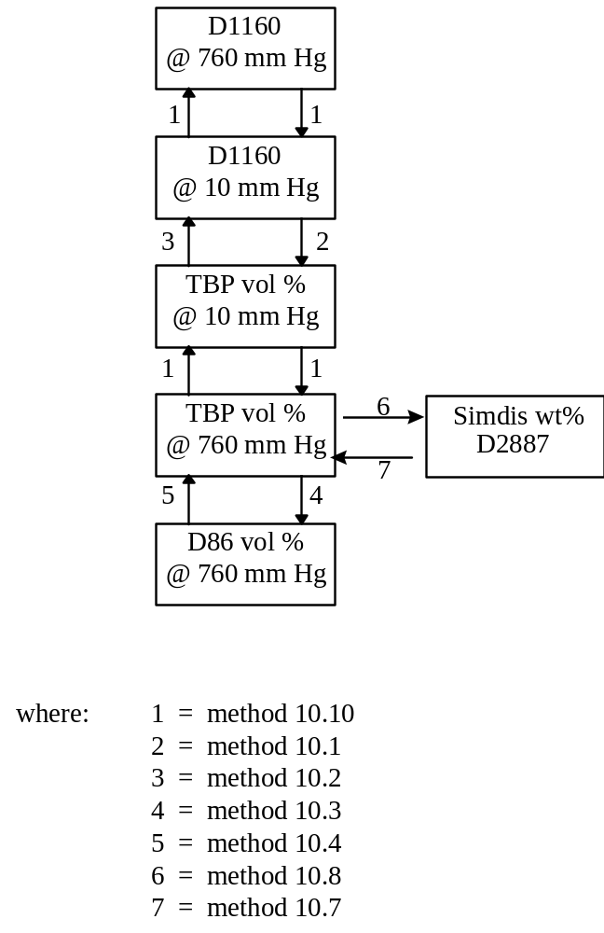

11 PHYSICAL PROPERTY CALCULATIONS AND CONVERSIONS
All methods have been taken from the 1987 API data book.
The general method is to convert the distillation type to equivalent D86 values, this allows determination of VABP (Volume Average Boiling Point). From the methods given in the data book, delta's can be evaluated to convert VABP to WABP (Weight), MABP (Mole), MeABP (Mean), and CABP (Cubic Average Boiling Point). All temperatures are in degrees Rankine.

11.1 Generation of Characterising Boiling Points
Given the D86 10%, 30%, 50%, 70%, and 90% points the VABP can be determined:
VABP = T10 + T30 + T50 + T70 + T90
5
Deltas can then be evaluated by the following equations to allow determination of the various characterising boiling points:
WABP = VABP + Del 1
MABP = VABP - Del 2
CABP = VABP - Del 3
MeABP = VABP - Del 4
ln (Del 1) = - 3.062123 - 0.018929 (Tv - 32) 0.6667 + 4.45818 SL 0.25
ln (Del 2) = - 0.56379 - 0.007981 (Tv - 32) 0.6667 + 3.04729 SL 0.333
ln ( Del 3) = - 0.23589 - 0.06906 (Tv - 32) 0.45 + 1.8858 SL 0.45
ln (Del 4) = - 0.94402 - 0.00865 (Tv - 32) 0.6667 + 2.99791 SL 0.333
WABP MABP CABP MeABP and VABP in oF.
Tv = VABP
SL = (T90 - T10) / 80
(API Data book 1987 Sect 2-11)

11.2 CALCULATION OF C_{A}
Two methods exist for calculation of CsubA depending on the type of feed analytical data available.

Short Calculation Method (sg & distillation)
The old equation was
freshfeed_CA_nmr = -172.611 + 266.64 * feed_sg - 0.07209 *DEGF_TO_DEGK(freshvabp)
It had a disadvantage of producing negative numbers when SG or ABP of a highly paraffinic feed was varied in the forward predictions.
v.3 equation: the ratio of Ca to the rest of the carbon is predicted first:
Ca_ratio = exp(13.86)*SG^15.65*ABP^-2.09
And then
Ca_nmr = 100.0/(1.0+1.0/ Ca_ratio)

Long Calculation (sg, RI, distillation)
Inputs:
feed_RI Refractive Index
RI_temp Refractive index temperature (°F)
feed_mw Feed Molecular Weight
feed_S Feed sulphur (wt%)
feed_N2 Feed Nitrogen (wt%)
feed_vabp Feed Average Boiling Point (°F)
feed_sg Feed specific gravity
CA_ndm Calculated CA_ndm
RI_Cor Corrected RI
Correct RI for temperature:
RIDEL = (-0.06798478 *feed_mw + 0.000073138305 * feed_mw ^ 2 + 27.995275) ^ 0.5
RI_67 = feed_RI - RIDEL * (67 - RI_temp) / 10000
Correct RI for sulphur and nitrogen:
RI_Cor = RI_67 - 0.0022 * feed_S - 0.005 * feed_N2
Correct sg for sulphur and nitrogen:
SG_Cor = feed_sg - 0.0064 * feed_S - 0.01 * feed_N2
RI for 0% aromatics - function of sg:
RI_Zero_Arom = 0.924 + 0.62 * SG_Cor - 0.8 * (SG_Cor - 0.783) ^ 2
RI for 100% aromatics - function of sg:
if (SG_Cor <= 0.9)
then {RI_100_Arom = 0.62 * (SG_Cor - 0.9) + 1.51}
else {if (SG_Cor <= 1.1)
then {RI_100_Arom = 0.6625 * (SG_Cor - 0.9) + 1.51}
else {RI_100_Arom = 0.03 * (SG_Cor - 1.1) + 1.6425}
Calculate fraction aromatics:
Calculate distance above 0% aromatics line:
Delta_Above_0_Arom = RI_Cor - RI_Zero_Arom
Calculate distance between 0 aromatics and 100% (D2):
Delta_100_0_Arom = RI_100_Arom - RI_Zero_Arom
Calculate relative distance between 0 and 100% aromatics (AN):
Rel_Delta_Arom = Delta_Above_0_Arom / Delta_100_0_Arom
Check if relative distance greater than 1 (if greater set to 1):
if (Rel_Delta_Arom > 1)
then {Rel_Delta_Arom = 1
Delta_RI = RI_Cor - RI_100_Arom

if (Delta_RI > 0.005)
then {RI_Cor = RI_100_Arom + 0.005}

if (Rel_Delta_Arom <= 0)
then {Rel_Delta_Arom = 0
XRel_Delta_Arom = Rel_Delta_Arom + 1}
else {XRel_Delta_Arom = Rel_Delta_Arom + 1}
Calculate aromatic fraction:
Frac_Arom = -1 + 14.918712 - 50.69636 * XRel_Delta_Arom + 69.723218 * (XRel_Delta_Arom) ^ 2 - 45.131829 * (XRel_Delta_Arom) ^ 3 + 13.710609 * (XRel_Delta_Arom) ^ 4 - 1.5228703 * (XRel_Delta_Arom) ^ 5
if (Frac_Arom > 1) then Frac_Arom = 1
Calculate paraffins fractions:
RI for 100% paraffins - function of ABP:
RI_100_Par = 1.398 + 0.01 * (feed_vabp * 0.01 - 4) - 0.00064 * (feed_vabp * 0.01 - 4) ^ 2
RI for 21% paraffins:
RI_21_Par = 1.475
RI for 0 PCT paraffins - function of ABP:
RI_0_Par = 1.64 - 0.0109 * (feed_vabp * 0.01 - 4)
RI for 60 % (max%) naphthenes- function of ABP:
RI_60_Nap = 1.46 + 0.02 * (feed_vabp - 400) / 500
RI for 9 PCT (min % for for high RI) naphthenes:
RI_9_Nap = 1.56
If RI is less than paraffins line set equal to paraffin RI:
if (RI_Cor - RI_100_Par < 0) then RI_Cor = RI_100_Par
If RI is less than 21% paraffins line:
if (RI_Cor - RI_21_Par < 0)
then Delta1 = RI_21_Par - RI_100_Par
Delta2 = RI_21_Par - RI_Cor
PXP = (Delta2 / Delta1) ^ 1.1
Frac_Para = 0.123 + 0.087 * 10 ^ PXP}
else if (RI_0_Par - RI_Cor < 0)
then Frac_Para = 0.08
else Delta1 = RI_0_Par - RI_Cor
Delta2 = RI_0_Par - RI_21_Par
Frac_Para = (Delta1 / Delta2) * 0.13 + 0.08
Calculate naphthenes and naph-benzenes by difference:
if (Frac_Arom + Frac_Para - 1 <= 0)
then Frac_TNaph = 1 - Frac_Arom - Frac_Para
else Temp = Frac_Arom + Frac_Para
Frac_Arom = Frac_Arom / Temp
Frac_Para = Frac_Para / Temp
Redistribute any aromatics greater than 0.65 (0.60 to arom, 0.10 to para, 0.30 to naph)
if (Frac_Arom > 0.65)
then DeltaA = Frac_Arom - 0.65
Frac_Arom = 0.65 + 0.6 * DeltaA
Frac_Para = Frac_Para + 0.1 * DeltaA
Frac_TNaph = Frac_TNaph + 0.3 * DeltaA
Calculate naphthenes and then naph-benzenes by difference:
Frac_NaphB = 0.3 * Frac_Arom + 0.05
Frac_Naph = Frac_TNaph - Frac_NaphB
if (Frac_Naph < 0)
then Frac_Arom = Frac_Arom + Frac_Naph
Frac_Naph = 0
Calculate CA and CN contributions:
Determine RI of each constituent:
RI_Arom = RI_Cor + 0.04 * (1 - Frac_Arom)
Determine CA of each constituent:
Calculate CA of aromatics:
CA_MonArom = 10 ^ (-0.1024 * (feed_vabp / 100 - 4) + 1.739))
CA_Arom = 10 ^ ((0.2085 * RI_Arom - 0.37) * (feed_vabp / 100 - 4) + (1.342 * RI_Arom - 0.2))
if (CA_Arom > 100)
then CA_Arom = 100
else if (CA_Arom < CA_MonArom)
then CA_Arom = CA_MonArom
Calculate CA of naph-benzenes:
CA_NaphB = 10 ^ (-0.000704 * *feed_vabp + 1.935)
Calculate CA of naphthenes:
if (RI_Cor < 1.56)
them Ratio = 0.937 *RI_Cor - 1.262
else Ratio = 0.2
CA_Naph = Ratio * CA_NaphB
Calculate CN of naphthenes:
Temp1 = 1.78 + 0.882 * (RI_Cor - 1.4)
Slope = -0.06 + 0.2 * (RI_Cor - 1.4)
CN_Naph = 10 ^ (Slope * (feed_vabp * 0.01 - 4) + Temp1)
if (CN_Naph > 95)
then CN_Naph = 95
if (CN_Naph < 10)
then CN_Naph = 10
Calculate CN of naph-benzenes:
CN_NaphB = 10 ^ (-0.048 * (feed_vabp * 0.01 - 4) + 9.25 *RI_Cor - 12.45)
Calculate another CN of naph-benzenes and weight results:
CN_NaphB = 0.7 * CN_NaphB + 0.3 * 0.7 * CA_NaphB
if (CN_NaphB > 65)
then CN_NaphB = 65
if (CN_NaphB < 5)
then CN_NaphB = 5
Normalise CA and CN contributions if necessary:
if (CA_Naph + CN_Naph > 95)
then {CA_Naph = CA_Naph * 95 / (CA_Naph + CN_Naph)
CN_Naph = CN_Naph * 95 / (CA_Naph + CN_Naph)}
if (CA_NaphB + CN_NaphB > 95)
then {CA_NaphB = CA_NaphB * 95 / (CA_NaphB + CN_NaphB)
CN_NaphB = CN_NaphB * 95 / (CA_NaphB + CN_NaphB)}
Calculate total CA_ndm amd CA_nmr
CA_ndm = Frac_Arom * CA_Arom + Frac_Naph * CA_Naph + Frac_NaphB * CA_NaphB
freshfeed_CA_nmr = 1.45 * CA_ndm

11.3 CONVERSION BETWEEN MAT & RMA
The following correlations have been derived from Naperville data:
MAT = 100 * (0.6 + 0.884 * (0.01 * RMA) ^ 2) / (1 + (0.6 + 0.884 * (0.01 * RMA) ^ 2))
RMA = 100 * SQRT (((G153 / (100 - G153)) - 0.6) / 0.884)

11.4 CONVERSION BETWEEN Conradson Carbon & Ramsbottom carbon
Recorrelation of the ASTM data on Ramsbottom carbon vs. Conradson carbon, making sure that equations are analytically reversible and always positive, led to the following:
For ConC<0.01 or RamsC<0.0553
RamsC = 5.53*ConC
For higher values (works great up to 20wt% of either one):
RamsC = EXP(0.0666*ln(ConC)^2+0.8821* ln(ConC)-0.2448)
And the reverse transformation:
ConC = EXP((-0.8821+SQRT(0.8821^2+4*0.0666*(0.2448+LN(RamsC))))/(2*0.0666))

11.5 CONVERSION BETWEEN MeABP, VABP & ABP
The following correlations have been derived from Sunbury data:
freshfeed_abp = (DEGC_TO_DEGF * (freshfeed_meabp) + 11.268) / 0.9672
freshfeed_vabp = (DEGC_TO_DEGF * (freshfeed_meabp) + 1.8283) / 0.9855

APPENDIX 1: QUENCH ADD-IN
Quench technology, where the gas exiting the riser is quenched to a lower temperature to reduce post-riser thermal reactions is practiced on Amoco-heritage FCC units in the BP system. The technology is an alternative to reduction of post-riser gas residence time (through DCC for example) for reduction of thermal reactions.
Catsim contains an implementation of the quench technology derived from FCCSIM (the Amoco heritage model).
The quench is assumed not to have any effect on the heat balance, coke and conversion. The dilute phase (or post riser zone) thermal reactions affected are cracking reaction of c6-430 material to yield c2s and c3s.
C6-430 → c2s
C6-430 → c3s
The post-riser yields of these reactions are predicted from kinetic expressions of the above reactions as a function of post-quench (dilute phase) gas temperature and post-quench gas residence time.
For more details see Amoco memos detailing the development of the technology and the validation of the resulting equations.
The c2s and c3s standard yield equations, when the Catsim quench model is turned on, have the following form
Yield = UF*(riser cracking technology yield) + (post-riser cracking technology yield) (Eq. A1)
where the riser cracking technology yield is the same as described in section 3.2.
Note that c2s and c3s unit factors will be different if the quench model is on (post-riser yields are predicted) or off (no separate post-riser yields are predicted, and the last term is equal to zero.)
The basic calculations consist of two steps:
1)Heat balance to estimate the gas temperature in the dilute phase (or post riser zone). This involves solving a quadratic equation resulting from an enthalpy balance.
2)Estimate of post-riser technology yields. This involves estimating rates of reactions and conversions of riser c6-430 yield to c2s and c3s.
In the calibrate case calculations, a measured dilute phase temperature is input and the heat balance step calculates an additive temperature unit factor (dilute phase heat balance calibration). C2 and C3 yileds unit factors are then calculated according to equation A1.
In the predict case, the heat balance step will predict a new dilute phase temperature and eq A1 is used to estimate new C2s and C3s yields.
Known problems:
The current implementation is very cumbersome as it is done as an add-in. Separate functions, c_quench and p_quench, which are essentially C++ versions of the VBA routines provided with Catsim v.1 are called from the spreadsheet. The calculations are hence done outside the regular Catsim engine to estimate the relevant standard yields unit factors which are then overwritten in the interface (see US generic interface). As a result, the plant yields will not be consistent with standard yields when the quench model is used. This should be corrected in future versions by much more simply implementing a dilute phase heat balance module in the main Catsim code and expressing the yields of c2s and c3s in the standard yields routine according to Eq A1 above.
See subroutines c_quench and p_quench for current implementation. Relevant technology equations (lifted from the code) are reported below.
The heat balance calculations (for calibrate case) are
// Heat Bal
QSPHin = (-143.464 + 0.1811395 * (QuenchTemp + 460) +
0.000225 * (QuenchTemp + 460) * (QuenchTemp + 460)) / sqrt(quenchsg);
C4Hin = c4minusrate * (C4minusCp * rot - C4minusF);
CCSHin = ccsrate * (LiquidCP * rot + LiquidF * CCSAPI - LiquidConst);
LCOHin = LCORate * (LiquidCP * rot + LiquidF * lcoapi - LiquidConst);
DCOHin = DCORate * (LiquidCP * rot + LiquidF * dcoapi - LiquidConst);
CatHin = CatRate * Catcp * rot;
QuenchHin = QuenchRate * QSPHin;
TotalHin = C4Hin + CCSHin + LCOHin + DCOHin + CatHin + QuenchHin;
QSPHoutConst = Houtk1 - Houtk2 * quenchsg + Houtk3 * 460 * (4 - quenchsg) +
460 * 460 * Houtk4 * (4 - quenchsg);
// Quadratic Coeffs
a = Houtk4 * (4 - quenchsg) * QuenchRate;
b = Houtk3 * QuenchRate * (4 - quenchsg) + 2 * 460 * Houtk4 * (4 - quenchsg) *
QuenchRate + c4minusrate * C4minusCp + LiquidCP * (ccsrate + LCORate + DCORate) +
CatRate * Catcp;
c = QuenchRate * QSPHoutConst - c4minusrate * C4minusF + LiquidF *
(ccsrate * CCSAPI + LCORate * lcoapi + DCORate * dcoapi) - LiquidConst *
(ccsrate + LCORate + DCORate) - TotalHin;
if (fabs(QuenchRate) < SMALLNUM)
PredTDil = rot;
else
PredTDil = (-b + sqrt(b * b - 4 * a * c)) / (2 * a);
diltempuf = diltemp - PredTDil;
while the kinetics for the thermal reaction to c2s and c3s and the related conversion of c6-430 material are calculated as follows (these are lifted from routine c_quench, the calibrate calculations)
// Rate Consts
C2minRC = 0.0175 * exp(-53000 / 1.987 * ((1 / (diltemp + 460)) - (0.0006849)));
C3RC = 0.004 * exp(-53000 / 1.987 * ((1 / (diltemp + 460)) - (0.0006849)));
Phi = 1 + C3RC / C2minRC;
C2minConv = (1 - pow(exp(-C2minRC * RxtResTime * 60),Phi)) / Phi;
C3Conv = (Phi - 1) * C2minConv;
See Amoco memos for derivation of these equations.

APPENDIX 2: CATCALC ADD-IN

INTRODUCTION
CatSim (like its predecessors PMS and FCCSIM) can be used to simulate the effects of catalyst changes. This is done using “catalyst factors” to modify yield and quality predictions relative to the base case. These factors can be generated in two ways:
- directly from lab test data
- using a computer model (“CatCalc”) based on the catalyst composition
CatCalc was originally set up to allow engineers experienced in FCC, but inexperienced in lab procedures to simulate “simple” catalyst changes such as reformulations. It requires a general understanding of catalyst technology which is covered briefly in this note. However, a basic level of catalyst knowledge is a pre-requisite - for example if you can not name the 4 basic components of FCC catalyst then stop reading now, and have a look at some of the training material on the web.
Converting lab-data to catalyst factors is really a specialist activity - although the chemical reactions are the same in both commercial and lab-equipment, the balance between different reaction types will differ between them. If you want to know what happens if you switch between major catalyst technologies, or introduce a new catalyst technology, then CatCalc alone will not help you. Converting lab data (or vendor data) into cat factors is fairly straight-forward provided you understand both CATSIM technology and lab procedures. If you do not know which Catsim correlations do not fit MAT data, then consult your technical advisor.

2. CATCALC - BASIC DESCRIPTION

Purpose
CatCalc is primarily intended for modelling reformulations of the incumbent catalyst type. For this it requires no lab test data other than the base and new catalyst formulations defined in terms of the zeolite content (surface area), the rare-earth content and the matrix content of the fresh catalyst, plus the wt% of any additives such as ZSM5 or bottoms-cracking additives. CatCalc uses a set of “structure-activity” correlations derived from lab-data, commercial trials and published information. Wherever possible, sources have been compared to give a “consensus.”

2.2 Basic Description
CatCalc is an extra sheet for CatSim which allows FCC catalyst changes or reformulations to be modelled by BPAmoco FCC models. Typical applications are:
- optimisation of catalyst formulation
- testing alternative operating strategies including catalyst formulation
- sense-checking of FCC vendor proposals
It acts by adjusting the equations within CatSim in order to simulate catalyst activity and selectivity:
- fresh catalyst activity (hence addition rate)
- e-cat selectivity for all light gases (hydrogen to i-butylene)
- e-cat selectivity for all liquid products (gasoline, light and heavy cycle oils)
- coke selectivity (including “kinetic” coke and metals effects)
- standard gasoline qualities
The basic principles are:
- e-cat performance can be predicted from e-cat condition and composition
- e-cat condition and composition can be predicted from fresh catalyst properties and FCCU operation
but in most cases these two steps are combined into a single correlation.

“Garbage-in = Garbage-out”
In most cases, the above two steps are represented as a single correlation which applies in most “normal” circumstances. HOWEVER the model will start to fail if either principle is violated eg. if your unit has been running abnormally (eg. high cat losses) then the catalyst selectivity might change and would not be predicted by CatCalc.
CatCalc will fail if your catalyst data are not consistent, but provided the data for the base and new catalysts come from the same source, it does not matter whether BPAmoco or cat supplier figures are used. “Fundamental” changes in catalyst type (eg. switch from AKZO to Grace; switch from Si-Sol to Al-Sol; switch from Z14 zeolite to Z17/CSSN zeolite) are a little more difficult to simulate, but can be done using “custom” catalyst factors.

Development History
CatCalc version 1 was originally developed in the mid-1990’s for PMS [1] and thus reflected the types of catalysts used by BP. Operational experience showed that some improvements were needed for current applications, but work on these was overtaken by the BP-Amoco merger. Amoco and BP differed in their FCC catalyst strategies (primarily RE content) but comparison of the technology in CatCalc Version 1 against Amoco FCCSIM technology [2] showed good agreement where the technologies overlapped. It was decided that CatCalc would be updated to cover a wider RE-range and incorporate some technology improvements.
Catsim was developed during 1999 to replace both FCCSIM and PMS, but resources were not available to complete the CatCalc revision - Catsim is thus being released with the early version, CatCalc 1.6. The technology for the extended version (CatCalc 2.0) has been developed (Appendix 1) but has yet to be coded and tested.

3 DETAILED DESCRIPTION

Add-in Structure
The un-installed add-in has three sheets:
- Installation Instructions - this explains how CatCalc should be linked
CatCalc Calculations sheet - this has several ranges which perform specific functions (formulation input, catalyst factor output, Zeolite/RareEarth calculations, ZSM5 calculations, Matrix Calculations and Custom Factors). Cells are colour coded by type
- Reformulation advice

Link to FCC Model
FCC yield and product quality predictions are based on standard correlations modified using “unit factors” eg.

product yield = unit factor * fn(feed, severity) or
product quality = unit factor + fn(feed, severity)

Catalyst changes are simulated by incorporating an additional “catalyst factor” into the equations in the model:
product yield = catalyst factor * unit factor * fn(feed, severity)
Multiplicative catalyst factors are always set to 1 except when a new catalyst is being simulated, in which case they are calculated within the CatCalc module. The user never “sees” the catalyst factors - a change in catalyst factor will not change the unit factor. This means that design changes and catalyst changes can be simulated simultaneously and independently. The rule is:
Design change ➔ change the unit factors
Catalyst change ➔ use CatCalc to change the catalyst factors

3.3 Description of Catalyst Formulation
As mentioned above, the catalyst formulations are described in terms of:
- the zeolite content of the fresh catalyst
- the rare-earth content of the fresh catalyst
- the matrix content of the fresh catalyst
These properties do not determine the performance of the catalyst directly, however we have found various “structure-performance” correlations.
Yield | Catalyst parameter
H2 | Matrix
H2S | none
C1 | none
C2= | none
C2 | none
C3 | RE2O3 + FSA + ZSM5
C3 Tot | RE2O3 + FSA + ZSM5
C4 Tot | RE2O3 + FSA + ZSM5
iC4 | RE2O3 + FSA + ZSM5
nC4 | RE2O3 + FSA + ZSM5
iC4= | RE2O3 + FSA + ZSM5
C4== | none
iC5 | not modelled in CatCalc 1.6
nC5 | not modelled in CatCalc 1.6
iC5= | not modelled in CatCalc 1.6
C5 Tot | not modelled in CatCalc 1.6
C5-221 | calculated by difference
LCO | calculated by difference
DCO | Matrix
Kinetic Coke | RE2O3 + FSA + Matrix
Kinetic Conversion | no impact (by definition)
GC-RON | RE2O3 + FSA + ZSM5
GC-MON | RE2O3 + FSA + ZSM5
FKMAT | RE2O3 + FSA

Cracking activity
The zeolite is the “powerhouse” of the FCC catalyst, especially for BPAmoco FCCUs which tend to use high zeolite/matrix ratios. The activity of the e-cat depends primarily on:
e-cat activity = activity per unit of zeolite * residual zeolite content.
We cannot routinely measure the actual amount of zeolite in the e-cat, however the surface area can be used instead. (In BPAmoco units, typically >75% of the surface area is due to the zeolite.)
e-cat activity = activity per m2 of zeolite * residual zeolite content in m2/g.
However, both activity per unit of zeolite and residual zeolite content are properties of the e-cat rather than the fresh catalyst, so we have to find a means of estimating them from the fresh catalyst properties and the unit operation.
Residual Zeolite Content depends firstly on the zeolite content of the fresh catalyst, secondly on the stability of the catalysts and thirdly on the severity of the regenerator operation (temperature, steam, metals, catalyst replacement rate.) We assume that the catalyst management model in CatSim can allow for the operation, hence that CatCalc need only estimate the residual zeolite content under “standardised” conditions. For a simple reformulation of a fixed zeolite type (eg. Z14, or ADZ-50), we thus assume that the residual content depends only on the fresh zeolite content, ie that stability differences can be ignored and that severity effects can be left to the CatSim’s catalyst management routines.
ESA_{NEW} = ESA_{BASE} * FSA_{NEW} * FSA_{BSE}
Activity per m2 (or specific Kinetic MAT, SpKMAT) depends on the number of active sites in the equilibrated zeolite. This cannot be measured directly, however the number of active sites depends on the amount of aluminium remaining in the zeolite framework whih in turn controls the unit cell size of the zeolite crystal This can be measured, and for a variety of units we have found it to be linked to the “Rare-earth Index” (REI) of the fresh catalysts. REI is defined as the wt% RE2O3 per m2/g of the fresh catalyst - it is really just an easily measured surrogate for the wt% RE2O3/zeolite: Broadly, this is equivalent to assuming that most of the catalyst in the inventory has equilibrated (or at least that the effect of non-equilibrated zeolite is the same for both new and base catalysts).
This approximates to:
SpKMAT_{NEW} = SpKMAT_{BASE} * ( 1 + k * REI_{NEW}) / (1 + k * REI_{BASE})
where k = 0.10
Implementation
In the CatSim catalyst management calculations, the e-cat MAT is predicted from the “Fresh MAT”, the catalyst addition rate, metals levels and regenerator operation. Fresh MAT (FMAT) is NOT measured in the lab (eg. by steaming real catalyst.) It is a fitting parameter which controls the “E-cat MAT/Addition Rate” response of the model. As such, the “Base Case FMAT” should already be contained within the CatSim Unit Monitoring sheet.
CatCalc simply prorates the fresh activity of the base/new catalysts on the basis of the formulations. For convenience, the inputs/outputs are given as MAT activities, although the calculation is done using the “kinetic MAT activities.” CatCalc lumps the residual zeolite content and specific kinetic MAT calculations into a single FrKMAT adjustment then leaves CATSIM to do the catalyst management calculations.
FrKMAT_{NEW} = FrKMAT_{BASE} * (FSA_{NEW} /FSA_{BASE} ) *
( 1 + k * REI_{NEW}) / (1 + k * REI_{BASE})
Note that the surface areas should really be zeolite surface areas, however for most catalysts one can use total surface areas and still be within the error of the catalyst management data. Exceptions are very high matrix catalysts (AKZO LA grade, Grace XP).

Hydrogen-transfer activity
The hydrogen transfer activity of the e-cat determines its ability to convert olefins to paraffins and naphthenes to aromatics. It is well known that this depends on the active site density in the equilibrated zeolite and thus can be correlated with the rare-earth index as described in the previous section. These equations were based on a combination of Sunbury and other pilot plant data [z]. We have found that these correlations fit most Y-based zeolite technologies.
Multiplicative: CF = (1 + k * REI_{NEW}) / (1 + k * REI_{BASE})
Additive: CF = (1 + k * (REI_{NEW} / REI_{BASE})
Hydrogen-transfer is assumed only to affect C3, C4 and kinetic coke yields. No data were available at the time to calibrate C5 yields hence these are not changed by CatCalc 1.6. Standard (C5-221C) octanes are also reduced when RE-content increases.
Note: CatCalc 1.6 does not have any detailed PIANO group adjustments. This upgrade was planned for Version 2.0
 | k | Form
C3 | -0.008 | Multiplicative
C3 Tot | -0.007 | Multiplicative
C4 Tot | -0.005 | Multiplicative
iC4 | 0.007 | Multiplicative
nC4 | -0.005 | Multiplicative
iC4= | -0.025 | Multiplicative
C4== | 0 | Multiplicative
iC5 | No Data
nC5 | No Data
iC5= | No Data
C5 Tot | No Data
DCO | 0
Kinetic Coke | 0.005 | Multiplicative
Kinetic Conversion | 0
GC-RON | -0.12 | Additive
GC-MON | -0.07 | Additive
LIMITATIONS
Commercial catalysts are limited in their range of properties. Different commercial grades have different maximum surface areas, and different zeolite technologies have different limiting rare-eath contents, hence REI values. Some representative data are summarised below - use these data to check that FSA and REI ranges are not exceeded.
Supplier | Types | Grades | UCS(F) | FSA-max | REI-max
Engelhard | Insitu | Reduxion | 24.49 to 24.51 | 350 | 7 to 8
Engelhard | Incorporated | Millennium | 24.49 to 24.52 | 350 | 7 to 8
Engelhard | Syntec | Ultrium | 24.51 to 24.52 | 360 | 7 to 8
Engelhard | Insitu | Dimension | 24.56 to 24.64 | 360 | 10 to 12
Engelhard | Insitu | Vektor | 24.57 to 24.60 | 400 | 10 to 12 (??)
Engelhard | Insitu | Maxol (BP 3695) | ca. 24.51 | 360?? | 7 ??
AKZO | Los Angeles pre 1996 | Horizon,Access | 24.40 to 24.65 | 320 | All grades:
AKZO | Pasadena pre 1996 | Advance, Vision, Octavision | 24.55 to 24.60 | 320 | 4 @ 24.52
AKZO | Amsterdam pre 1996 | Advance, Vision, Octavision | 24.51 to 24.64 | 320 | 9 @ 24.60
AKZO | All Post 1996 | Centurion, Cobra | 24.40 to 24.62 | 320 | 12 @ 24.64
Grace | US Z14 | Orion, Octacat, Ramcat | 24.52 to 24.56 | 290 | 7 to 8
Grace | Worms Z14 | Spectra 900, Ultima | 24.48 to 24.55 | 310 | 7 to 8
Grace | CSSN / Z17 | Futura, Kristal, Spectra-E | 24.58 to 24.60 | 325 | 11 to 12

Matrix Activity (including BCA)
Matrix activity is assumed to affect three things - DCO yield, coke yield and H2-yield to simulate changes in metal (Ni) tolerance. Matrix technology shows greater variety than zeolite technology, thus the “rules” are less robust, however the ones in CatCalc 1.6 are reasonably representative of “incorporated” catalyst tehnology (such as most Grace, AKZO and CCIC catalysts.)
It is assumed that the first 30 m2/g of “fresh” matrix is inactive with the yields
varying linearly thereafter. (This model drives from graphs of H2-factor vs Fr-MSA [w]). Some sources try to correlate matrix activity with “matrix/zeolite ratio.” This is often incorrectly equated with surface areas, whereas it should refer to the matrix/zeolite activity ratio (ie. incluing the effect of RE/zeolite.) This term thus will reduce the apparent matrix activity if the catalyst character is made more zeolitic simply by changing the RE-content (and leaving the ZSA and MSA unchanged.)
MSA factor = (MSA_{BEW} - 30) / (MSA_{BASE} - 30)
M/Z activity factor = 1 - 0.163 * (KMAT_{NEW} / KMAT_{BASE})
CF = 1 + k * (Tech Factor * M/Z activity factor *MSA factor -1)
The “Tech Factor” was intended to provide a facility for describing the fact that different matrix technologies show different activities per unit of MSA. This however has not been activated and left at unity - deviation might be expected for Engelhard insitu catalysts.
 | K
H2 | 1
DCO | -0.056
Kinetic Coke | 0.153
Bottoms-cracking additive (BCA) can be treated as a simple matrix reformulation. The simplest approach is to treat the catalyst/additive blend as a single material whose formulation is the weight average of the two components.
LIMITATIONS
This area is probably the weakest part of CatCalc due primarily to the difficulty of obtaining reliable data (both lab data for technology development and plant data for validation), the wide range of catalyst types and complications such as strong catalyst-feed interactions (eg. see Grace papers by R Harding and X Zhou.) The technology described above is our best “general” description, but if matrix effects are important then we strongly recommend using customised catalyst data from pilot tests using refinery feedstock. In the absence of such data, it is vital to do “sensitivity checks” using manual adjustment of the cat factors.
If changing MSA in CatCalc makes you money then it may mean that you ought to consider a different matrix type. Do not simply ask the supplier to “increase the MSA,” instead ask them “how can I increase the matrix activity?”

ZSM-5 Additive
BP made a series of ZSM5 trials during the late 1980’s/early 1990’s; these data have been used to set up the ZSM5 model. CatCalc 1.6 was intended primarily for scoping studies (eg. whether to use ZSM5) rather than detailed optimisation of ZSM5 usage. Its main features are thus:
- adjustment of LPG yields and quality
- adjustment of standard octanes
Multiplicative: CF = 1 + wt% ZSM5 * (k - 1)
Additive: CF = 1 + wt% ZSM5 * k
 | k
C3 Tot | 1.06 | Multiplicative
C4 Tot | 1.04 | Multiplicative
iC4 | 1.03 | Multiplicative
nC4 | 1 | Multiplicative
iC4= | 1.064 | Multiplicative
GC-RON | 0.11 | Additive
GC-MON | 0.14 | Additive
All other factors are set to unity.
CatCalc 1.6 was set up for the conventional additives of the era (eg ZCatPlus) rather than the high activity additives available now. It thus does not simulate some of the effects of high ZSM5 loading (eg. non-linearity). These effects were planned for Version 2.0. Also, it is well known that the performance o ZSM5 additives depend on feedstock and operating conditions. (ZSM5 appears more active if the base gasoline is highly olefinic). Currently we do not have consistent data for catalyst-feed interactions, hence there were no plans to include this in version 2.0

Combined Formulation Changes
It has been assumed that combinations of reformulation changes (eg. change RE and add ZSM5) can be modelled using the product of the individual factors ie.
Final UF = UF (RE, FSA) * UF (ZSM-5) * UF (Matrix).
(The exception is the optional REI-based Zeolite/Matrix activity correction.).
This is only an approximation - for example, we have limited MAT data showing that ZSM5 performance depends on the RE-content of the base catalyst. However, in this particular case, the linkage is due to a reduction in the reactivity of gasoline intermediates because the HT-activity is accentuated. This is the same chemistry as the feed-ZSM5 interaction noted above, hence has not been implemented for the same reason).

Custom Factors
If independent catalyst data are available (eg. from testing), then these can be used in the CatCalc sheet. “Custom factors” can be set up using the Custom Range on the CatCalc Sheet; whenever these factors are non-zero, then all other calculations are over-ridden.

3.4 SIMULATING CATALYST REFORMULATIONS

Base Case
Define a base case and a set of one or more trial catalysts in terms of RE2O3, fresh zeolite surface area, fresh matrix surface area and ZSM5 content. If no MSA data are available, then assume that all catalysts have the same MSA (50 m2/g is reasonable value for most high Z/M catalysts.) Ensure that the base case data all come from the same source (eg. all Grace).
Also check that the base case FMAT is sensible. As mentioned above, the “best” FMATs are derived by fitting unit data so that CATSIM correctly represents the Addition rate/Ecat MAT response of the unit. If the fitted FMAT is within a few numbers of the highest e-cat MATs or is mid-80’s or higher then be suspicious.
NB. This area is one of the more difficult aspects of catalyst simulation, so assistance is advisable.

New Case
If “creating” your own set of new catalysts, then use CatCalc to change the RE, surface areas and ZSM5 content. If trying to simulate a specific catalyst (eg. from vendor formulation data), then ensure that it comes from the same source as the base case data. If this is not possible, then it can be adjusted using inter-vendor conversion tables available from RTG.

Sense Check the Formulations
Both base and new formulations have to be physically sensible. Check that the Fresh SA and REI values remain in the ranges listed above. (NB. Staying within the limits simply means that you are staying with the same catalyst technology. It is quite acceptable to have a quick look and see if exceeding these limits would make money. If it does, then it would be worth discussing the work with your technical advisor to see if alternative catalyst technology is available).
If trying to “sense check” a vendor proposal, then check the REI and FSA as above to see if they are consistent with the proposal If not, then it is possible that the vendor is assuming a change in technology type - if so, then discuss the proposal with your technical advisor.

Unit Response
CatSim will update its prediction as soon as the formulation change is made.

Common Problems
Common pitfalls are
- RE - some vanadium trap technology contains RE, in which case not all of the RE in the catalyst will affect the zeolite performance. If your catalyst contains an RE-based trap (eg. Grace RV-technology) then consult your technical advisor about getting a breakdown of the RE-distribution.
- Vanadium traps are relatively easy to model, but need careful allocation of the effects. Things to consider are (a) does the trap back-out fresh catalyst? (b) how is the RE distributed? Trap calculations are normally made by changing the V-deactivation constant in the cat management model - this is not included in CatCalc hence it is recommended that you consult your technical advisor.
- Changes in zeolite type eg. Grace Z14 and Grace CSSN/Z17 will “stretch” CatCalc outside its calibrations. Directionally it should be OK, but accuracy and detail will be lost.
- If changing ZSM5 additive type, then “normalise” to ZCat+. As a rough guide, we suggest assuming that Grace OlefinsPlus and Intercat Pentacat have ca. 40% less active than ZCat+, that Grace OlefinsExtra and Intercat PentacatPlus are roughly equivalent to ZCat+, and that Grace OlefinsMax and Intercat ZCatHP are 30-40% more active than ZCat+.
- Matrix changes are often problematic. With Akzo catalysts, then is usually a progressive change in performance when the matrix surface are is altered. With Grace and Engelhard catalysts, use the MSA to model matrix effects, BUT please be aware that both Grace and Engelhard matrix types (eg. Grace SAM-100, -200, -300 and -400) can have different activities even for the same surface area. This is because they change the alumina type rather than the amount of matrix. Akzo tends to use blends of its ADM 30 and ADM40 matrices, hence fresh MSA is a guide to the ration of the two, hence the performance. If your catalyst contains anything other than these “standard” ADM, then treat the same way as the Grace and Engelhard catalysts. If changing MSA in CatCalc makes you money, then all it means is that you may need to change matrix type.

4 SIMULATING NEW OR ALTERNATIVE TECHNOLOGY USING LAB DATA

Using Custom Factors
The Custom Catalyst Factors allows the use of cat factors derived from lab test data. The new factors can be typed in directly or alternatively the user can link the custom cat factor range to a database. Whichever approach is used, the catalyst factors MUST be normalised to the catalysts from the CatSim base case.
One of the biggest values of the custom cat factors is the ability to “turn off” parts of the catalyst change. This helps the user to understand which bit of the catalyst technology is really of value. For example. consider a change from Cat A (base case) to Cat B. This can be broken into several steps, for example:
BaseCase | Factors for Cat A (all = 1) | Sets base level of performance
Case 1 | + hydrogen CF for B | checks value of metal tolerance
Case 2 | Case 1 + kin coke CF for Cat B | checks value of coke selectivity
Case 3 | Case 2+ DCO CF for Cat B | checks value of matrix activity
Case 4 | Case 3+ C3 and C4 CFs for Cat B | checks value of RE/zeolite or ZSM5
Case 5 | Case 4 + RON/MON CFs for Cat B | ditto
Case 6 | Case 5 + FMAT of Cat B | checks value of cat activity
Case 7 | All CFs for Cat B | checks anything else
Because the yields can interact (eg. increased H2 might limit ability to make LPG when wet-gas compressor constrained), this is not a rigorous procedure however it is extremely valuable in understanding how the catalyst and unit complement each other.

Scope of test data
First, because CatSim is a base/delta model you will always need test data using the base catalyst for the FCCU being modelled as well as the new catalyst. Ideally you will have data showing the variation of yield and product qualities with conversion (and cat/oil ratio), although yields/qualities interpolated at constant conversion are a good second best. Metal tolerance data should be presented as variation of hydrogen and coke-yields with metal level, and variation of activity with metal level.

Check the Deactivation protocol
Ideally, you will have test data for both the e-cat from the unit and the corresponding lab-deactivated fresh catalyst . This can be used to check the lab pre-treatment protocols.
At the same conversion, e-cat should give the same (or slightly lower) LPG olefinicity and similar bottoms conversion. Matching coke and hydrogen yields will be difficult because few lab procedures will be able to match exactly the metals-level and -activity, at the same time as matching the deactivation of the zeolite (cracking activity). However, kinetic coke yields (ie. coke yield corrected to remove metals) should be in reasonable agreement.
The validity of the metals testing procedure can only be checked by comparing the relative responses of two e-cats with the relative responses of the two corresponding lab-cats.

Fitting Pilot Plant data with CatSim
Ideally, the pilot plant data will conform to the CatSim correlations. The yield (and product quality) factors can thus be set up either by having a “Pilot Plant CatSim” or by processing the data using the CatSim correlations. This is fairly straightforward, with the exception of coke and kinetic conversion factors (see below.). For example:
Total C3 yield = UF * Fn(feed) * fn(RXT, RXP) * Kinetic Conversion^{0.5057}
In lab data, RXT, RXP and feed should be constant hence the above equation can be simplified to:
Total C3 yield = cat-dependent constant * Kinetic Conversion^{0.5057}
Simply plot the data in linear form to get the cat dependent constants for the base and the new catalysts, then calculate the catalyst factors using:
CF = constant for new catalyst / constant for base catalyst.
Data validity should always be checked by “free-fitting” the data using a correlation containing the same terms as CatSim, but with fitted exponents. For example, a base and set of new catalysts are assumed to have yield equations of the form:
Total C3 yield (Base) = Cat constant (Base) * Kinetic Conversion^{A}
Total C3 yield (New 1) = Cat constant (New 1) * Kinetic Conversion^{A}
Total C3 yield (New 2) = Cat constant (New 2) * Kinetic Conversion^{A}
.......
The data are then fitted to give a set of constants (Base, New 1, New 2....) combined with a single exponent A. Cat factors can then be calculated:
CF (New 1) = Cat constant (New 1) /Cat Const (base)
CF (New 2) = Cat constant (New 2) /Cat Const (base)
......
If CatSim and the pilot plant have the same response, then A should be pretty close to the CatSim exponent. If this is not the case, then a judgement will have to be made about the validity of the cat factor set. NOTE: this does not mean that the data are “wrong” or “bad”, it simply means that CatSim either does not represent that particular pilot plant, or that the catalyst has a technology which was not present in the data sets used to create CatSim.

4.5 Fitting Kinetic Coke Catalyst factors using CatSim
Coke is more difficult than the other products because it is a summation of different coke types: kinetic + metals + feed + stripper.
First, the feed coke contribution should be removed using one of the following methods:
- by calculation: feed coke = fn (concarbon and tot nitrogen) as defined in CatSim
- by measurement: plot total coke vs cat/oil for all the data sets; in theory all should intercept the y-axis at the same point, which corresponds to the feed coke. Use a concensus value.
Ideally, both procedures should be done and should agree.
Secondly, if metals are present on the catalyst, then the metals coke contribution should be estimated by calculation: metals coke yield = 5.5 * H2-yield. (It is possible to check this correlation from the raw data, but it is not a job for the faint-hearted or those short of data/time.)
Finally, stripper coke normally is lumped in with the kinetic coke, with the implication that both catalysts are equally “strippable.” The vendors (particularly AkzoNobel) claim that this is not true, and various correlations have been published. Unfortunately, we have no validation of any of these, nor do we know whether they actually apply to pilot plant operations, hence it is simpler to assume that the stripper contribution is constant. Tests suggest that stripper coke contributes ca. 15% to the total coke yield. It normally shows similar cat/oil dependence to kinetic coke which contributes 60-80% of the total coke, thus variations in strippability would have to be enormous for this assumption to be invalid.
For the pilot plant data set, calculate kinetic coke = total coke - feed coke - metals coke, then fit kinetic coke to the CatSim correlation as described for the other yields above (except use cat/oil instead of conversion).
There is a potential pitfall. The CatSim correlations for coke and kinetic conversion include MAT activity data which may not be available or not sufficiently accurate to get decent Kinetic Coke catalyst factors. Check the quality of the MAT data by calculating kinetic conversion cat factors using fits to kinetic conversion = fn(MAT) * fn(cat/oil) as defined in CatSim.- if the Kinetic Conversion Factors are not the same for all the catalysts, then the MAT data are suspect. If this is the case, then calculate the kinetic coke cat factors from fits to kinetic coke yield vs conversion. This is not strictly correct, but will give answers within 5% provided that the catalyst are all of roughly similar activity).

4.6 Using Vendor Yield projections
Vendor yield projections or test data sets are often given at constant conversion. In this case most of the catalyst factors can be estimated from the ratio of the yields. The exception is coke - this will have to be stripped of the feed and metals terms based on some assumed relationships, leaving the kinetic coke factor to be estimated from the ratio of the kinetic coke yields. This has the same caveat as before - the bigger the difference between the activity of the catalysts, the less accurate the procedure.

APPENDIX 3: MODEL INPUT/OUTPUT
Catsim can be run either from Excel interface using XLLs or from any other program providing an interface to the DLLs, e.g. HYSYS. The inputs to the XLLs and DLLs are similar with the exception of feed and product distillation. XLLs accept string inputs which are replaced with numbers as follows: 0:SIMDIS, 1:D86, 2:TBPVOL, 3:D1160.
Catsim calibrate case is essentially one function, CS_calibrate (wrap_calibrate for DLL). Its only output is a message which could be either OK or an error message. Similarly, for the predict case the functions are CS_predict and wrap_predict.
Catsim output is keyword driven. Functions c_extra (wrap_c_extra) and p_extra (wrap_p_extra) take a keyword (string) as an input and output corresponding value. For example, property curves are output using keywords
nf_basicn2(0) to nf_basicn2(140) for basic nitrogen in each narrow fraction at the following temperature (deg C) points:
double nf_mid_temps[FIMAXNFS] = {-32.5,
-27.5,-22.5,-17.5,-12.5, -7.5, -2.5, 2.5, 7.5, 12.5, 17.5,
22.5, 27.5, 32.5, 37.5, 42.5, 47.5, 52.5, 57.5, 62.5, 67.5,
72.5, 77.5, 82.5, 87.5, 92.5, 97.5,102.5,107.5,112.5,117.5,
122.5,127.5,132.5,137.5,142.5,147.5,152.5,157.5,162.5,167.5,
172.5,177.5,182.5,187.5,192.5,197.5,202.5,207.5,212.5,217.5,
222.5,227.5,232.5,237.5,242.5,247.5,252.5,257.5,262.5,267.5,
272.5,277.5,282.5,287.5,292.5,297.5,302.5,307.5,312.5,317.5,
322.5,327.5,332.5,337.5,342.5,347.5,352.5,357.5,362.5,367.5,
372.5,377.5,382.5,387.5,392.5,397.5,402.5,407.5,412.5,417.5,
422.5,427.5,432.5,437.5,442.5,447.5,452.5,457.5,462.5,467.5,
472.5,477.5,482.5,487.5,492.5,497.5,502.5,507.5,512.5,517.5,
522.5,527.5,532.5,537.5,542.5,547.5,552.5,557.5,562.5,567.5,
572.5,577.5,582.5,587.5,592.5,597.5,605, 615, 625, 635,
645, 655, 665, 675, 685, 695, 725, 775, 850, 950};
and similarly:
nf_Concarb for Conradson carbon
nf_kv50 for kinematic viscosity
nf_mon for motor octane
nf_ron for research octane
nf_S for sulfur
nf_sg for specific gravity
nf_mw for molecular weight
liq_nf_paraffins for vol% saturates
liq_nf_aromatics for vol% aromatics
liq_nf_olefins for vol% olefins
For a complete list of keywords refer to the c_extra and p_extra functions in the Catsim code.

APPENDIX 4: MOLECULAR WEIGHT CONSTANTS
Inerts 29.0
H2S 34.078
Hydrogen 2.015
Carbon 12.01
Oxygen 32.0
Sulphur 32.063
Water 18.015
Air (0.21*32+0.79*28.013)
Methane 16.043
Ethane 30.07
Ethene 28.054
Propane 44.097
Propene 42.081
Butane 58.124
Butene 56.108
Butadiene 54.092
Pentane 72.151
Pentene 70.135
C6 plus 100.0

